I heard the prophet speak today

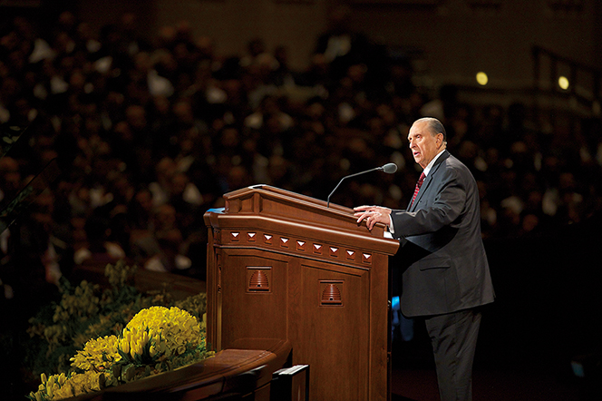

He spoke of [Jesus Christ](http://www.mormon.org/beliefs/jesus-christ)

He said that I should always pray



And live a righteous life

I heard the prophet speak today

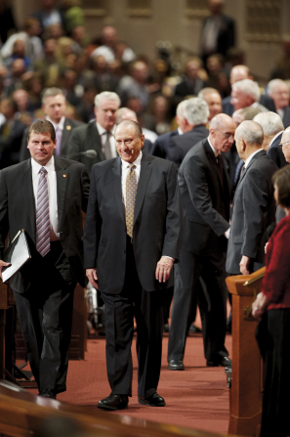

I felt his words

Did you?

I know that he was sent by God

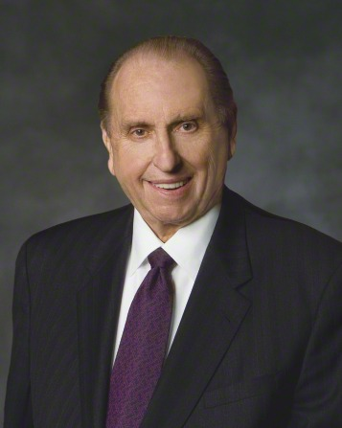

And what he says is true

Now Joshua, and [Joseph Smith](http://www.mormon.org/beliefs/joseph-smith),

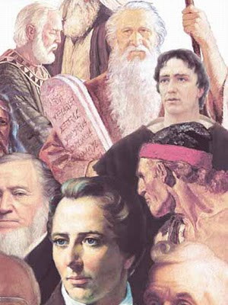

And Paul, and Nephi, too,

Were called by God, who spoke to them

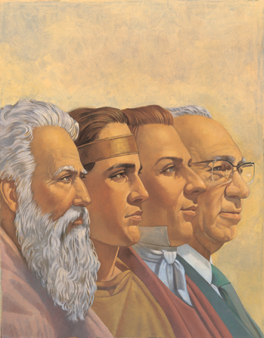

And told them what to do

Some built a ship Some healed the sick

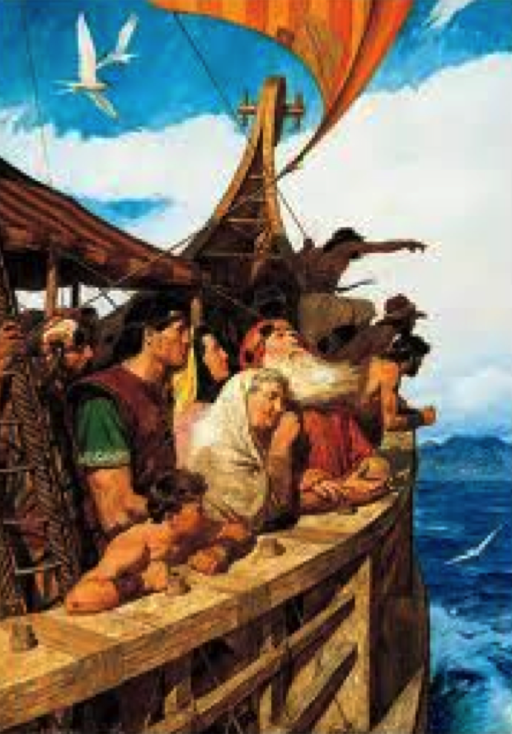

Some turned the night to day

But ev’ry prophet knows the Lord

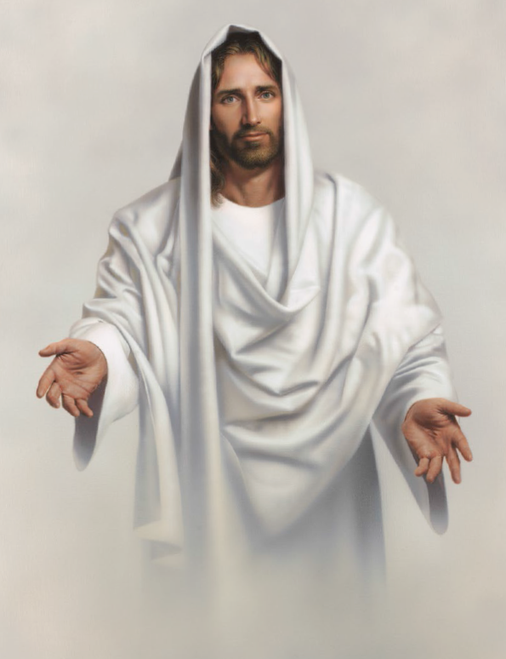

And teaches us His ways

I heard the prophet speak today

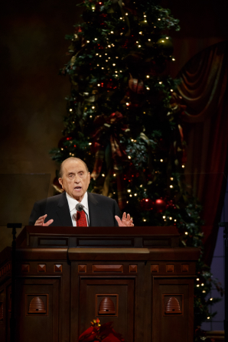

His words were sure and true

He said, “Serve God and you’ll be blessed



In righteous things you do



God’s chosen prophet leads our church

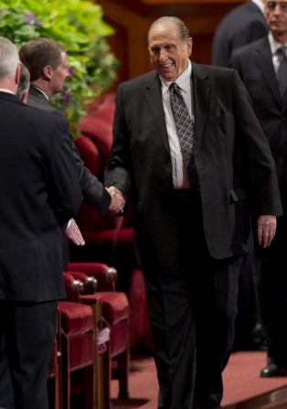

And teaches us today

I’ll listen as God speaks through him

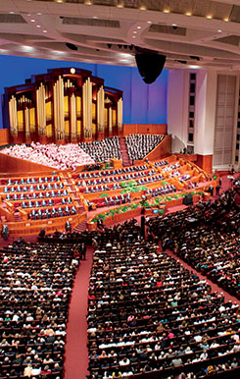

And willingly obey