When I’m sad or I’m lost
When my heart is broken
When my friends turn away
Or harsh words are spoken
There’s a place I can turn
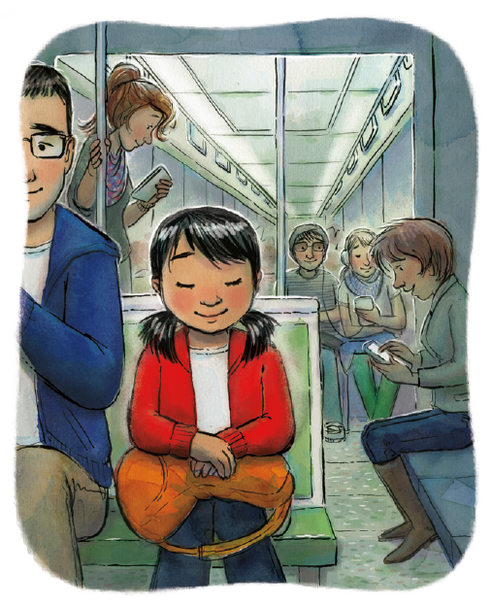
When I need heaven’s wisdom
I can speak from my heart
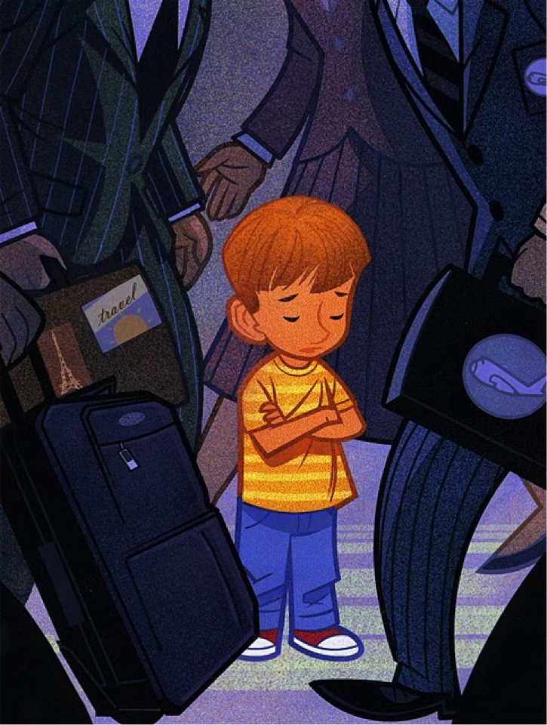
An I know He will listen
There’s a place I can turn
When I need heaven’s wisdom
I can speak from my heart
And I know He will listen
I will say a prayer and God will hear
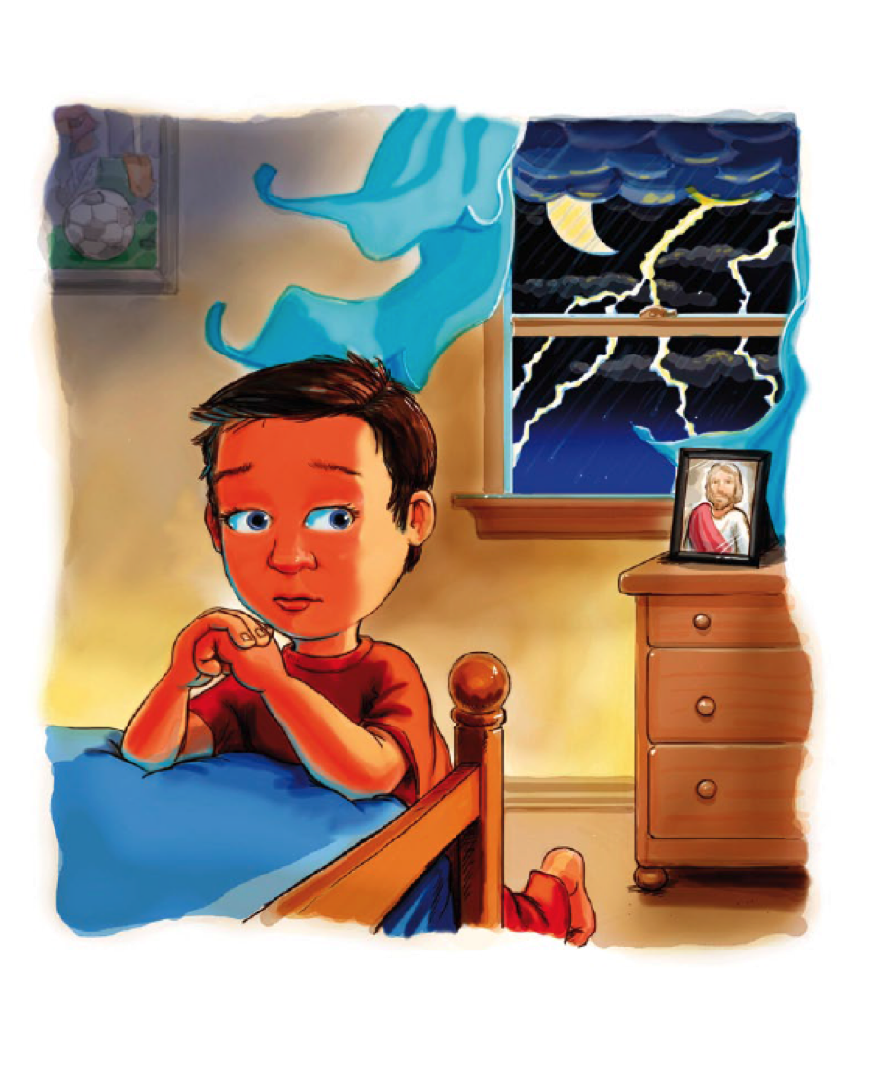
He’s always there beside me
He will rescue me, He’ll comfort me
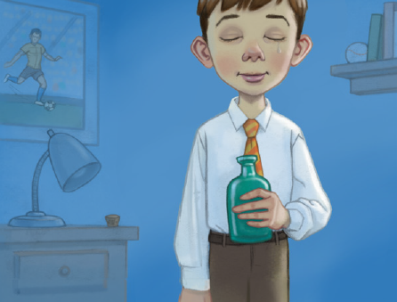
And always gently guide me
Each time I pray I feel his love

A quiet peace surrounds me
For in my heart I seem to feel
His loving arms around me

