No matter where I go
I know I’m not alone
I feel my Savior there beside me

He leads me through the night
He’s always been my guide
He promised He will never leave me
Though my burdens seem too much to bear
He’ll bless me
So, whatever He commands
I will go and do
I will stand for truth
Though the world may back away
I will walk right through
I know if I follow Him
Follow Him in faith
He will ease my burdens
And He’ll provide a way
He’ll provide a way
When I feel overcome
And all my strength is gone
I think of all the ways He’s blessed me
My journey may seem long
But He’ll lift me with His love
A perfect love that’s never ending
He will give me
Give me all the strength I’m needing
So whatever He commands
I will go and do
I will stand for truth
Though the world may back away
I will walk right through
I know if I follow Him
Follow Him in faith
He will ease my burdens and
He’ll provide a way
He’ll provide a way
For me to cross the desert
To sail across the ocean
If that’s where He sends me
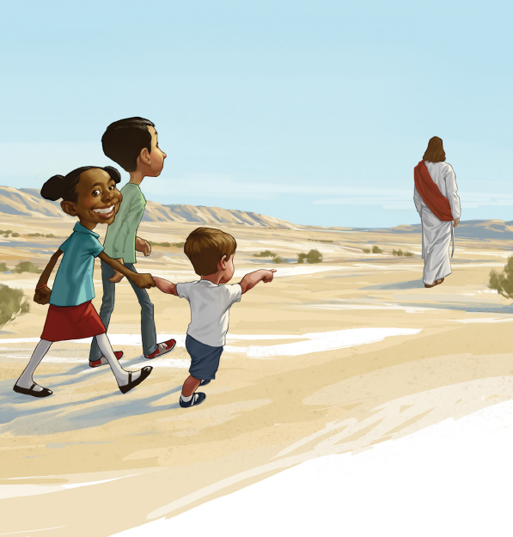
I’ll follow His plan
I’ll do whatever He commands me

For I know that He will lead me
To the promised land
I will go and do
I will stand for truth
Though the world may shut Him out
I will make Him room
I know if I follow Him
Follow Him in faith
He will ease my burdens
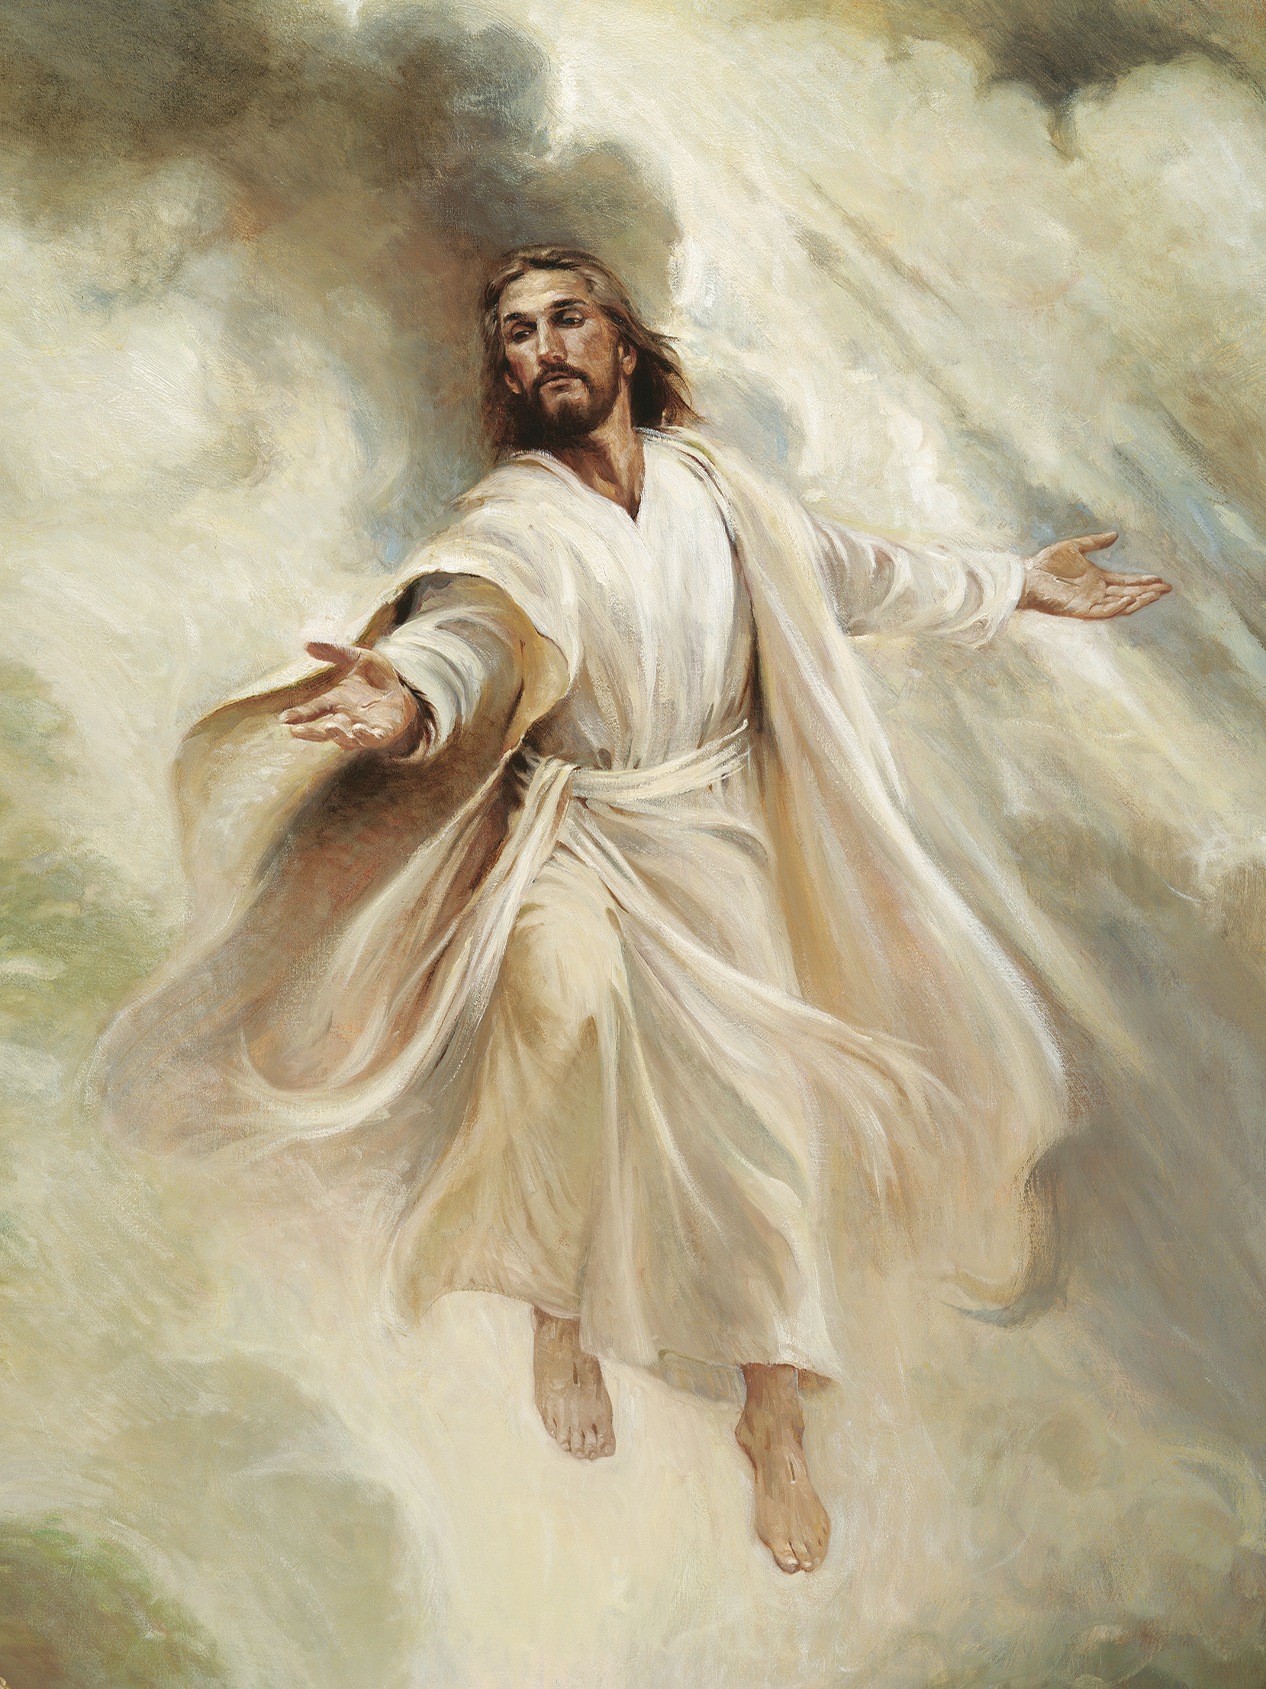
And He’ll provide a way
He’ll provide a way
He’ll provide a way
No matter where I go
I know I’m not alone
I feel my Savior there beside me

