I see the Savior smiling

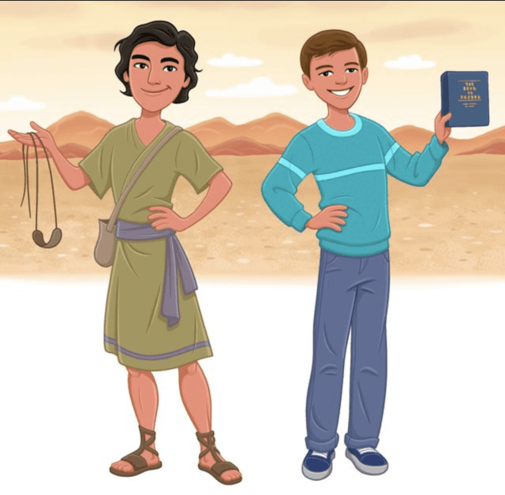
as I stand for truth and right
I see the Savior smiling


as I serve with all my might
I see the Savior smiling


as I give unselfishly
Oh, I see the Savior smiling



as I trust in His love for me
I see the Savior smiling


as I share the
truths I know
I see the Savior smiling


as I make my talents grow
I see the Savior smiling


as I listen
and obey
Oh, I see the Savior smiling



as I worship
each Sabbath day
I see the Savior smiling



as I kneel in
family prayer
I see the Savior smiling



as I love and
show I care
I see the Savior smiling

as I keep
my body clean

Oh, I see the Savior smiling



as I give thanks
for everything

