I like to listen to the prophet
His words are good and true
When he speaks
He always tell us

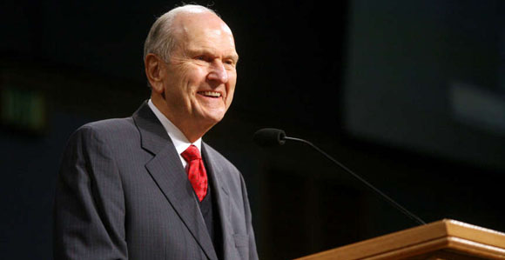
Good things that we can do
I see love shining like the Savior’s
In his face for me and you
He cares for each one of God’s children
I know he loves me too
He wants us all to live
So we can be with God once more
And if his counsels we’ll obey
They’ll open wide the door
I like to listen to the prophet
He’s here to show the way
When he speaks I want to live
To be with the Lord someday

