I know that Jesus lives
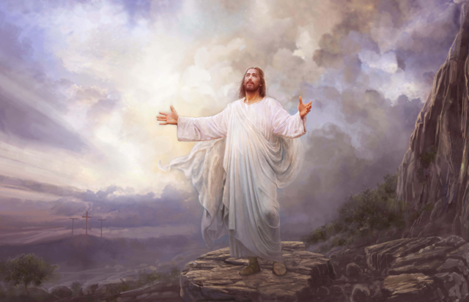
And that he loves me
I know a prophet leads our church

And guides me
I know the Book of Mormon
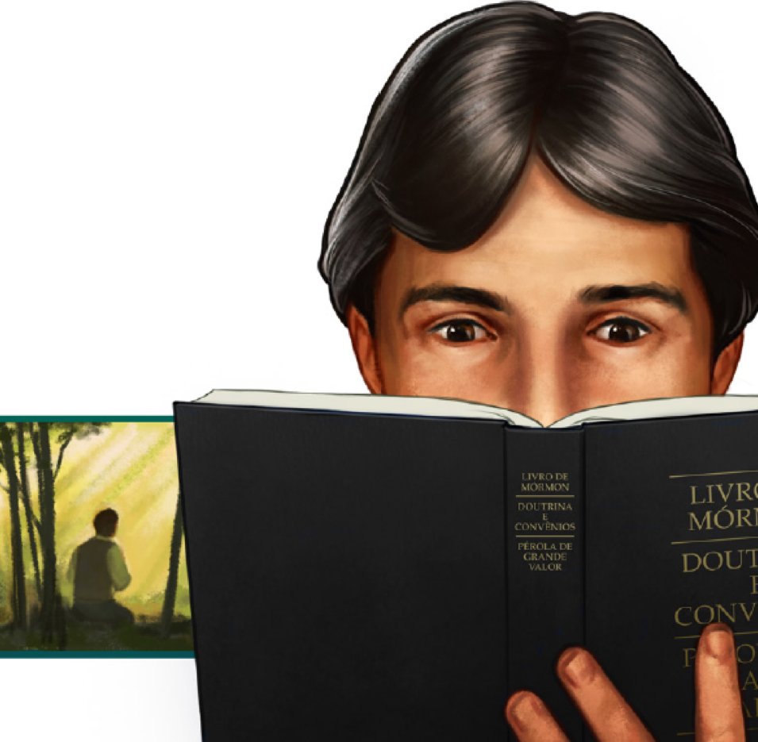
Is a witness of Jesus Christ
I know the gospel’s true
The gospel is true!

