I know my Father lives
And loves me too.
The Spirit whispers this to me
And tells me it is true.
And tells me it is true.
He sent me here to earth
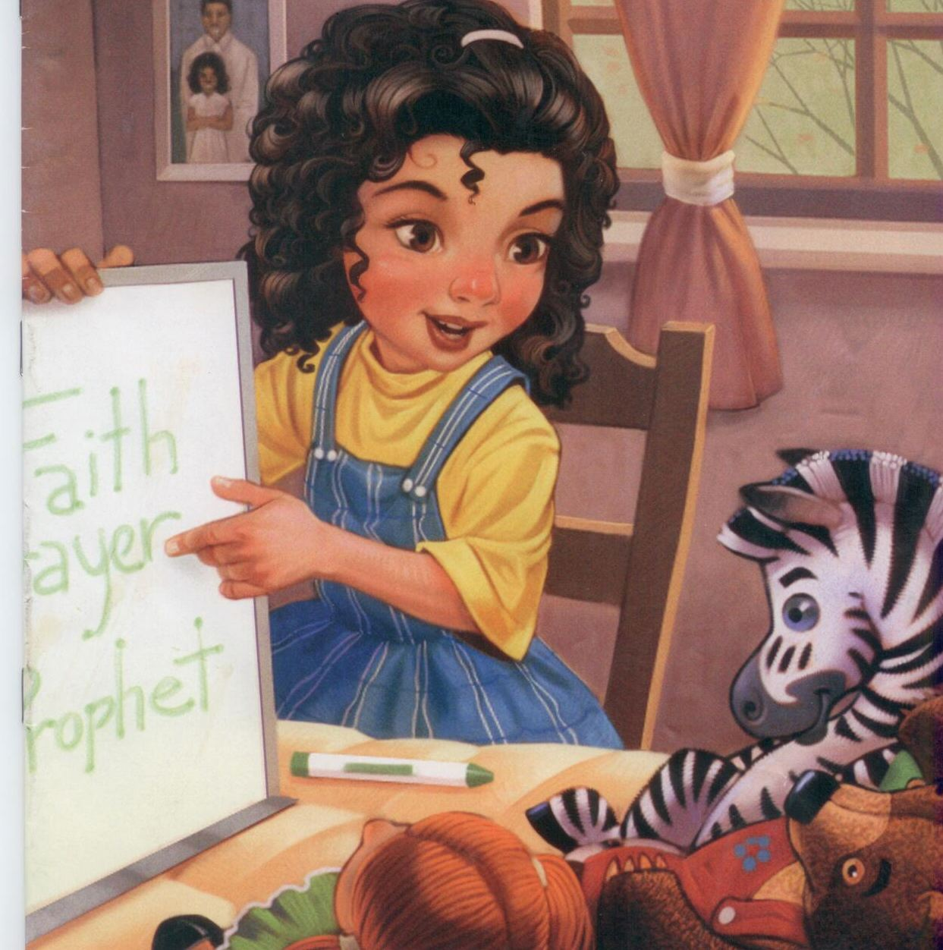
By faith to live his plan.
The Spirit whispers this to me
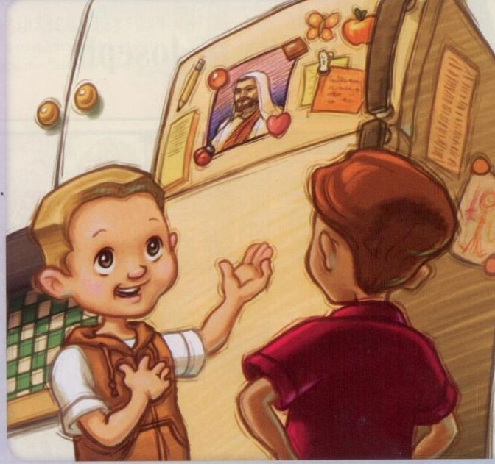
And tells me that I can
And tells me that I can

