I have two ears to hear the truth
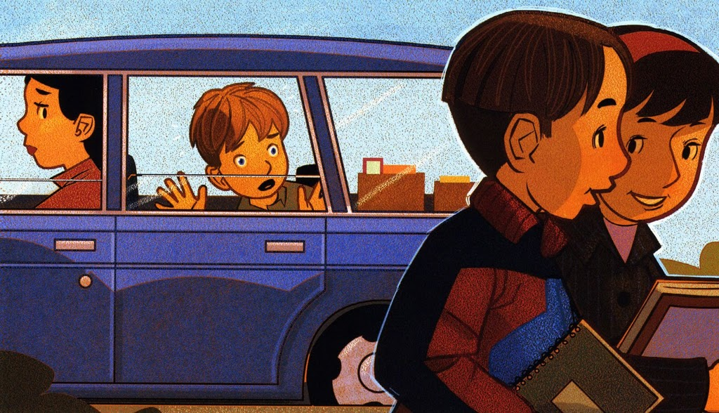
Two eyes to see the good

I have two feet to carry me
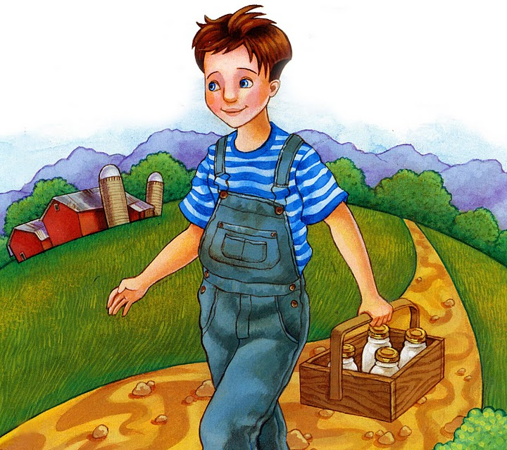
To places where they should
I'll try to use them wisely
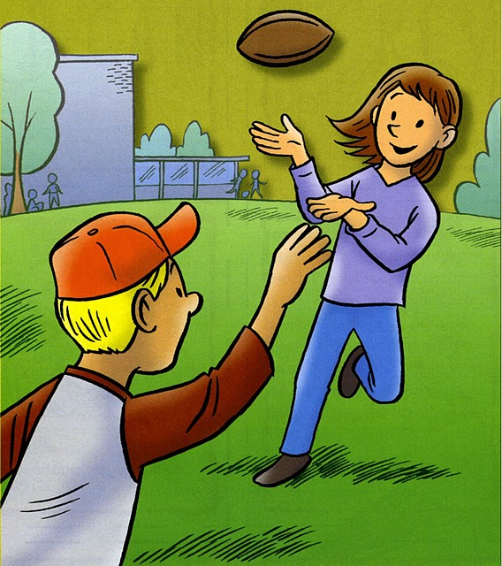
In my work and play
I thank my Heav'nly Father
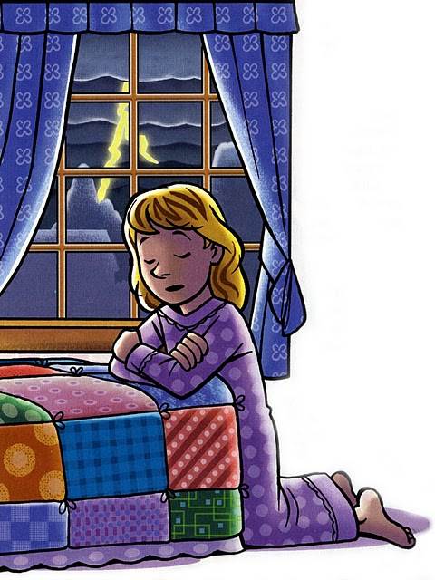
For making me this way
I have two lips to speak kind words
Two hands to work for me
All these loving helpers
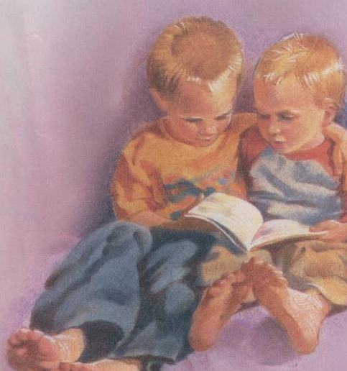
Heav'nly Father gave to me

