I feel my Savior’s Love
In all the world around me
His Spirit warms my soulThrough ev’rything I see
He knows I will follow him
Give all my life to him
I feel my Savior’s love
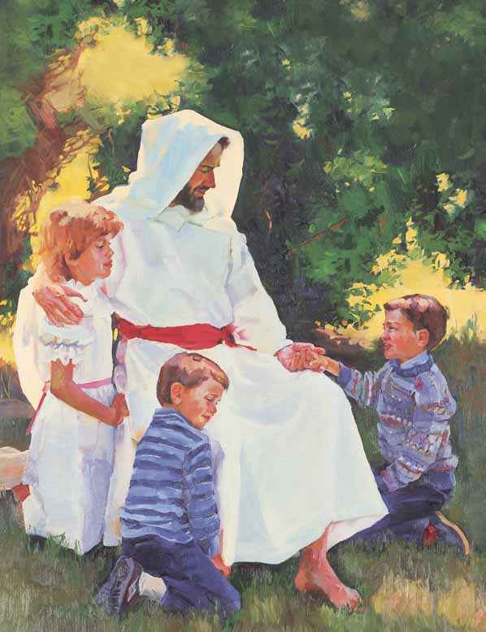
The love he freely gives me
I feel my Savior’s love
Its gentleness enfolds me
And when I kneel to pray
My heart is filled with peace
He knows I will follow him
Give all my life to him
I feel my Savior’s love
The love he freely gives me
I feel my Savior’s love
And know that he will bless me
I offer him my heart
My shepherd he will be
He knows I will follow him
Give all my life to him
I feel my Savior’s love
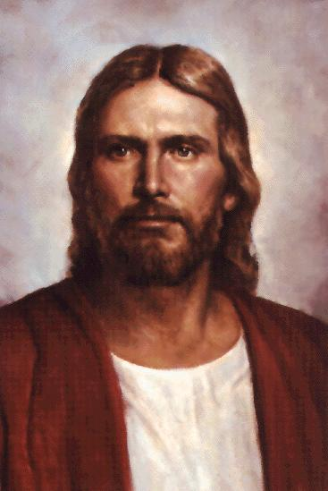
The love he freely gives me
I'll share my Savior's love
By serving others freely
In serving I am blessed
In giving I receive
He knows I will follow him
Give all my life to him
I feel my Savior's love
The love he freely gives me

