I come to the water
In faith to begin
My life in God’s kingdom
To cov’nant with Him
I’ll keep his commandments
I’ll walk in His way
For I am His child
And I want to obey
I am baptized by immersion
For remission of sins
By faith and repentance
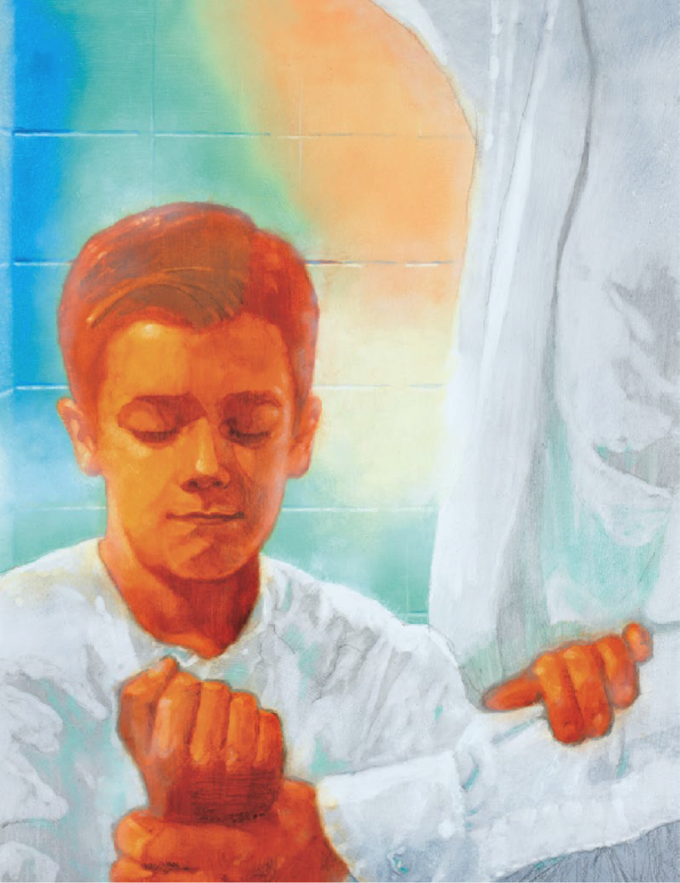
I am clean before Him
I’ll prove to the Father
By all that I do
I know that His teachings are true
And after I’m baptized
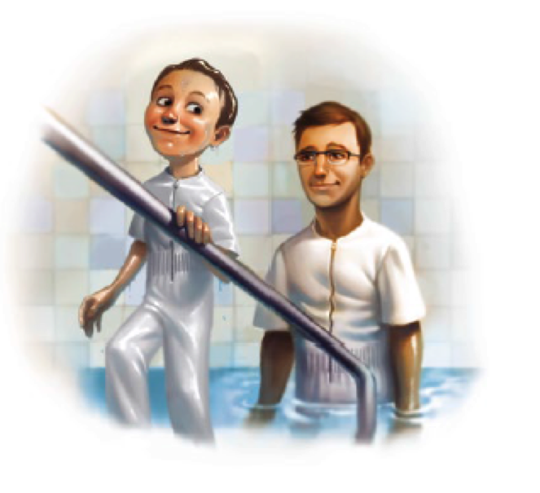
A blessing is said
As men of the priesthood
Place hands on my head
The gift of the Holy Ghost
Given to me
Will guide me and prompt me
To live righteously
I am baptized by immersion
For remission of sins
Receiving the Holy Ghost
Now I begin
To prove to the Father
By all that I do
I know that His teachings are true

Dear Father please help me
Remember this day
I promise Thy will
To Obey

