I am a child of God
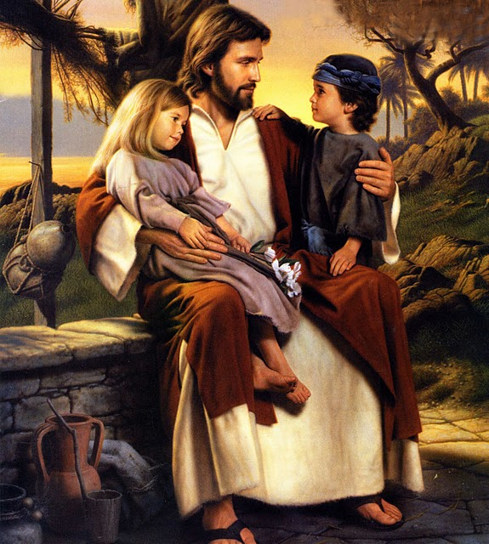
And He has sent me
here
Has given me an earthly home
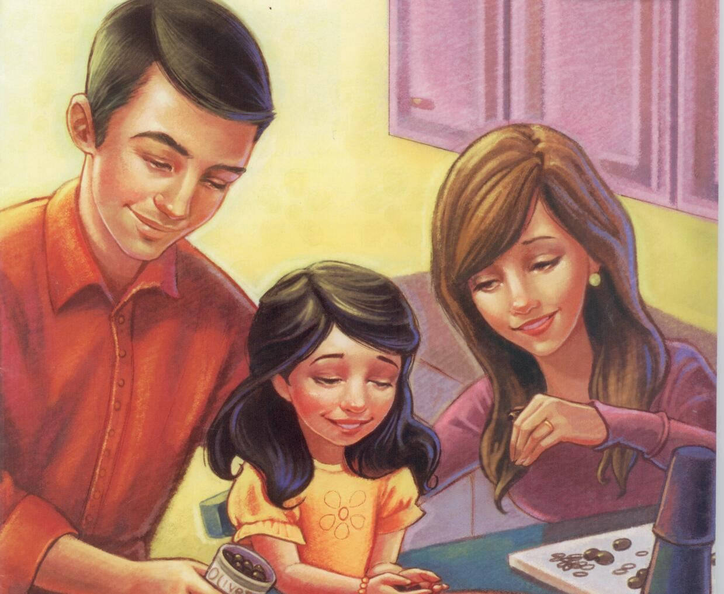
With parents kind and dear
Lead me guide me
Walk beside me
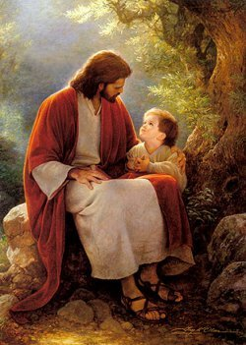
Help me find the way
Teach me all that I must do
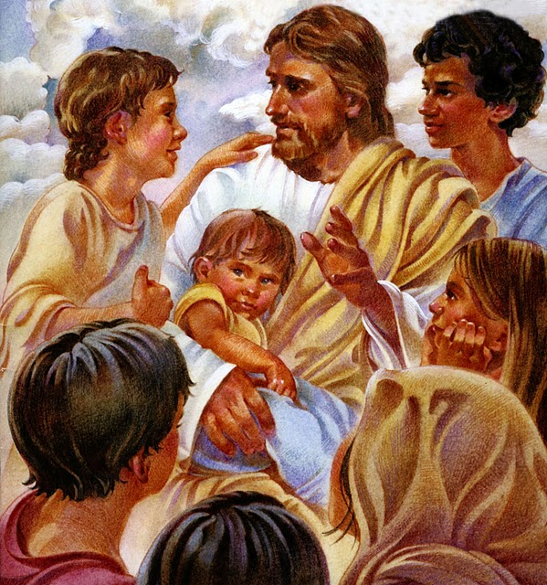
To live with Him someday
I am a child of God
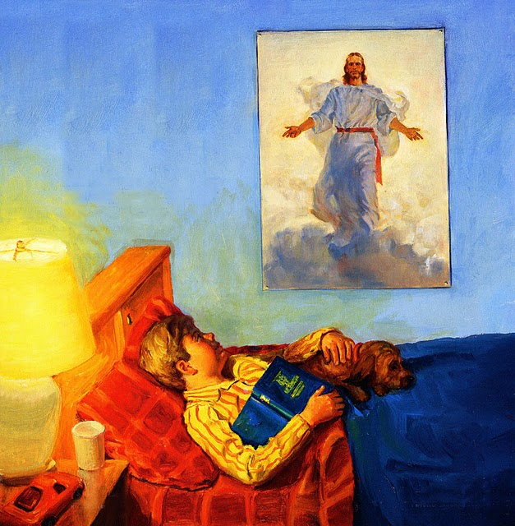
And so my needs are great
Help me to understand his words
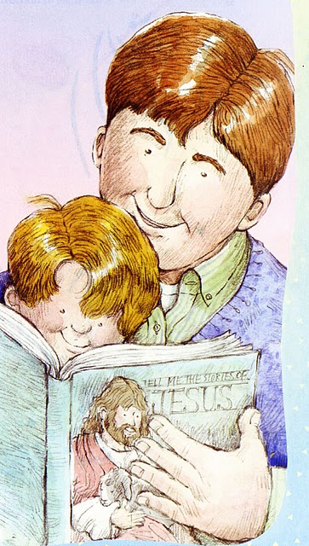
Before it grows too late
I am a child of God
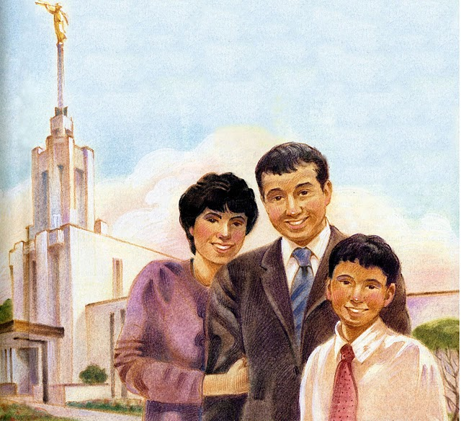
Rich blessings are in store
If I but learn to do his will
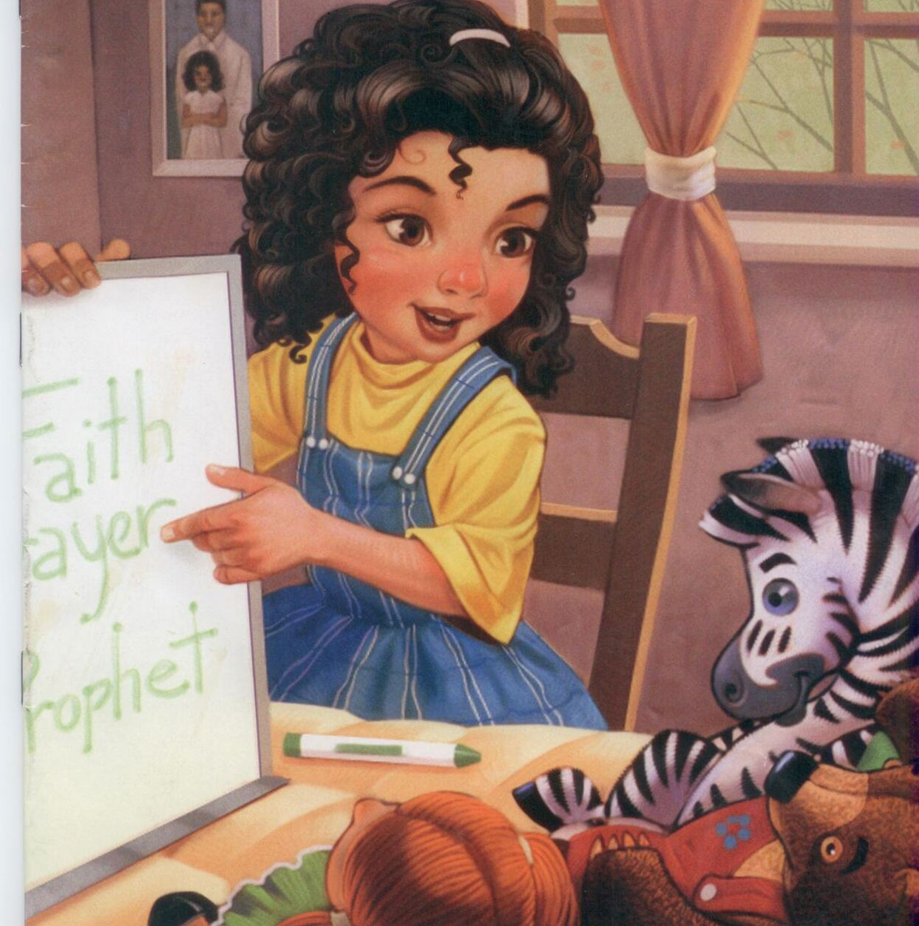
I’ll live with him once more
I am a child of God

His promises are sure
Celestial Glory shall be mine

If I but can endure
The Following Pages are the Descant
I am a child of God,

And blessings are in store
If I learn to do his will
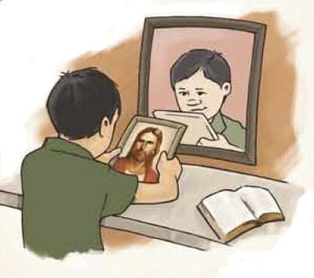
I’ll live with him once more
Oh, lead, guide, walk beside

Help me to find the way
Teach me what I must do

To live with him someday

