Said Samuel within five years
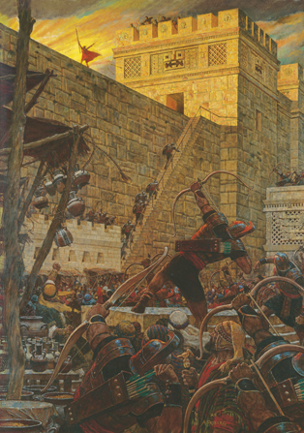
A night will be as day
And Baby Jesus will be born
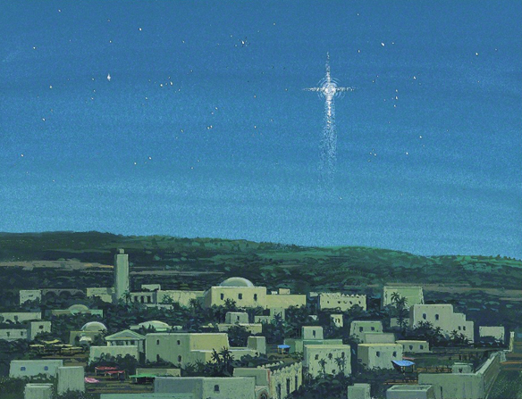
In a land far, far away
Far far away
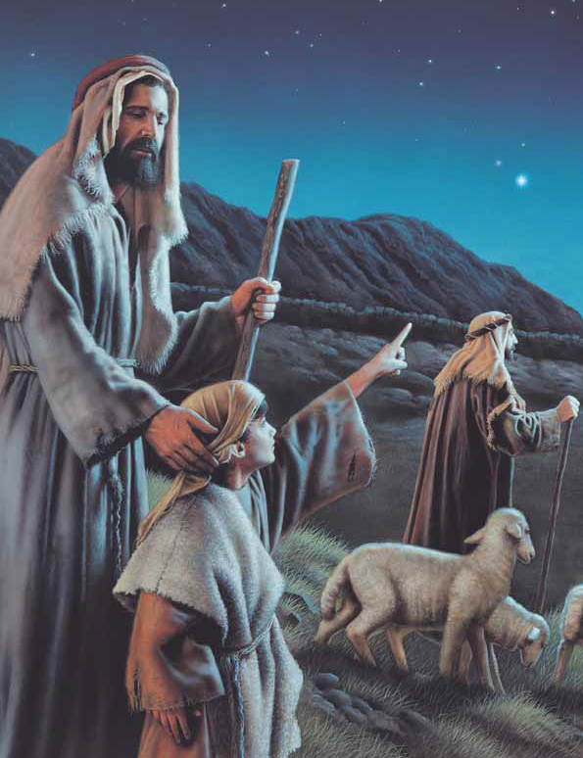
On Judea's plains
Shepherds of old
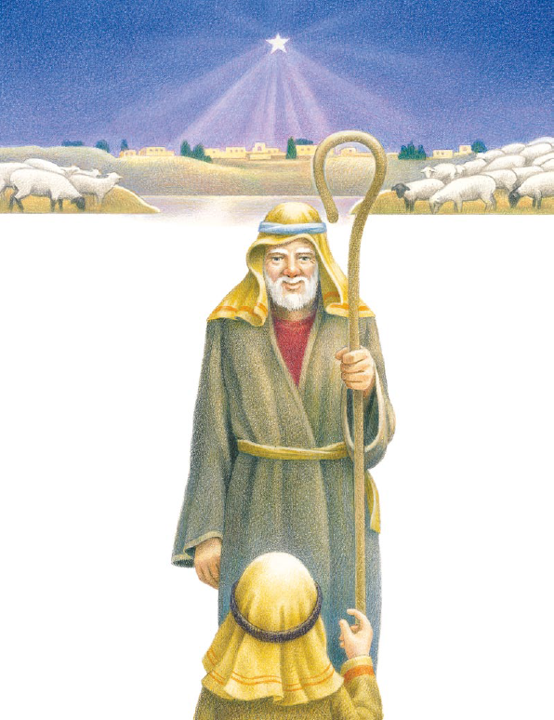
Heard the joyous strains
Glory to God, Glory to God
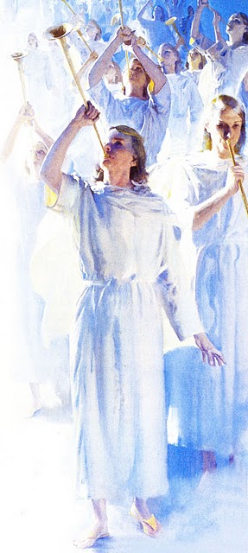
Glory to God in the highest
Peace on earth goodwill to men
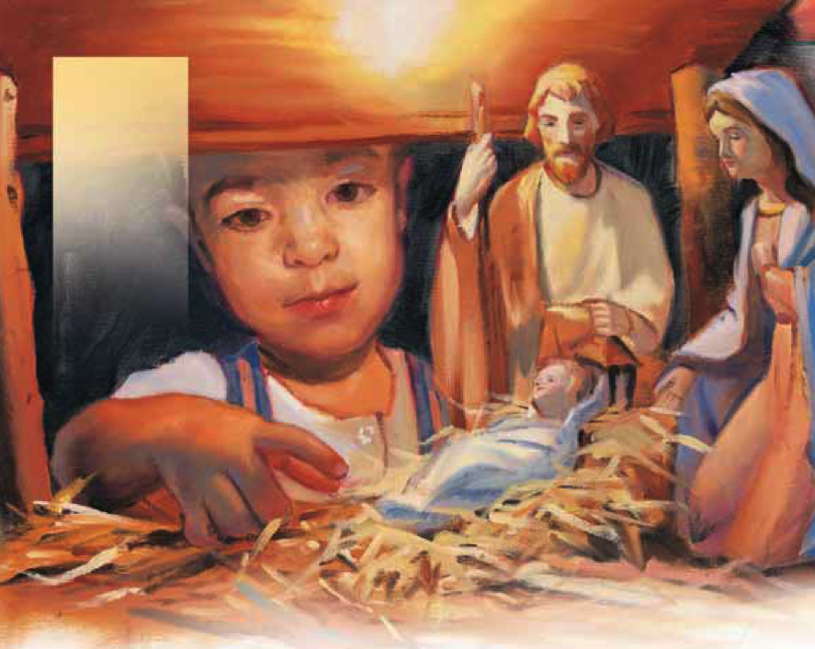
Peace on earth,
goodwill to men!
Hosanna! Hosanna!
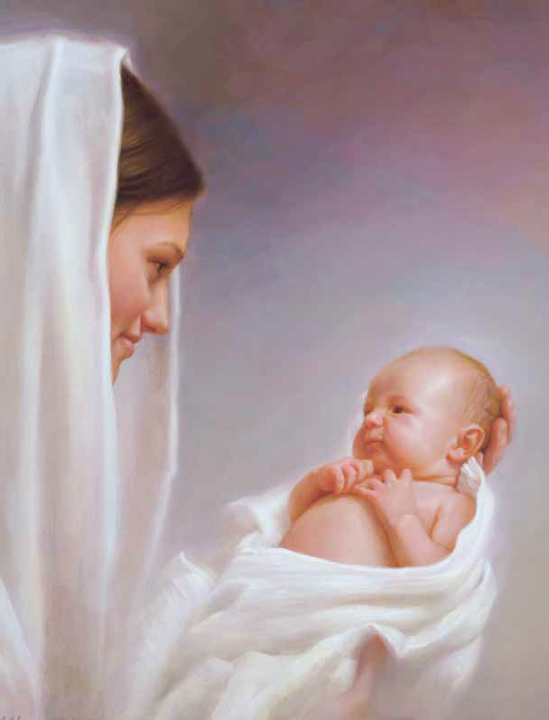
Oh, let us gladly sing
How blessed that our Lord was born
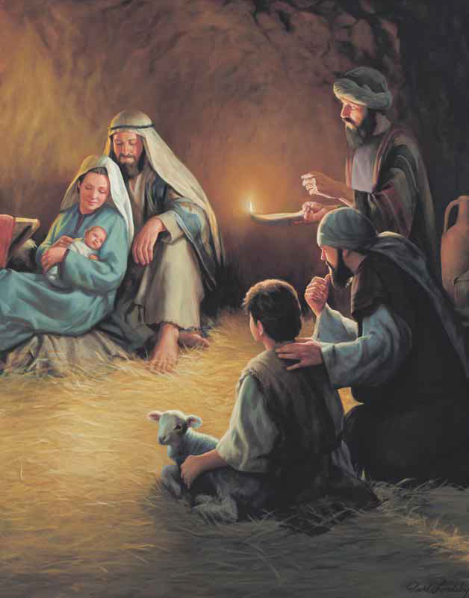
Let earth receive her King!
Across the sea in Bethlehem
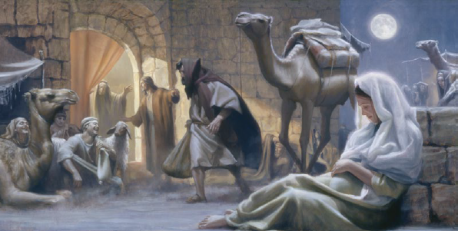
Lord Jesus came to earth
As Samuel had prophesied
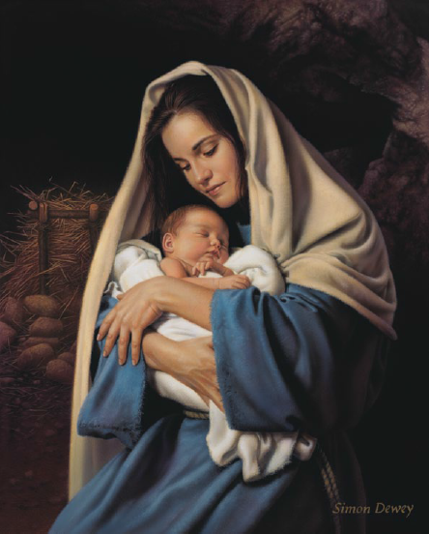
And angels sang His birth
Hosanna! Hosanna!
Oh, let us gladly sing
How blessed that our Lord was born
Let earth receive her King!
Glory to God, Glory to God
Glory to God in the highest
Peace on earth goodwill to men
Peace on earth,
goodwill to men!

