Hope of Israel Zion's army
Children of the promised day
See, the Chieftain signals onward
And the battle's in array!
Hope of Israel, rise in might
With the sword of truth and right
Sound the war-cry, "Watch and pray!"
Vanquish ev'ry foe today
See the foe in countless numbers
Marshaled in the ranks of sin
Hope of Israel, on to battle
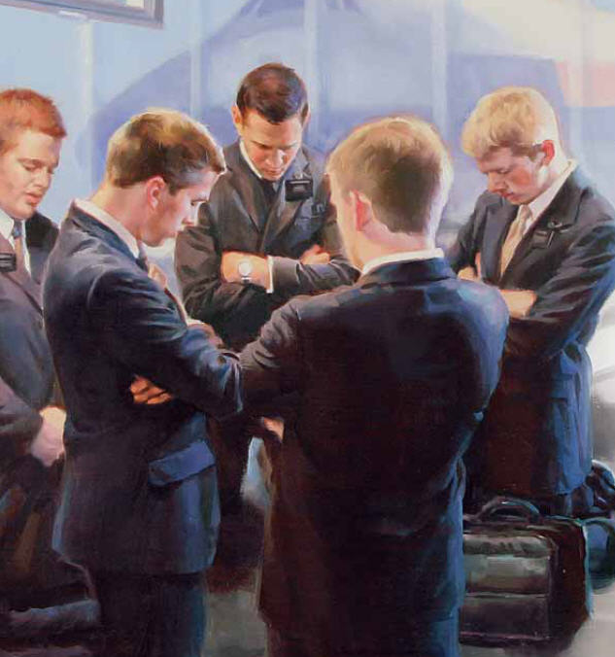
Now the vict'ry we must win!
Strike for Zion, down with error
Flash the sword above the foe!
Ev'ry stroke disarms a foeman
Ev'ry step we conq'ring go
Soon the battle will be over
Ev'ry foe of truth be down
Onward, onward, youth of Zion
Thy reward the victor's crown

