The temple is a holy place
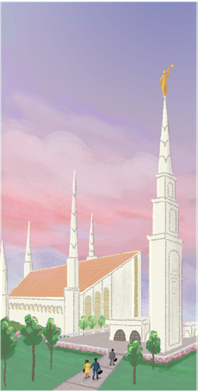
Where heaven touches earth
A rev’rent place, a hallowed space,

Where we do the Savior’s work
I’ll stand in holy places



With a heart that’s firm and true
Until Christ returns and makes all the world
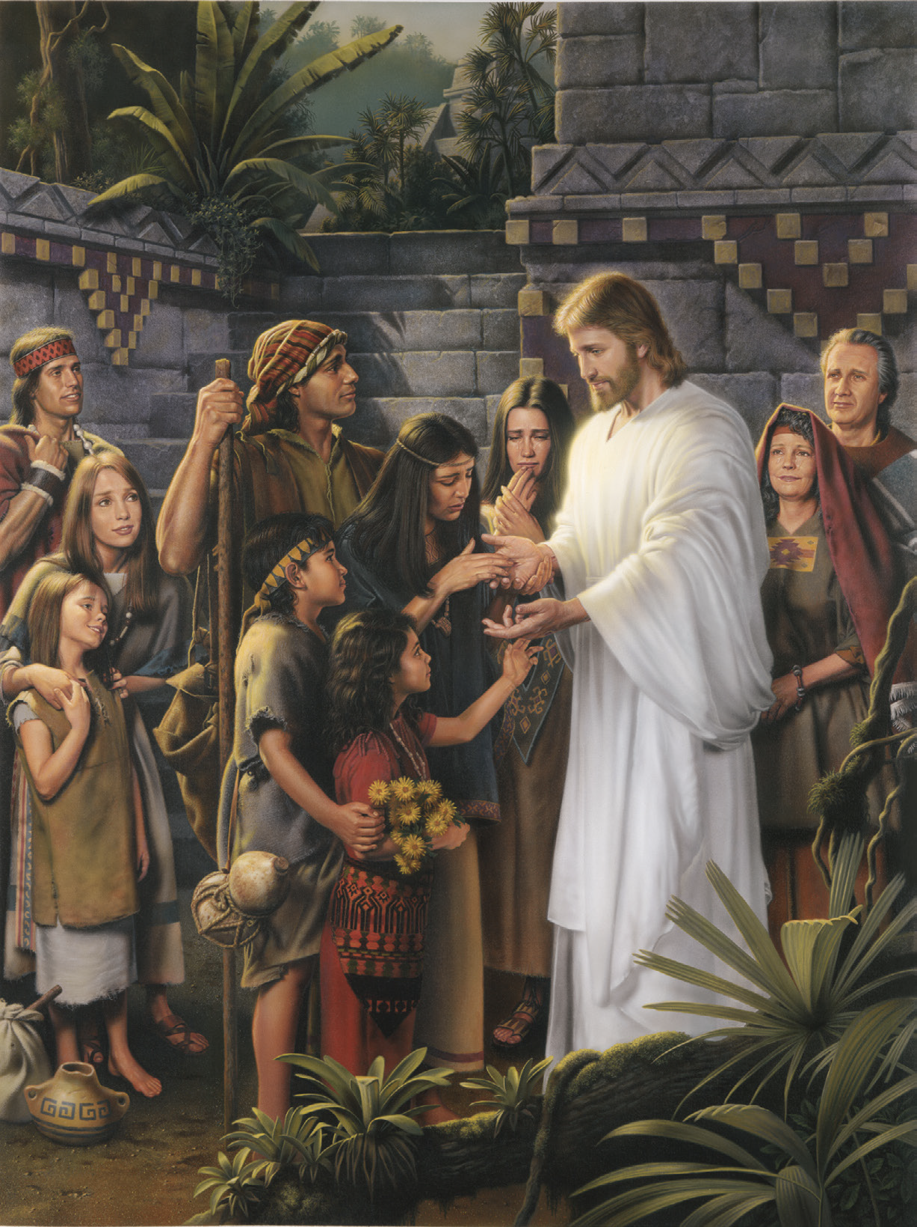
Holy, clean, and new
A home can be a holy place

To learn of God above
A prayerful place to seek His face

Where we grow in faith and love
I’ll stand in holy places
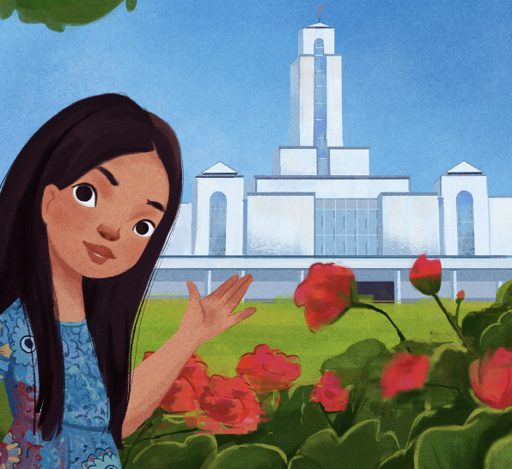
With a heart that’s firm and true
Until Christ returns and makes all the world
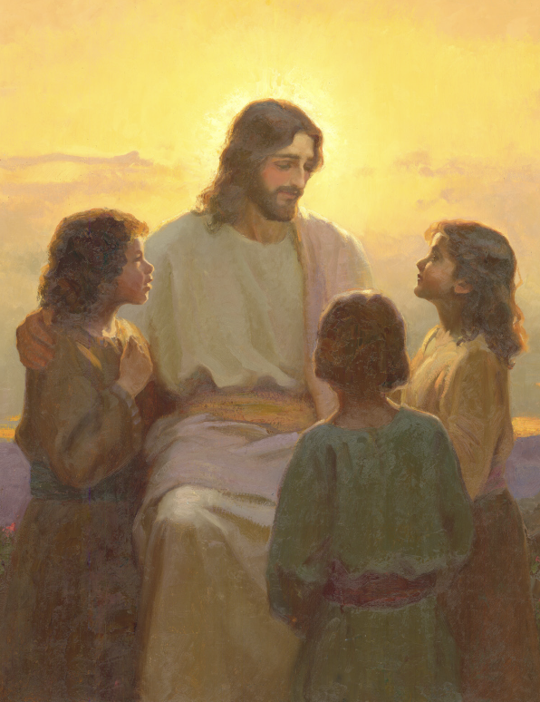
Holy, clean, and new
My heart can be a holy place

When all around is dim
A peaceful place of hope and grace

Where the Spirit shines within
I’ll stand in holy places
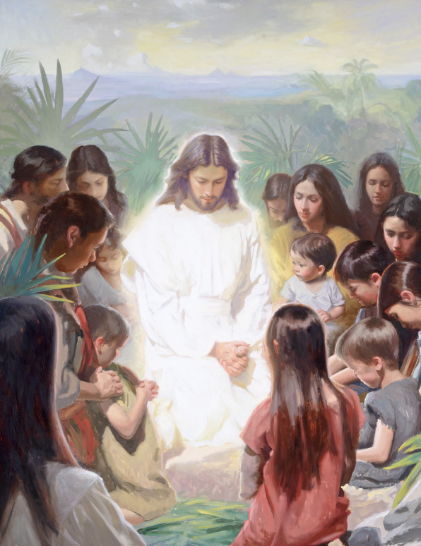
With a heart that’s firm and true
Until Christ returns and makes all the world
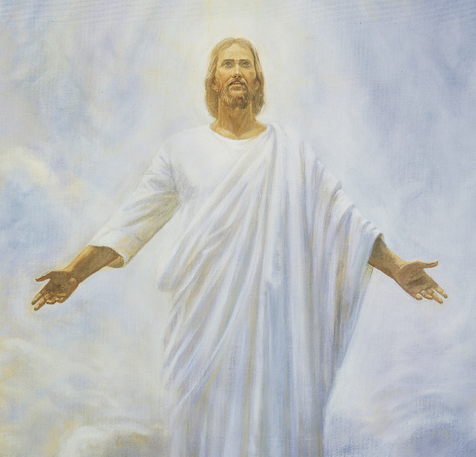
Holy, clean, and new

