Sunrise, full moon,
Colored leaves in autumn falling
I love the nature created for me
Mountains, sledding,
Softly falling snow flakes glist’ning
Heavenly Father’s great beauty I see
Cloud shapes floating
In the sunlit summer blue sky
The tulips blossoming
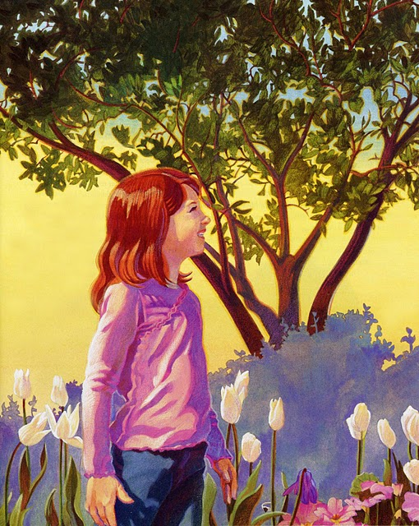
And daisies nearby
My life is abundant
With His blessings and care
I feel of His gifts of love ev’rywhere
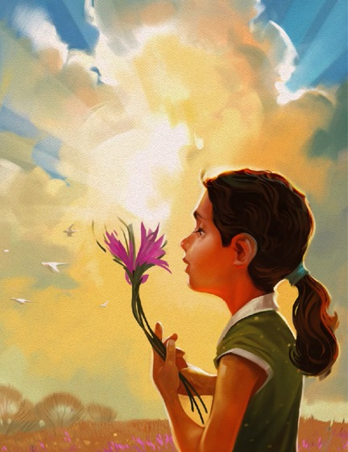
Warm rain, crisp chills
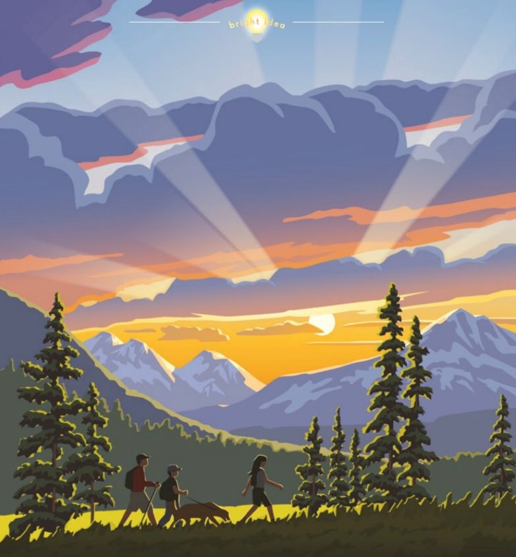
Mountains high and rolling green hills
I am admiring His beautiful love
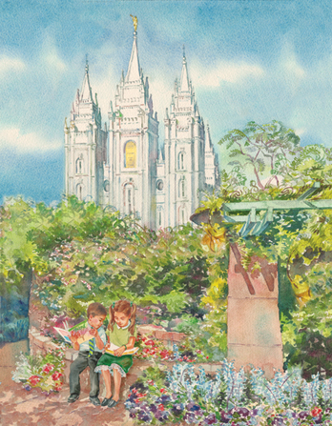
Solace, quiet,
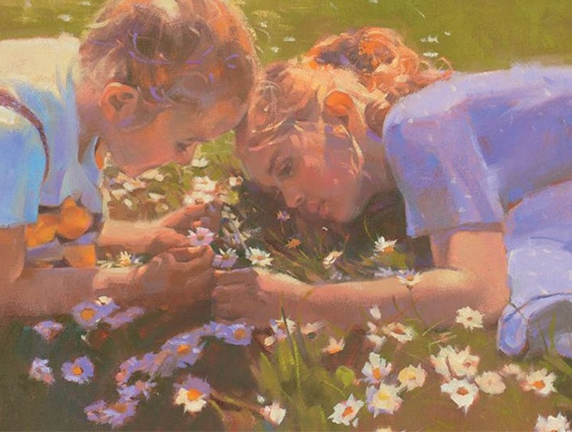
Pondering in fragrant meadows
I feel His pure love from Heaven above
Beach waves crashing
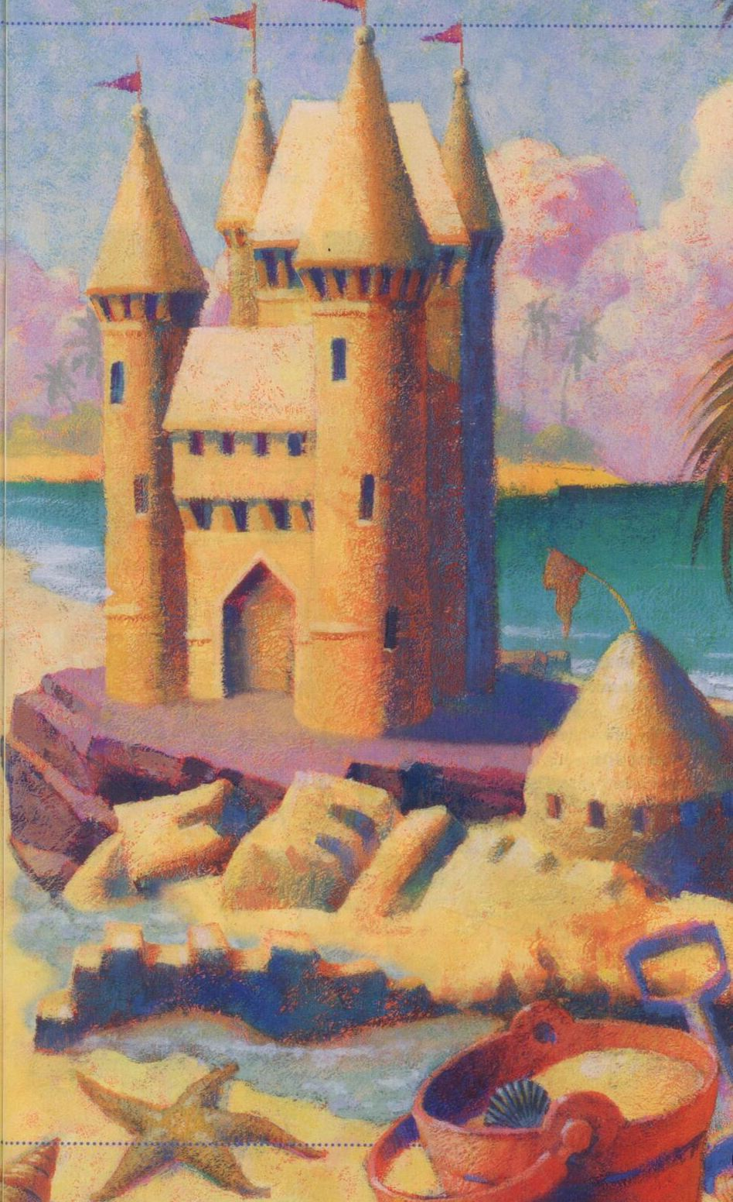
Where the water and the land meet
The sand has thousands
Of grains touch my feet
My life is abundant
With His blessings and care
I feel of His gifts of love ev’rywhere

