He is the Gift

by Shauna Edwards
Music has a copyright. Please order your own sheet music at
http://shawnaedwardsmusic.com

In every star we see
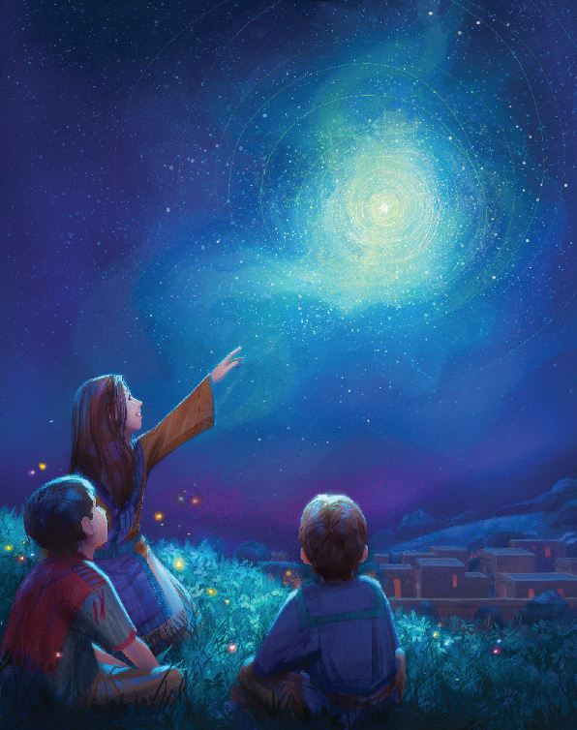
And all
the songs we sing
Of shepherds on a hillside
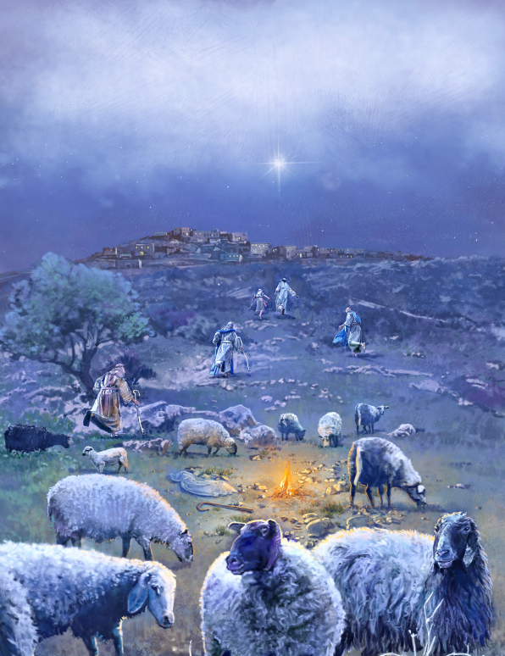
Of goodwill and peace
The lights on every tree
And all the
gifts we bring
In every part of Christmas
We’ll see our King
For He is the light
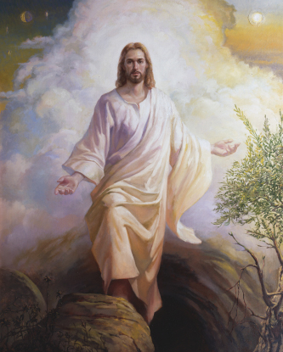
That shines from the star
He is the shepherd
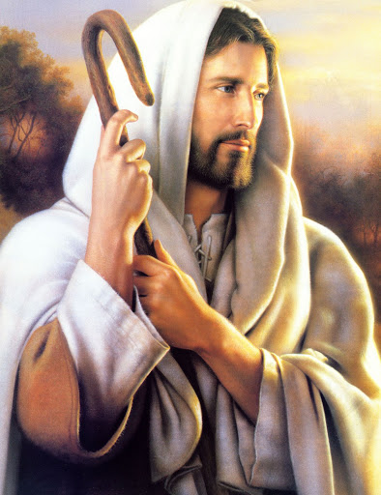
Watching over us all
And He is the peace
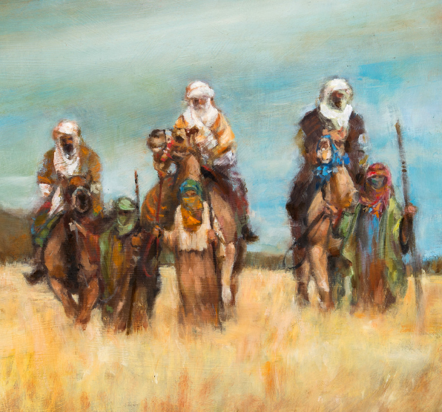
That wise men still seek

A Savior born
that we might live
He is the gift
Hope and joy and strength
He offers all our days
Pure and perfect blessings
All wrapped in His grace
And when the lights come down
the moments disappear
He who gives us everything
Will still be here
For He is the light
That shines from the star
He is the shepherd
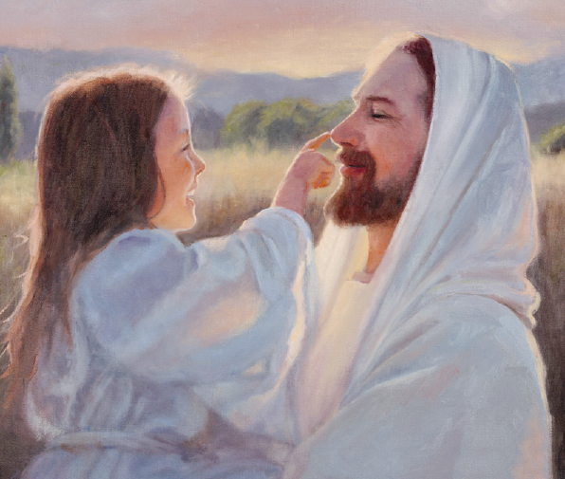
Watching over us all
He is the peace that
Wise men still seek
A Savior born that we might live

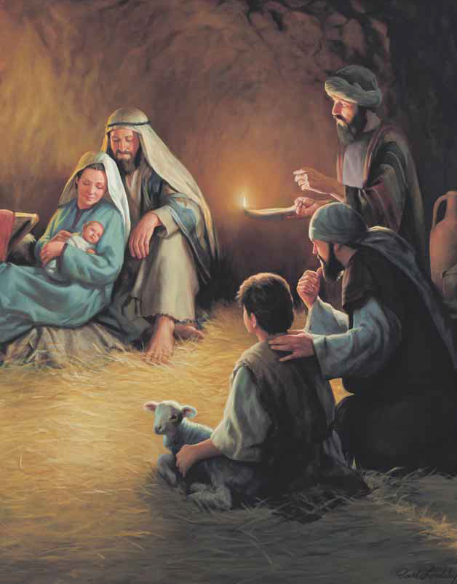

He is the gift
A Savior born that we might live

He is the gift

