Come, good people, to the stable
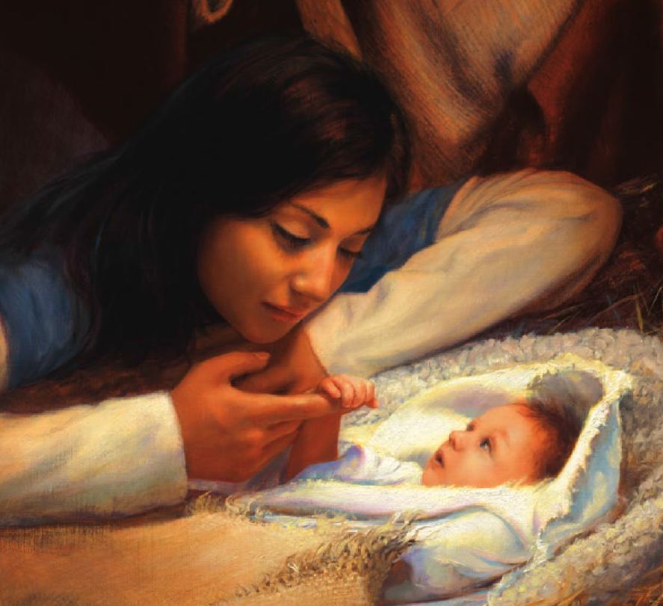
Hasten to the manger-side
Come, behold the Infant holy
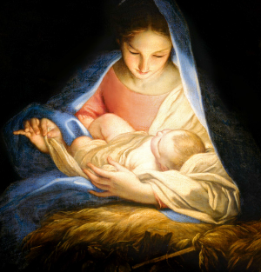
Come and see the blessed Child
Come and follow, one and all
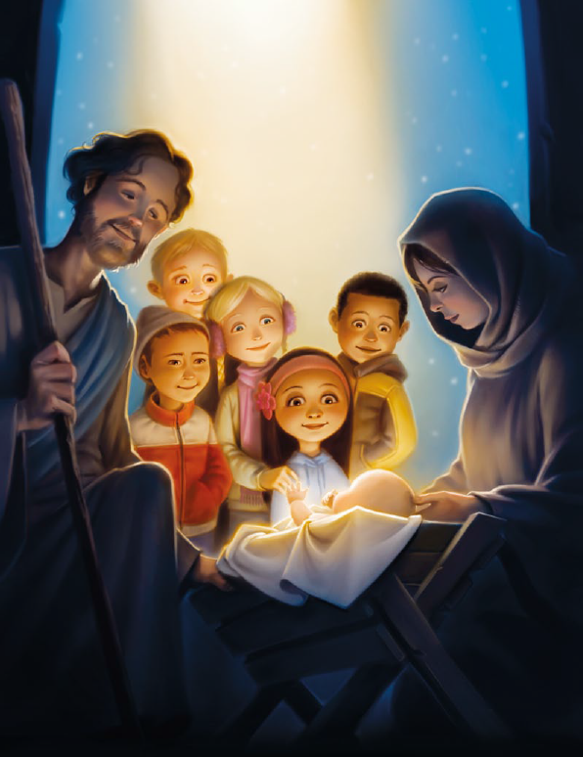
Come see him lying in the stall
For He is born, the Child divine
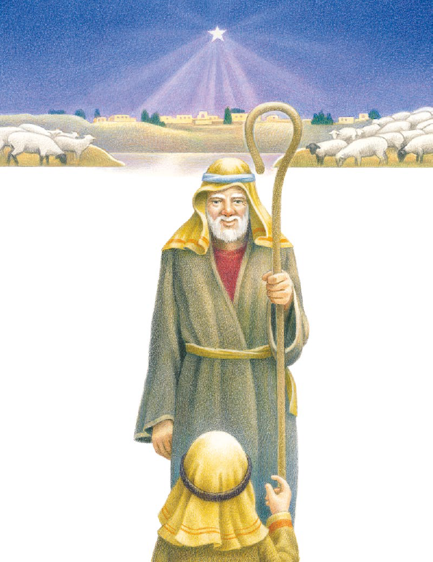
Faithful shepherds watching ever
O’er their flocks by dark of night
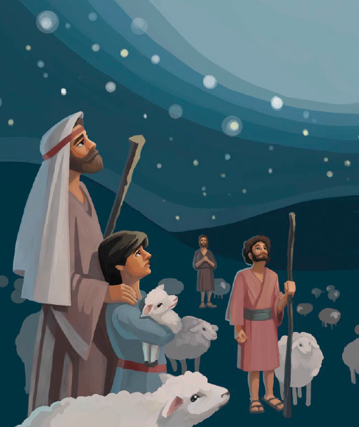
Wondering, fearing, tidings hearing
‘Mid a glorious, shining light
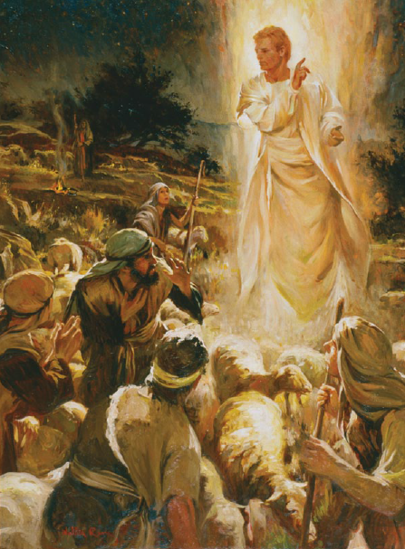
Music ringing
Angels singing
News of joy and comfort bringing
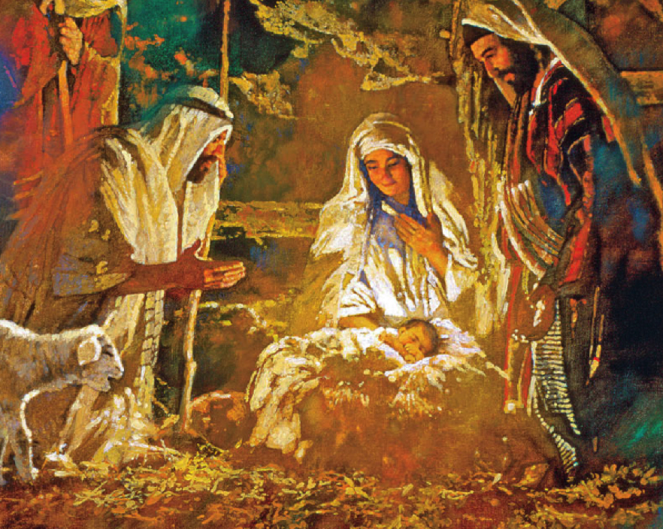
He is born, the Child divine

