How could the Father tell the world
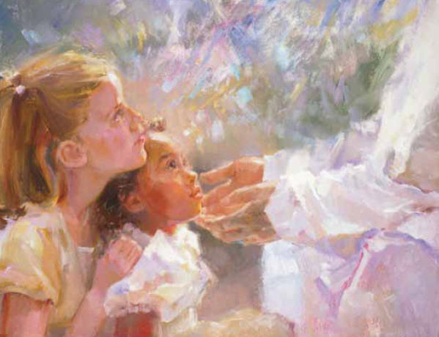
Of love and tenderness?
He sent his Son, a newborn babe
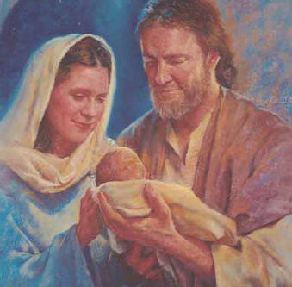
With peace and holiness
How could the Father show the world
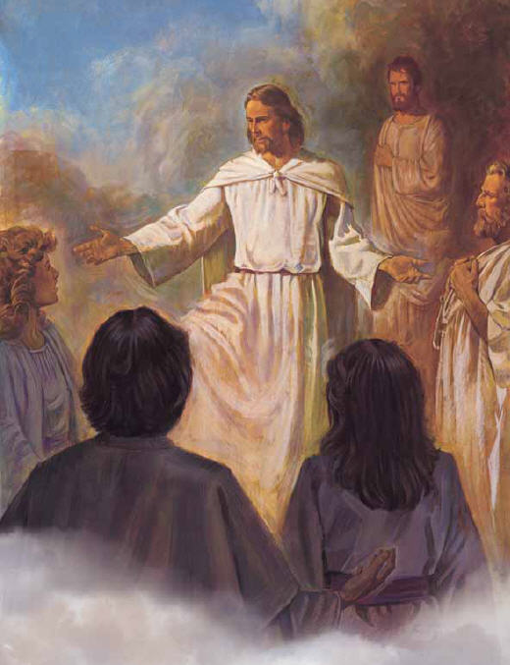
The pathway we should go?
He sent his son to walk with men
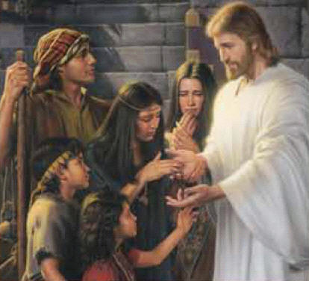
On earth that we may know
How could the Father tell the world
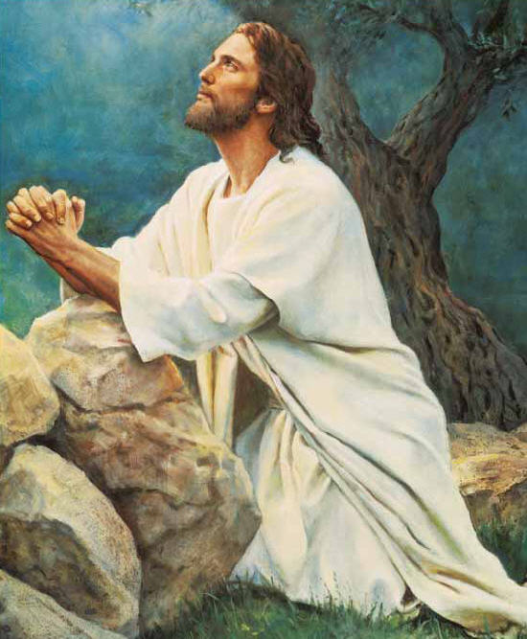
Of sacrifice, of death
He sent his Son to die for us
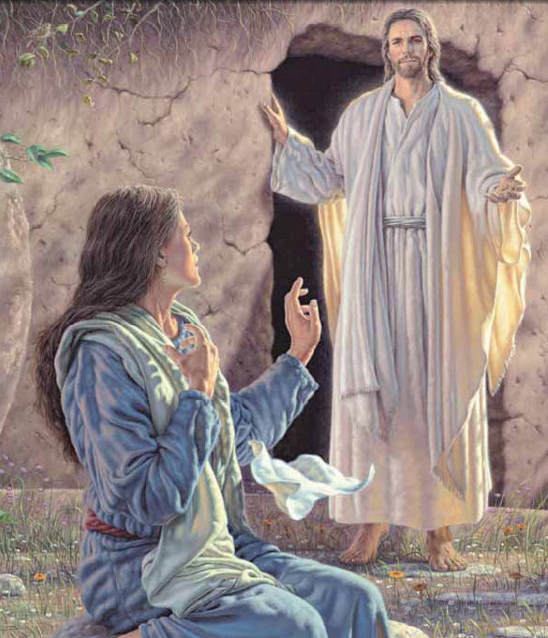
And rise with living breath
What does the Father ask of us?
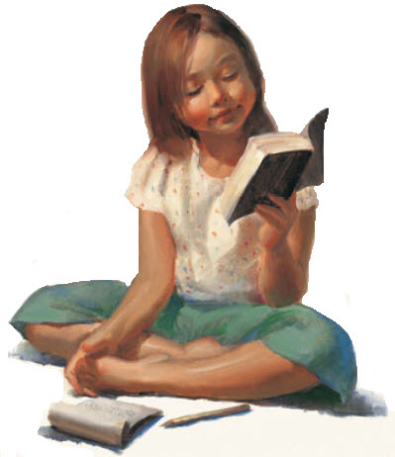
What do the scriptures say?
Have faith, have hope, live like his Son
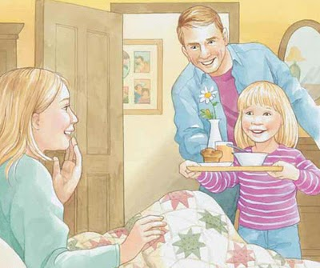
Help others on their way
What does he ask?
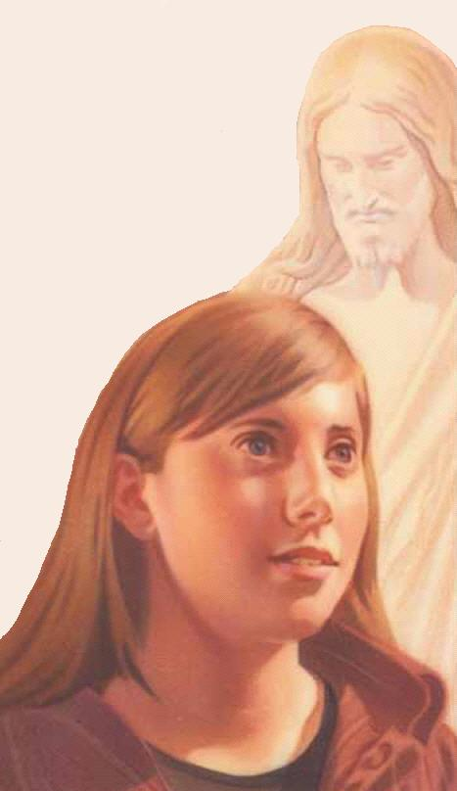
Live like his Son

