He Lives and He Loves Me

By Anji Branch & Monica Scott

Sheet Music Available at
www.monicascottmusic.com

From heaven I came to earth
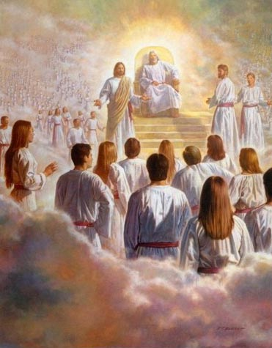
To learn and to grow from birth
I know who I am and I know His plan
And someday I’ll return to Him
For I am a child of God
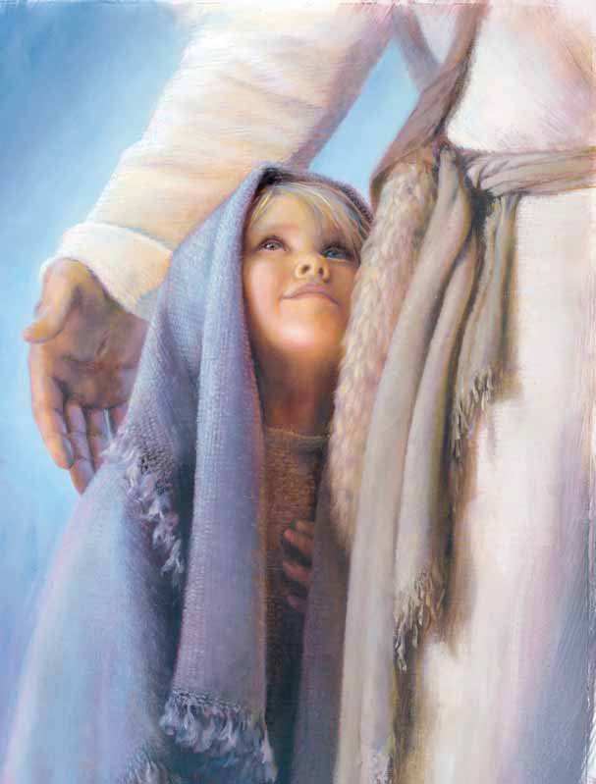
Child of a King who knows me
I remember in prayer
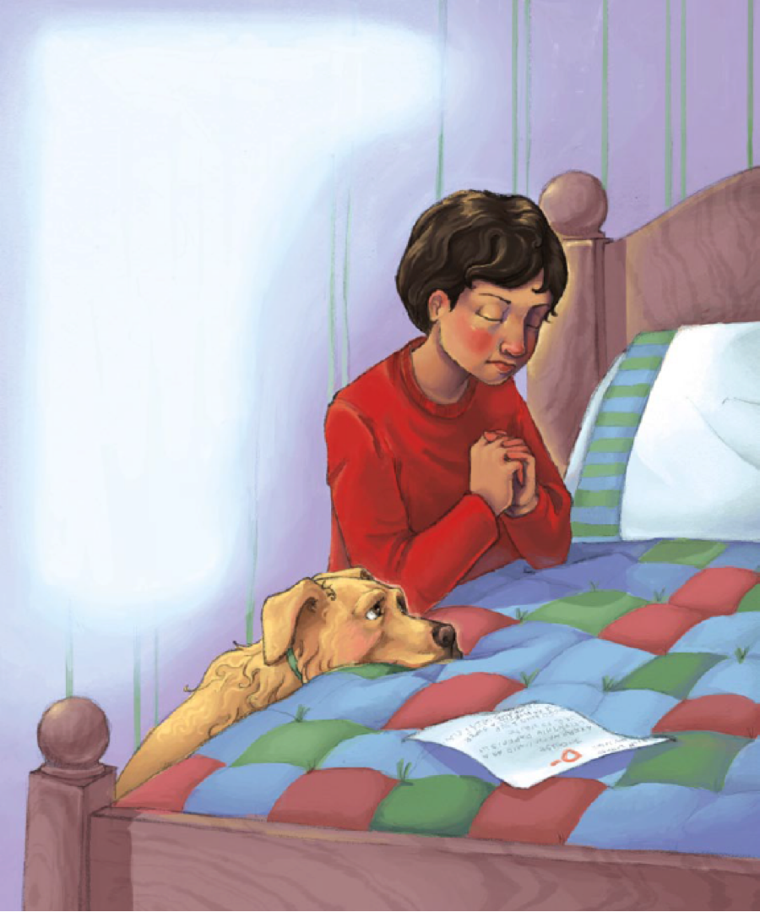
My faith draws me near
He lives and He loves me
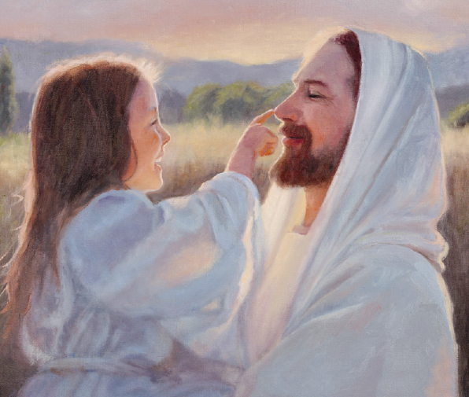

I will not forget who I am
I will strive to remember His plan for me
I will love
I will serve in my time here on earth
And someday I will return to Him
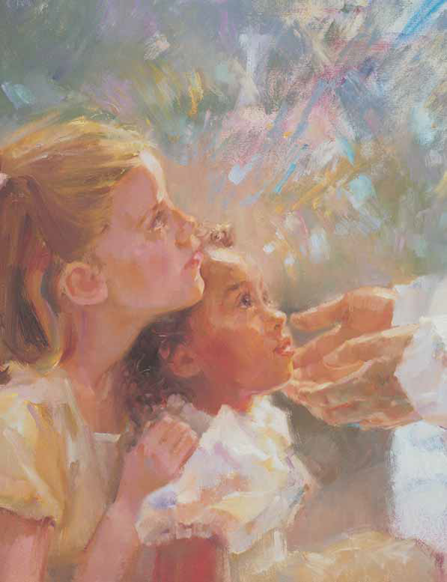
He will bless me and guide me

He lives and He loves me
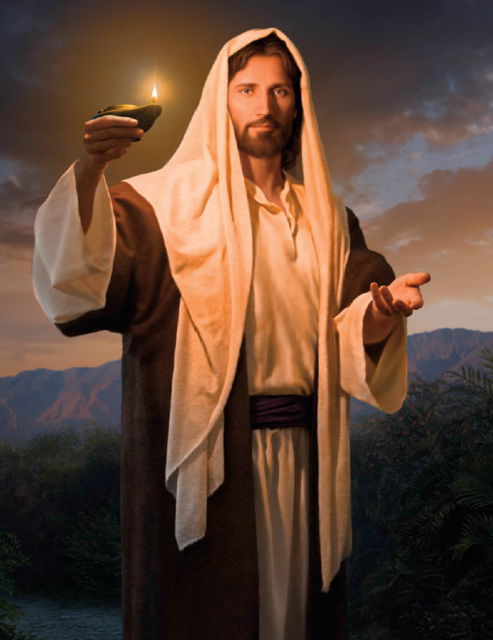
He lives and He Loves me

