In the grand council
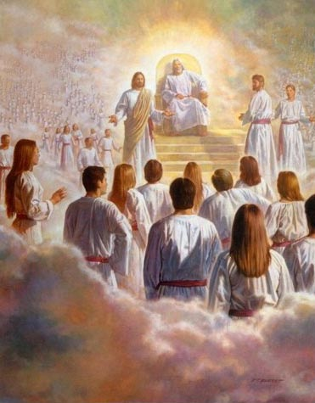
Before we came to earth
Christ was chosen with the promise
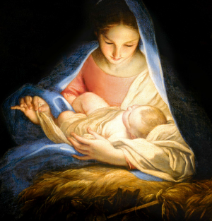
Of His humble birth
His life was perfect
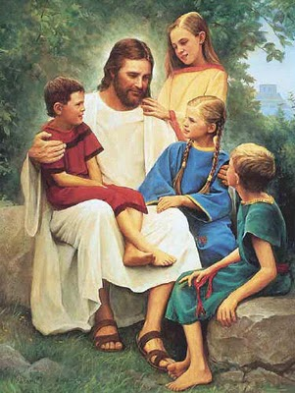
In showing us the way
We honor Him
We sing to Him
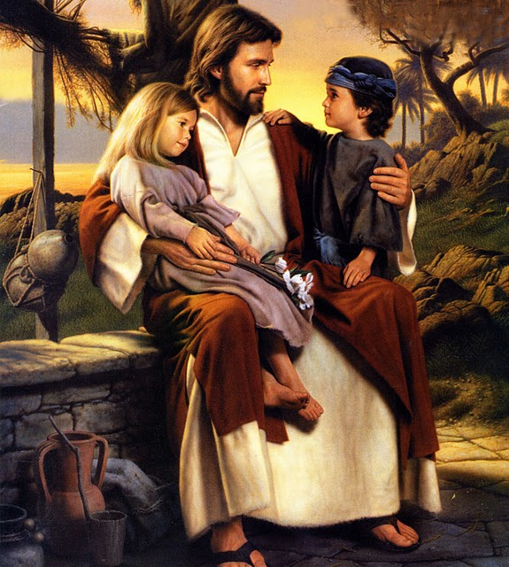
On this joyous day
He lives again!
He lives again!
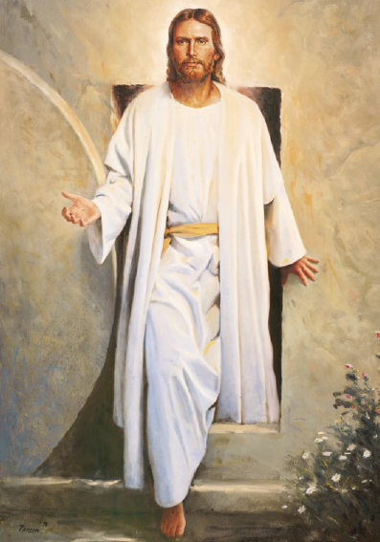
My loving friend
He lives again!
Christ came to show us
The path that we should go

Suffered for our pains and sins
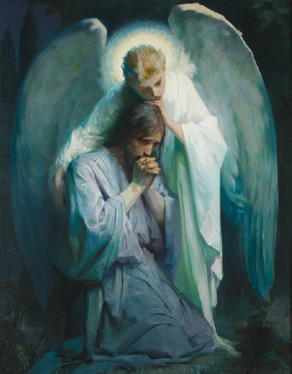
Our sorrows He does know
His life was perfect
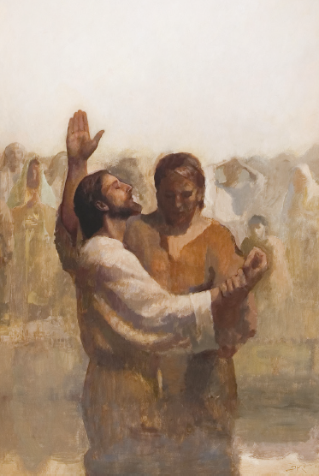
In showing us the way
We honor Him
We sing to Him
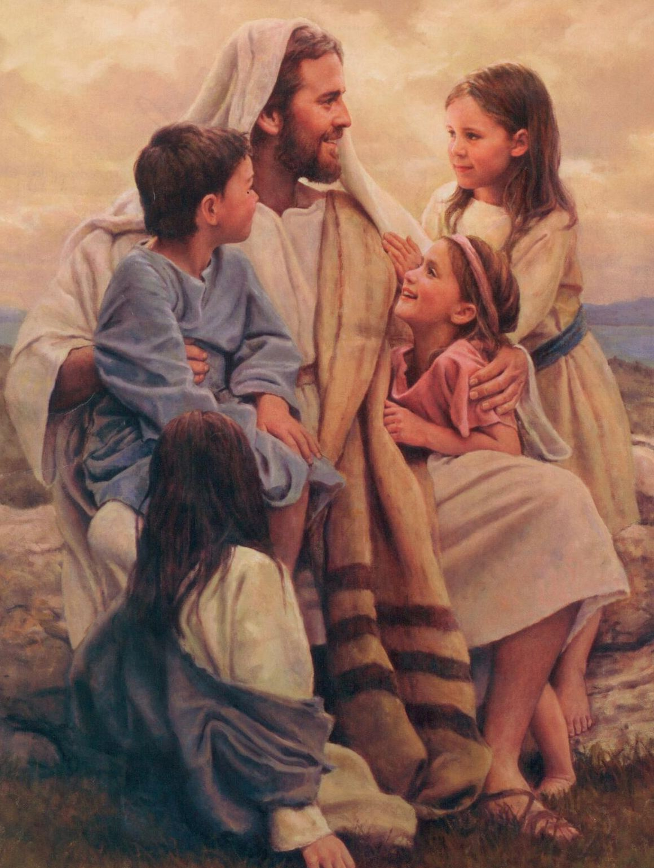
On this joyous day
He lives again!
He lives again!
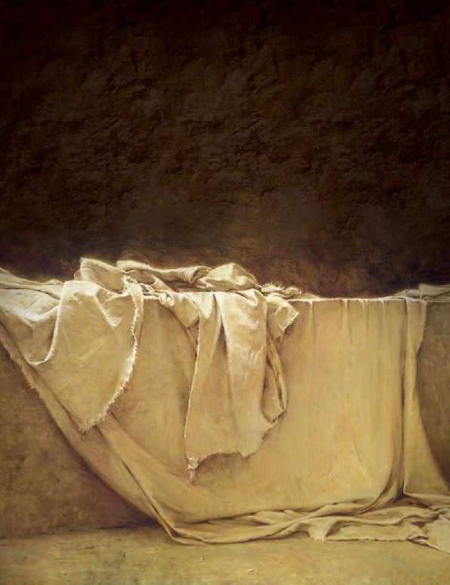
My loving friend
He lives again!

