He died that we might live again
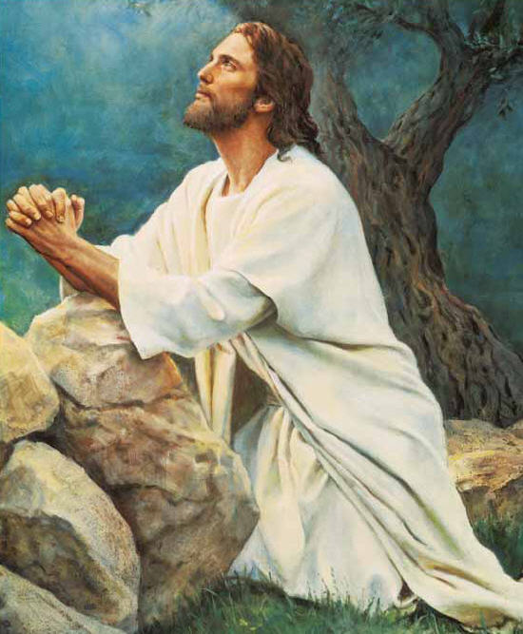
Lord Jesus our Redeemer true
He died on Calv’ry’s lonely hill
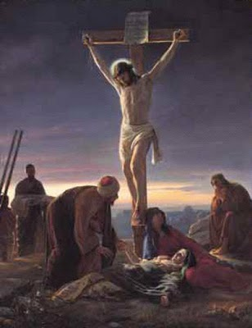
His life he gave for me and you
He rose from the grave on Easter morn
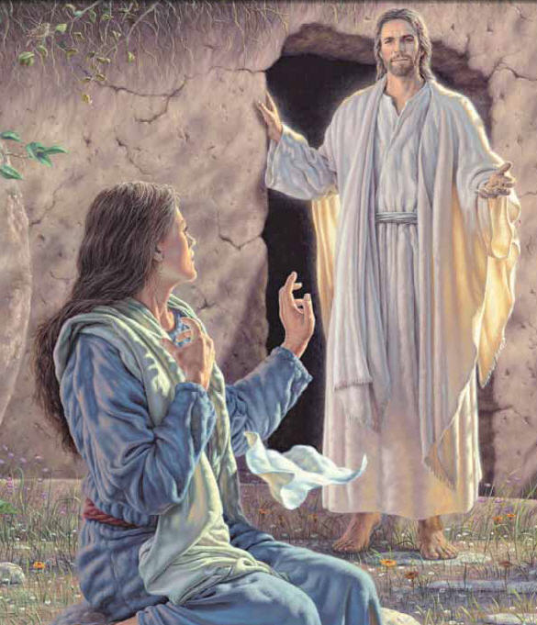
Our Savior and Our King
He showed his love for all mankind
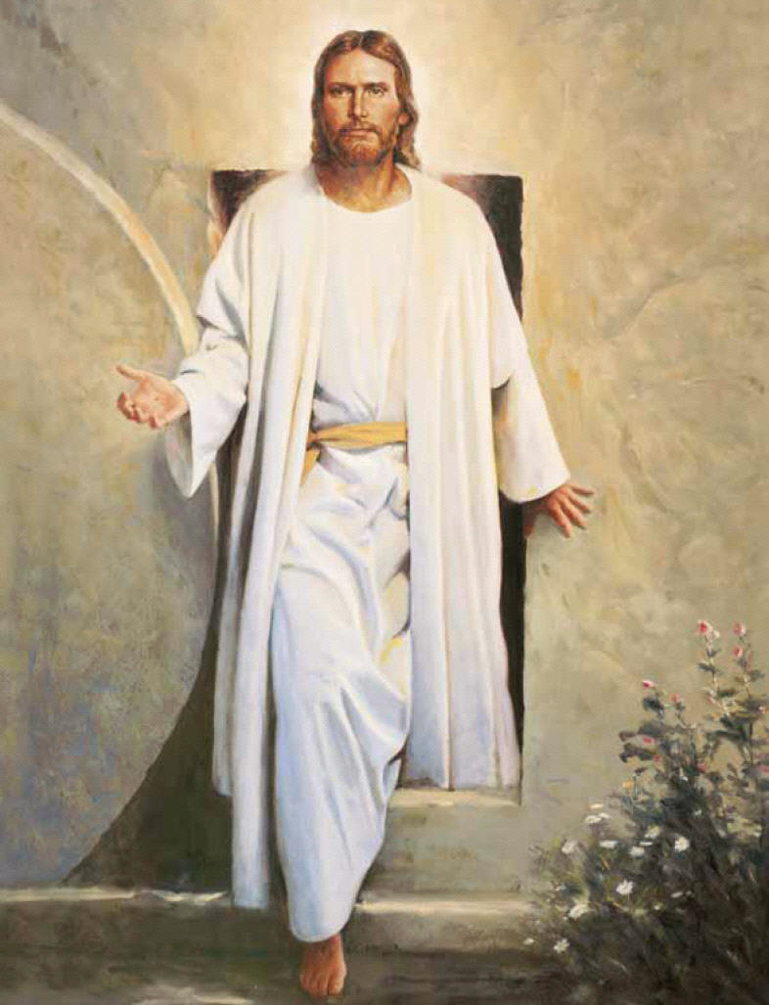
For his great love give thanks and sing
Rejoice! Rejoice! And sing, sing, sing.
