On that first Christmas day
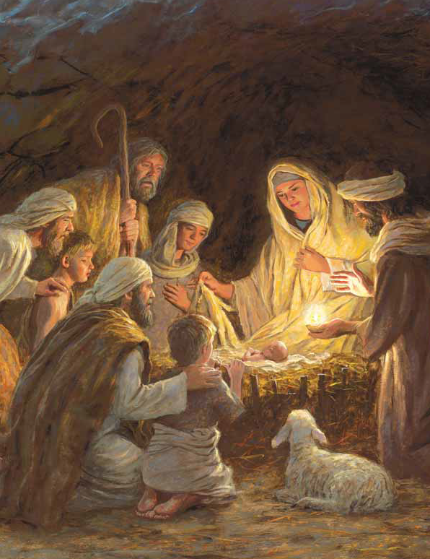
A baby cried
And his mother laid him in a manger
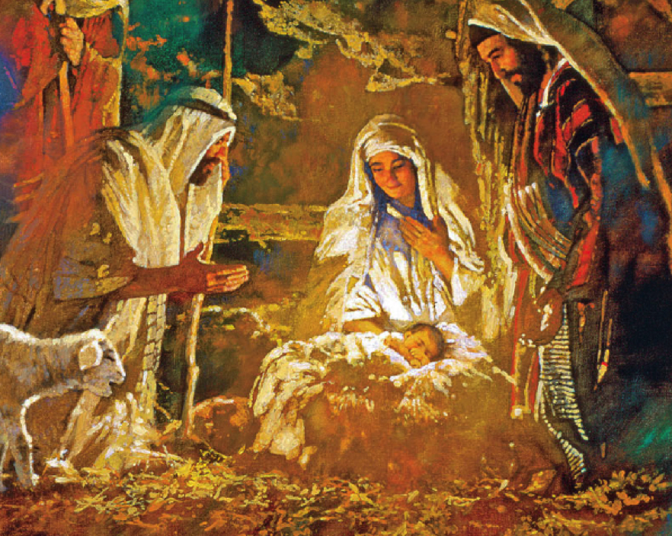

As Heav’nly Father gave his son
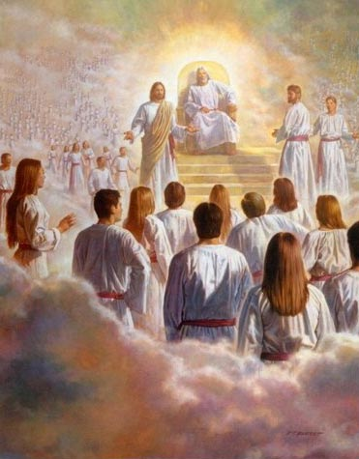
To save the world
The angels rejoiced and sang
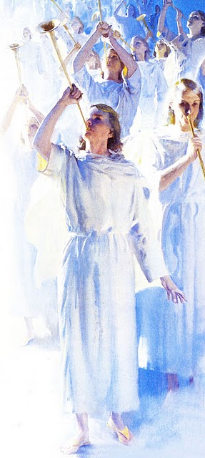
Born this day King of Kings
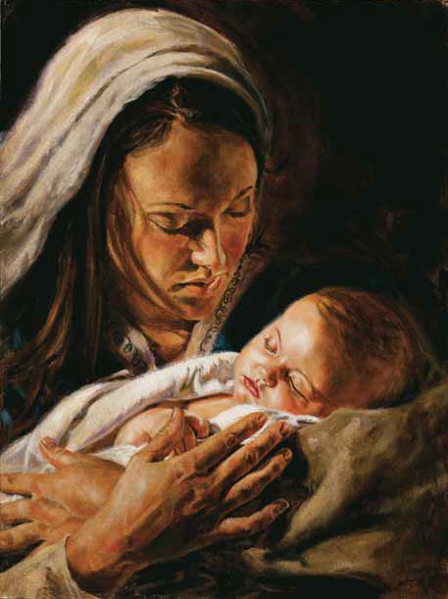
He’s come to set us free
Born this day is the Prince of Peace
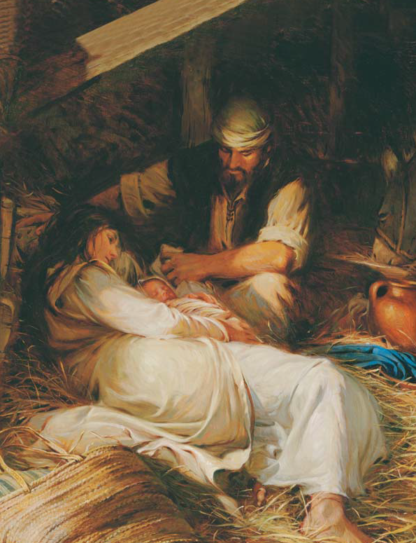
He came here just for me
How I wish I had been there
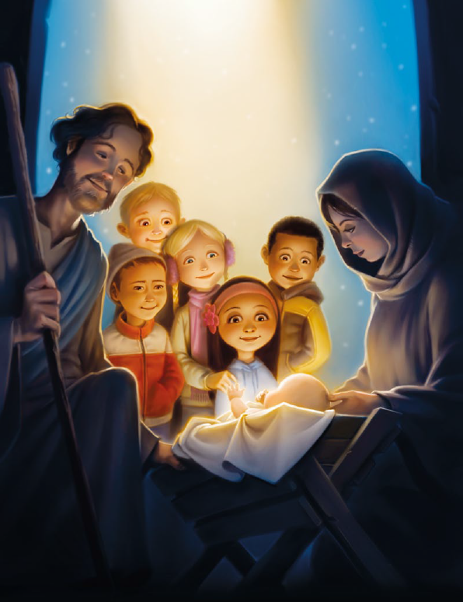
On that night
To rejoice with angels
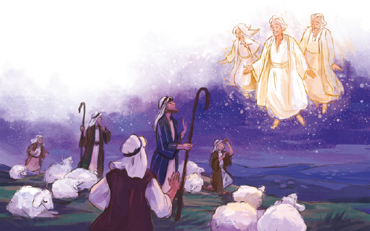
And with shepherds

Oh to see the baby
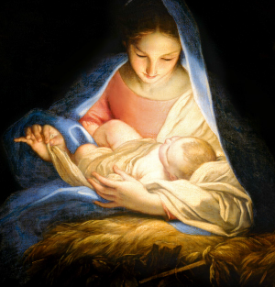
In his Mother’s arms
And know Heav’nly Father loves me
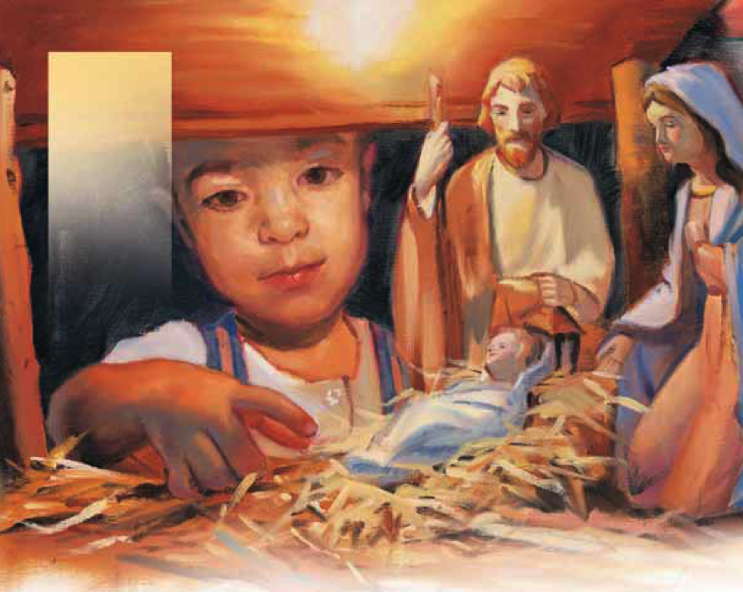

Still I know Jesus came here
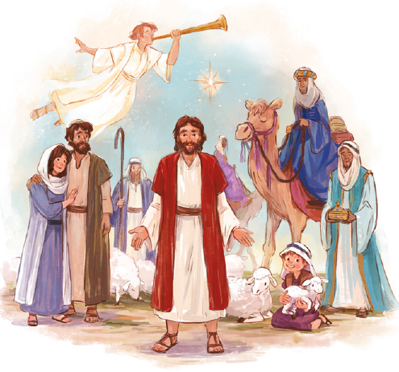
To the world
I know He came
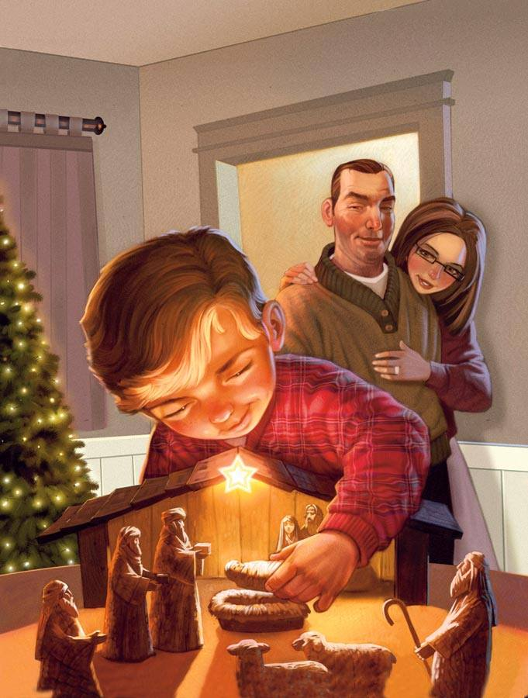
Because He loves me so
And every day in every way
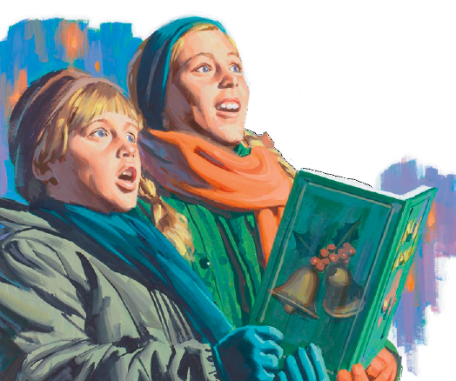
I will stand with faith and sing
Born this day is the King of Kings
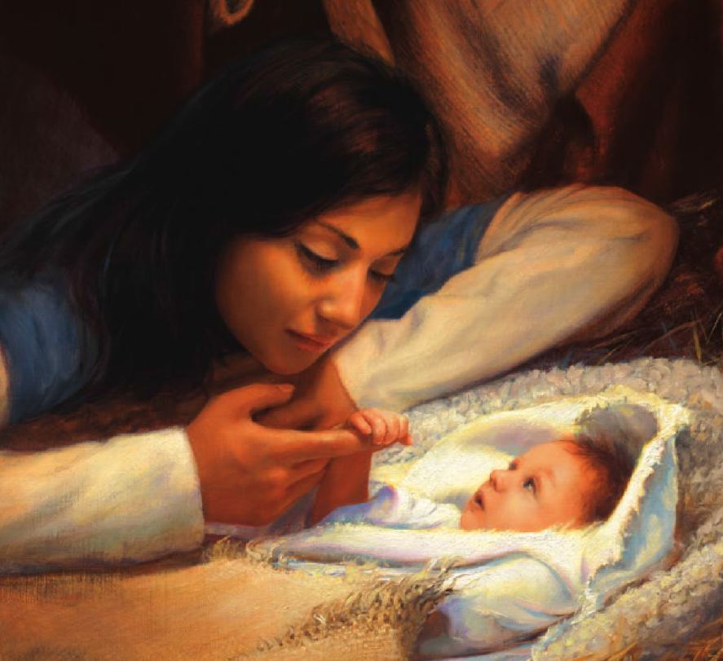
He’s come to set us free
Born this day is the Prince of Peace
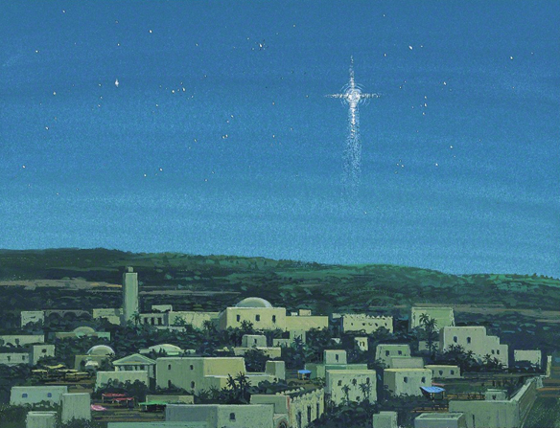
He came here just for me
Born this day is the King of Kings
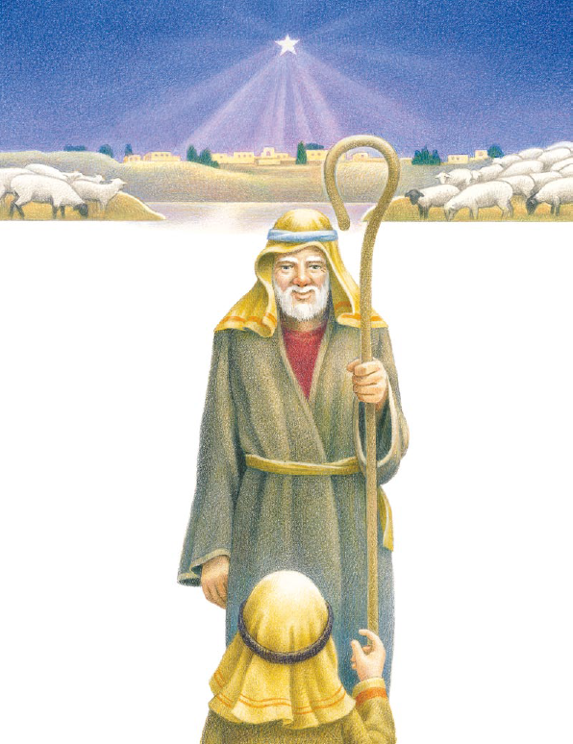
He’s come to set us free
Born this day is the Prince of Peace
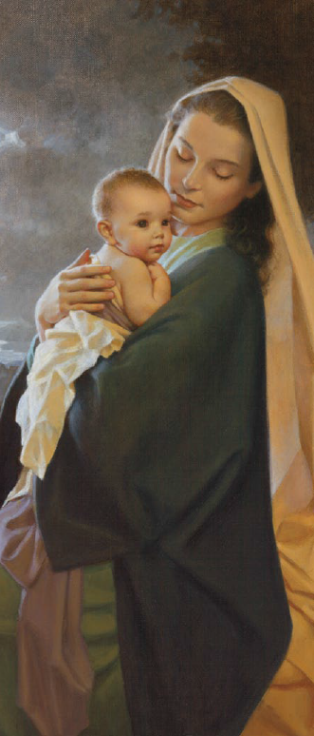
He came here just for me
He came here for you and me
