Hearken ye nations of the earth
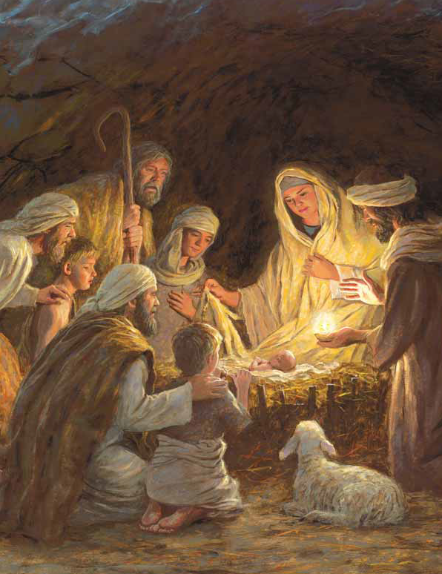
Hearken hear Heavenly choirs sing
Christ is born in Bethlehem
Wisemen come to honor Him
Treasure in your heart this song
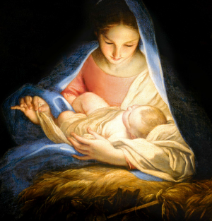
Hearken Christ is born

