Happy happy birthday, children
dear
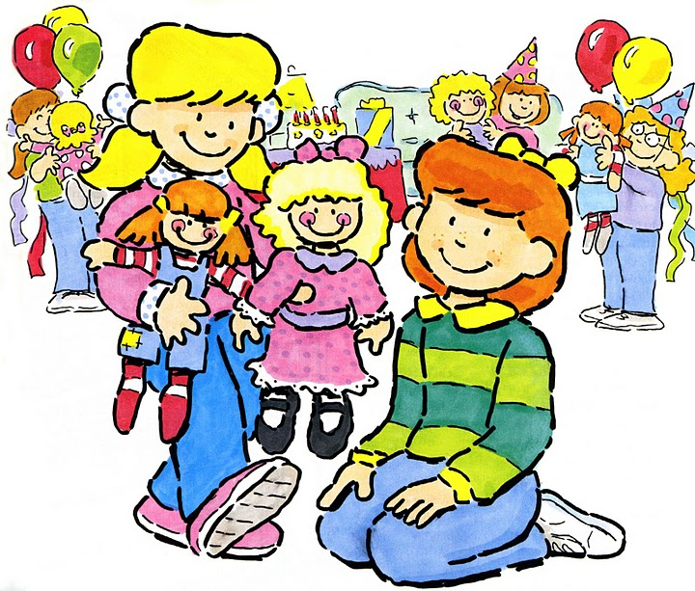
Happy days will come to you all year
If I had one wish, then it would be
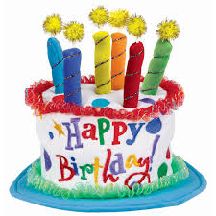
A happy happy birthday to you
from me

