God’s Love

by
Shawna Edwards

He was there to comfort
Joseph in a jail

He kept Jonah safe in the belly
of a whale

And he gave Job
Sons and daughters again
And protected Daniel
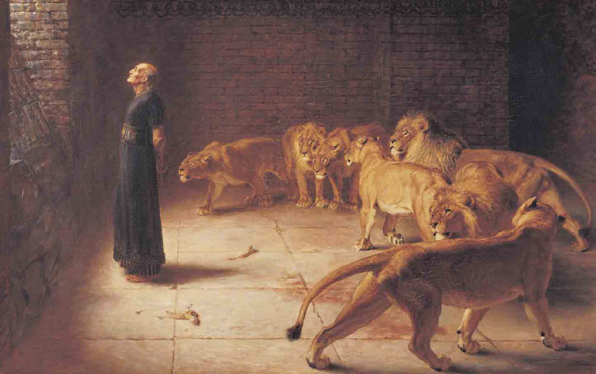
In the Lion’s Den
In every Bible story I read
I learn this undeniable thing
That God’s Love is wider than the sky
And deeper than the deep blue sea
God’s love can light the darkest night
And fill and aching heart with peace
God’s love is guaranteed to be
Unchanging through eternity
Just as God loved
Joseph, and Jonah, and Job
I know He loves me
He blessed Hannah with a son 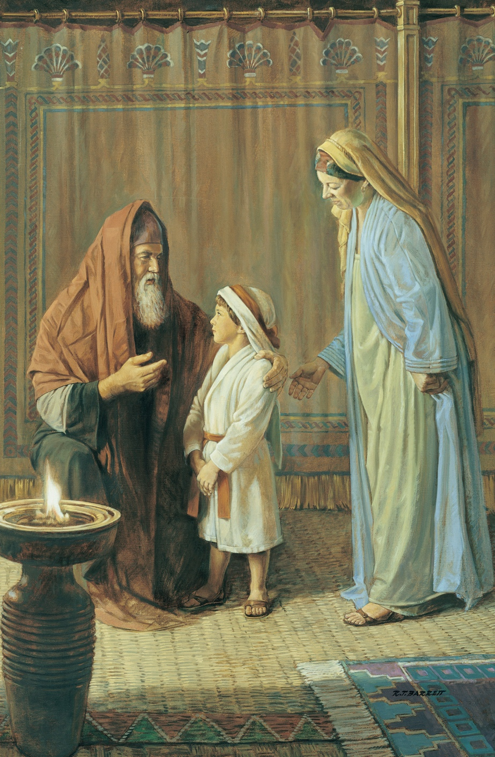
When she was old
He led Ruth to find
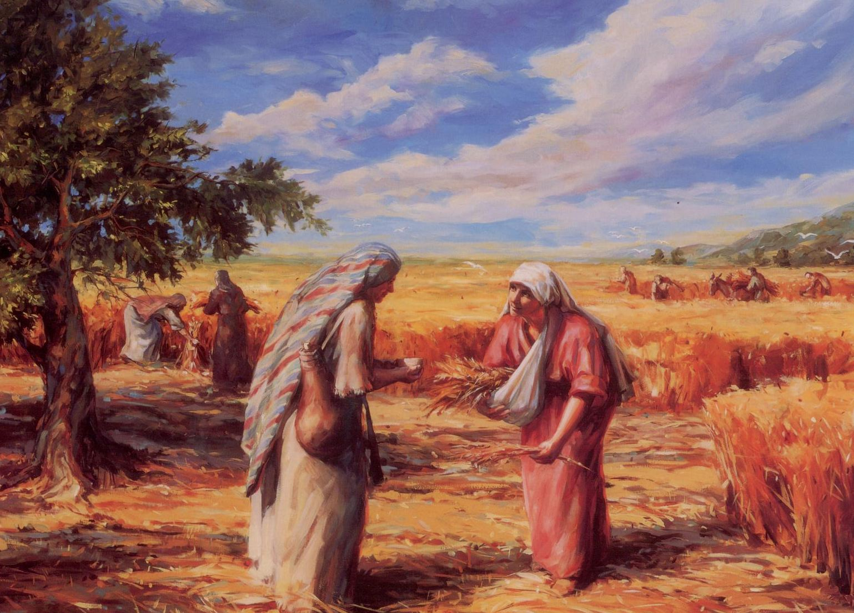
a new family and home
And He cooled the fiery furnace
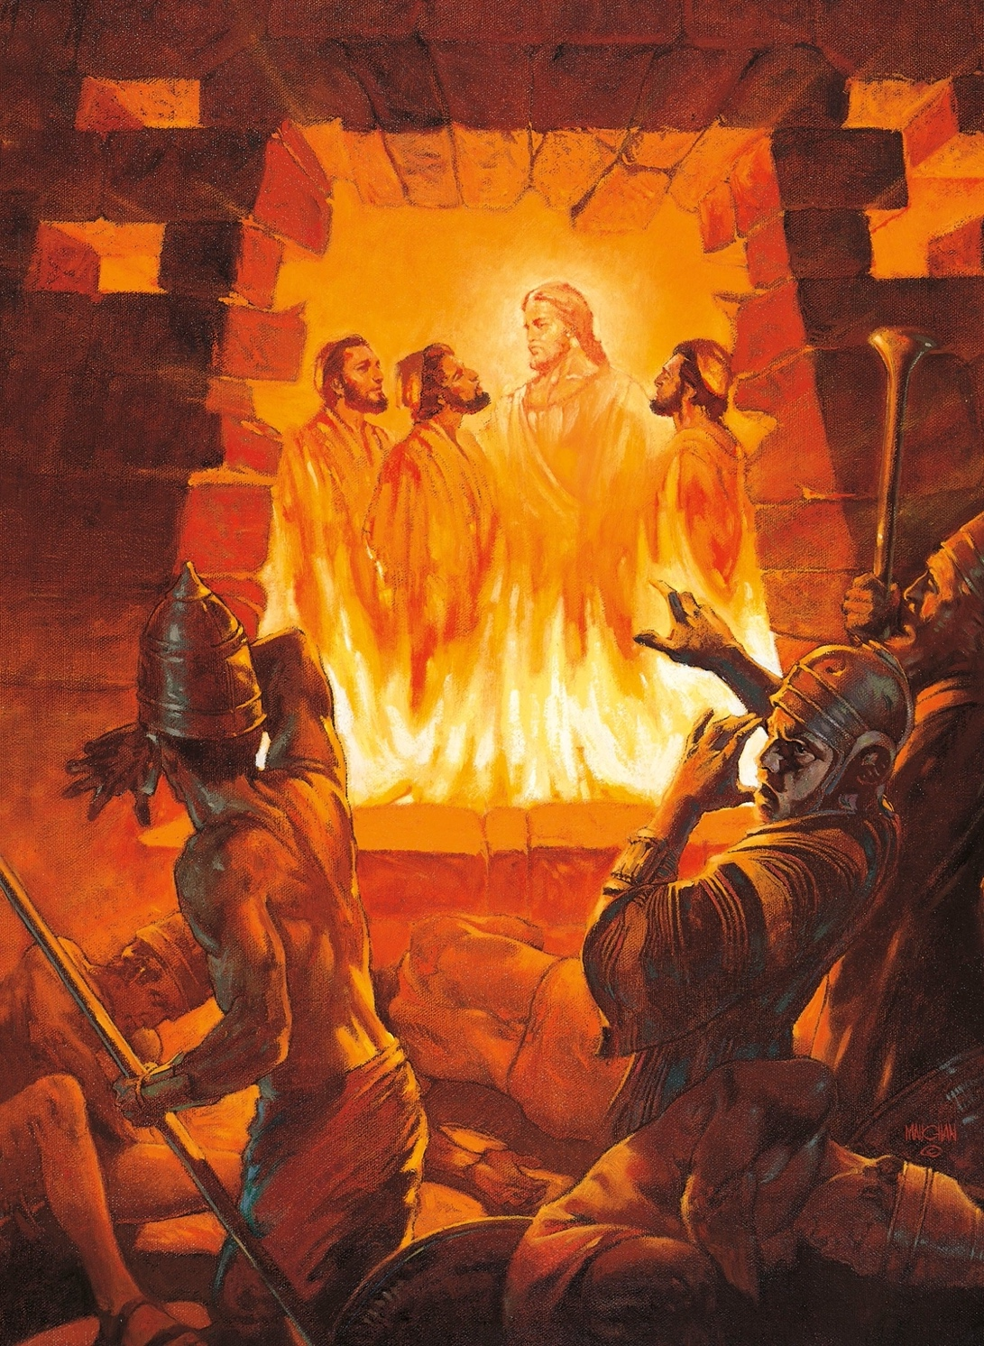
We know
For Shadrach, Meshach
And Abednego

In every Bible story I read
I learn this undeniable thing
That God’s Love is wider than the sky
and deeper than the deep blue sea
God’s love can light the darkest night
And fill an aching heart with peace
God’s love is guaranteed to be
Unchanging through eternity
Just as God loved
Joseph, and Jonah, and Job

I know He loves me
God’s Love is wider than the sky
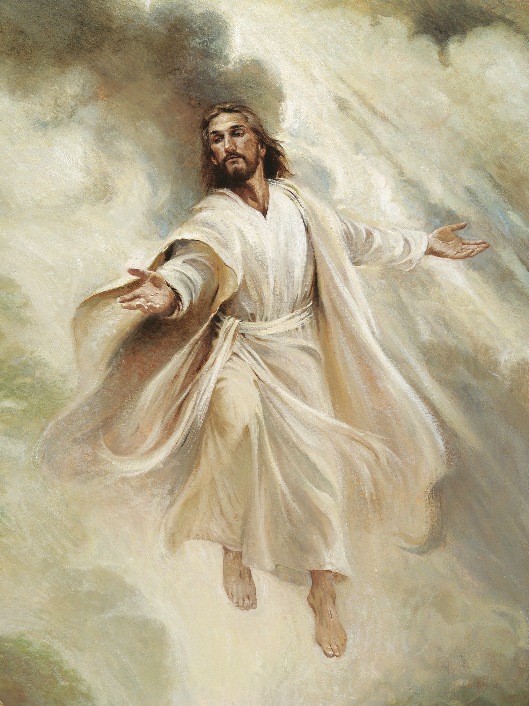
And deeper than the deep blue sea
God’s love can light the darkest night
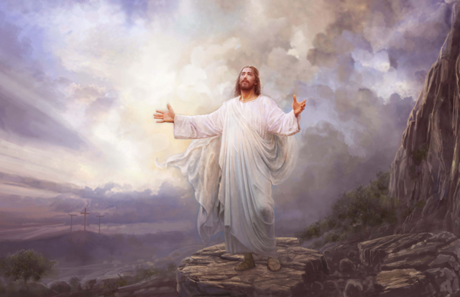
and fill and aching heart with peace
God’s love is guaranteed to be
Unchanging through eternity
Just as God loved
Joseph, and Jonah, and Job,
I know He loves me

