God be with you till we meet again
By his counsels guide, uphold you
With his sheep securely fold you
God be with you till we meet again
Till we meet
till we meet
Till we meet at Jesus’ feet
Till we meet
till we meet
God be with you till we meet again
God be with you till we meet again
When life’s perils thick confound you
Put his arms unfailing round you
God be with you till we meet again
God be with you till we meet again
Keep love’s banner floating o’er you
Smite death’s threat’ning wave before you
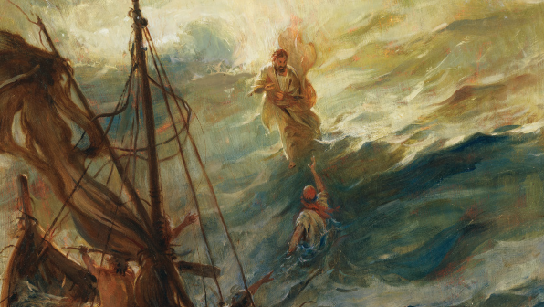
God be with you till we meet again

