Go tell it on the mountain
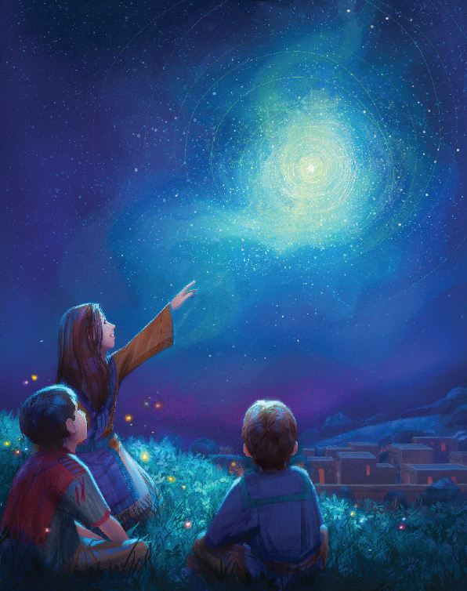
Over the hills and everywhere
Go tell it on the mountain
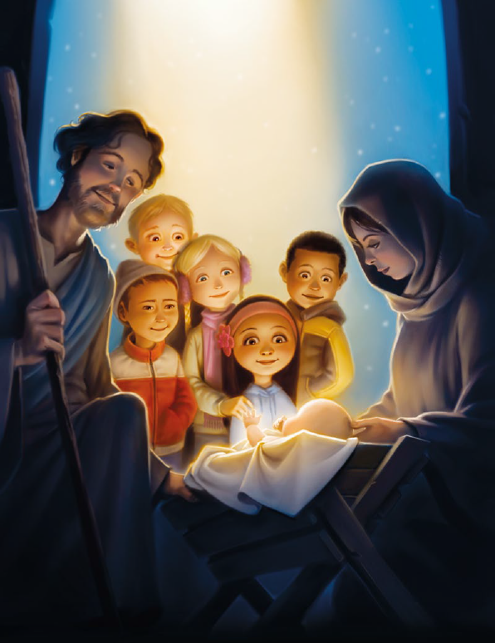
Our Jesus Christ is born
While shepherds kept their watching
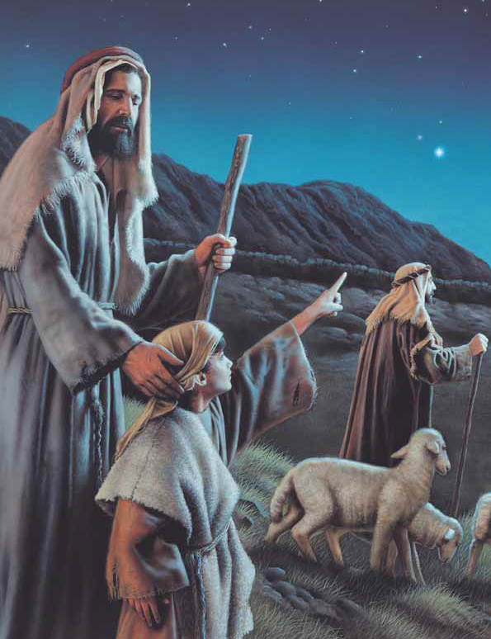
Over silent flocks by night
Behold throughout the heavens
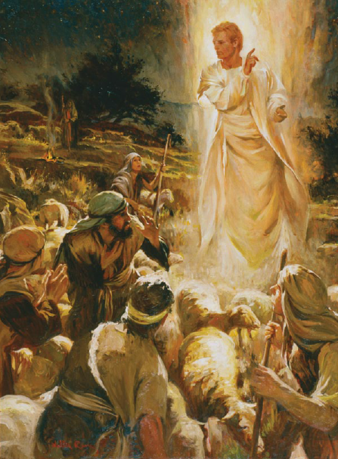
There shone a holy light
The shepherds feared and trembled
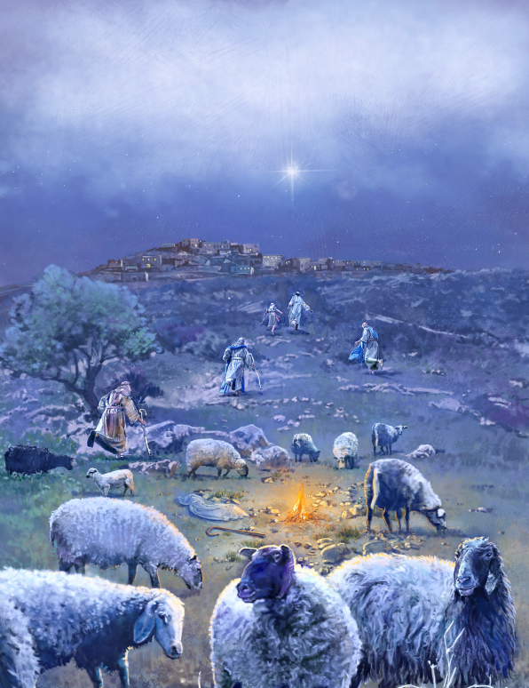
When lo above the earth
Rang out the angel chorus
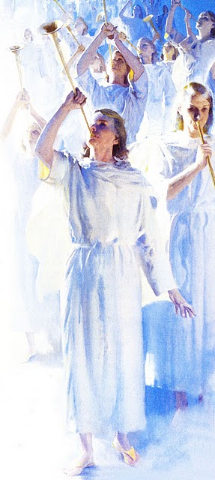
That hailed our Savior's birth
Down in a lowly manger
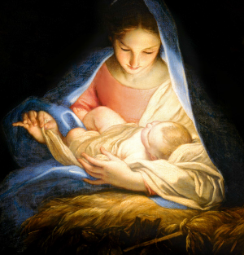
Our humble Christ was born
And God sent us salvation
That blessed Christmas morn

