"Give," said the little stream,

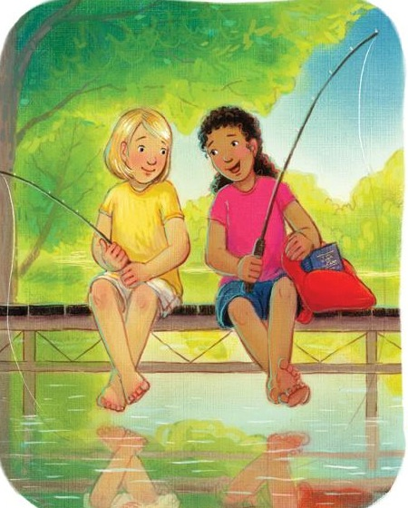

"Give, oh! give, give, oh! give."

"Give," said the little stream,

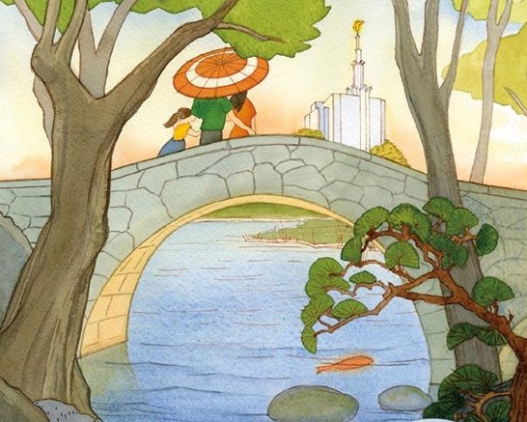

As it hurried down the hill

"I'm small, I know, but wherever I go

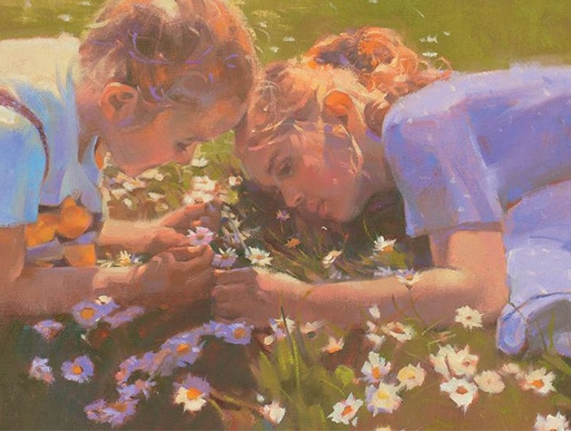

The fields grow greener still."

Singing, singing all the day,

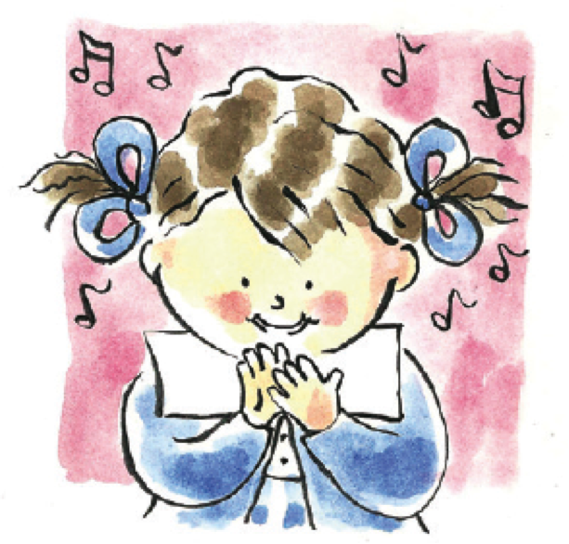

"Give away, oh! give away."

Singing, singing all the day,

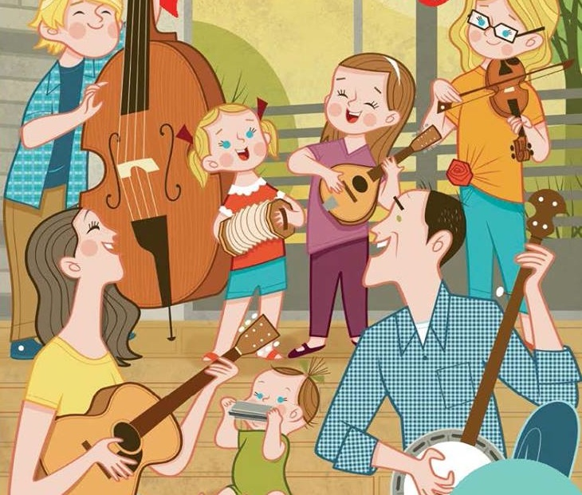

"Give, oh! give away."

"Give," said the little rain,

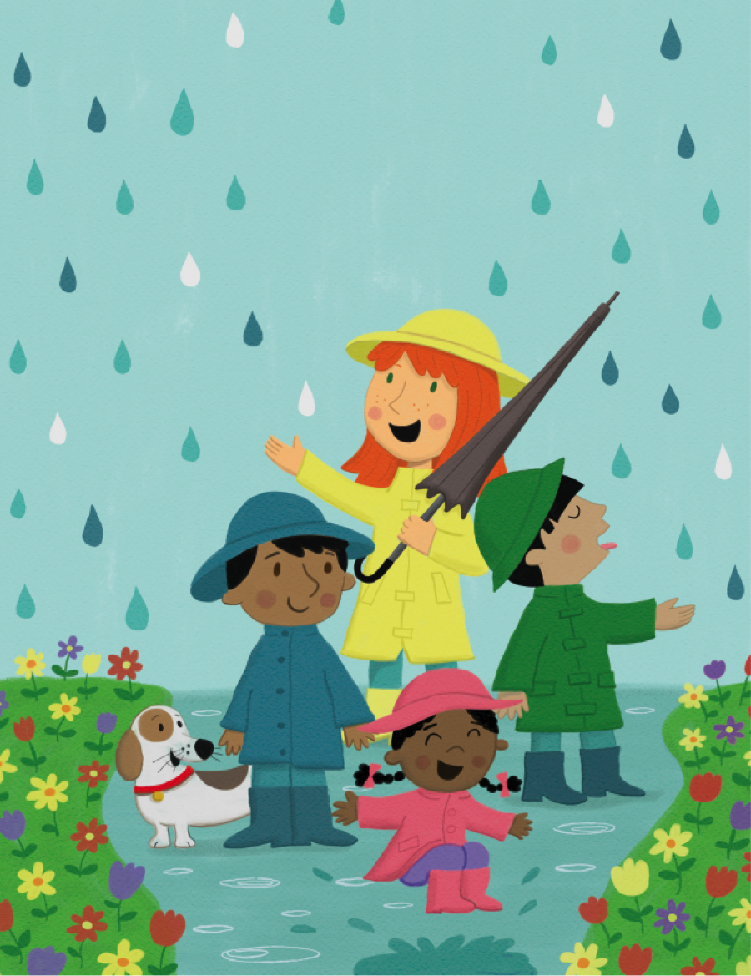

"Give, oh! give, give, oh! give."

"Give," said the little rain,

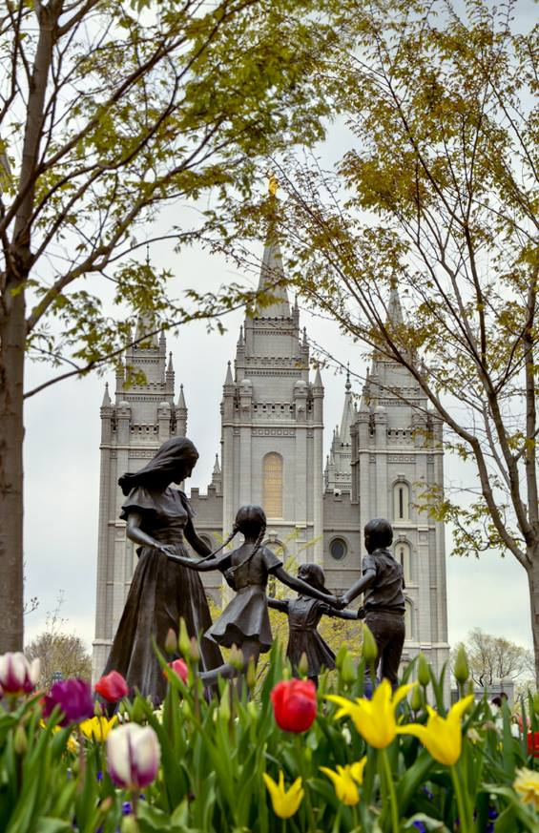

As it fell upon the flow'rs;

I'll raise their drooping heads again,

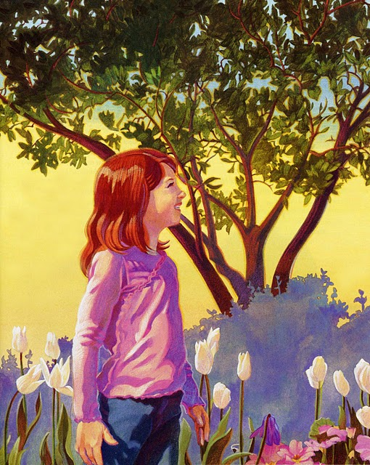

As it fell upon the flow'rs

Give, then, as Jesus gives

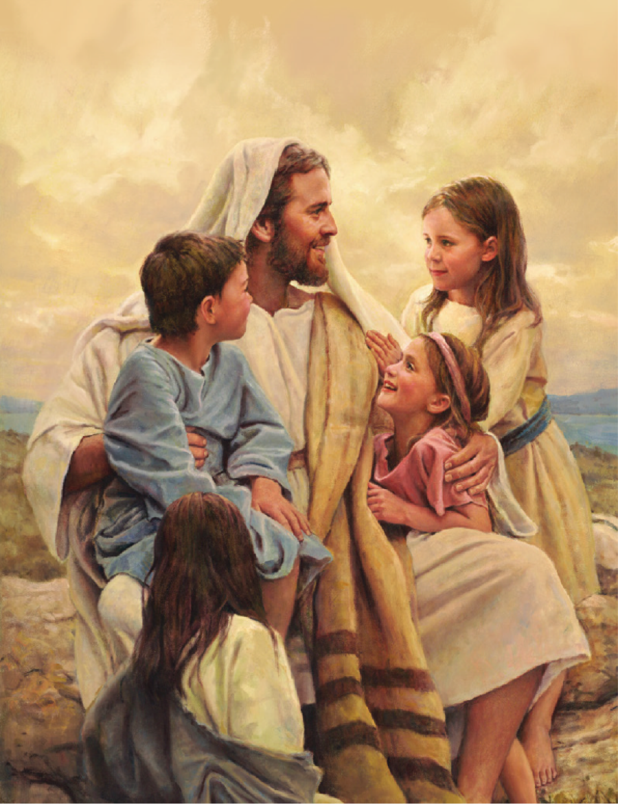

Give, oh! give, give, oh! give

Give, then, as Jesus gives

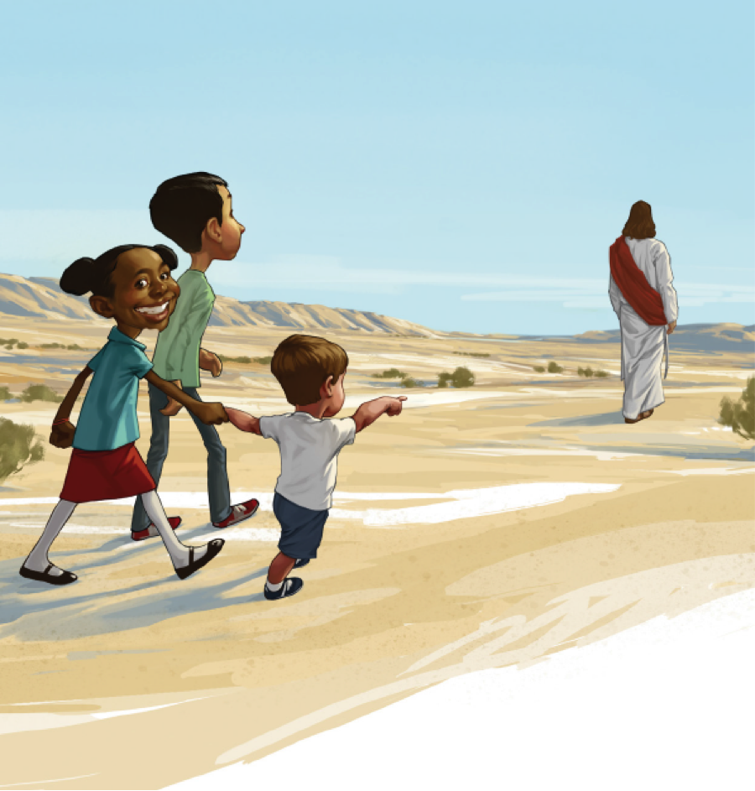

There is something all can give

Do as the streams and blossoms do

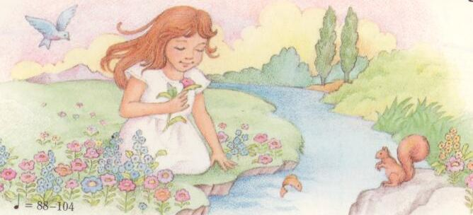

For God and others live