Gethsemane
By Melanie Hoffman

Purchase the Sheet Music at
www.hoffmanhouse.com

Jesus climbed the hill
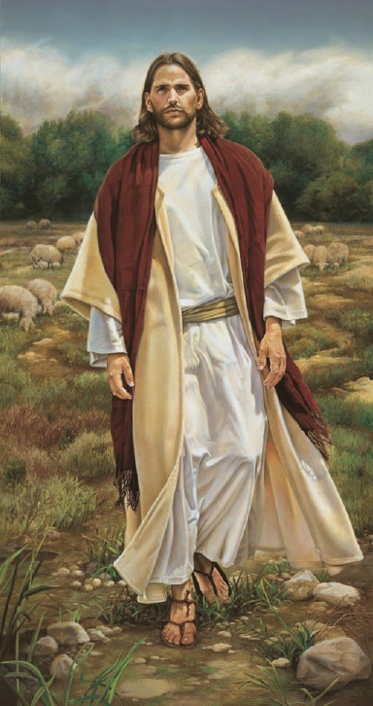
To the garden still
His steps were heavy and slow
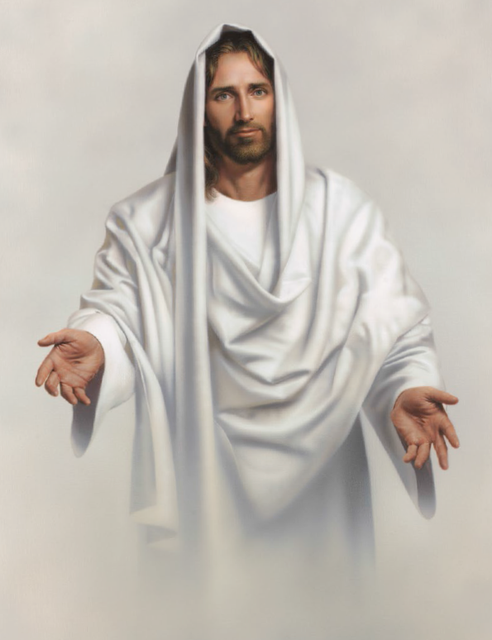
Love and a prayer
Took Him there
To the place only He could go
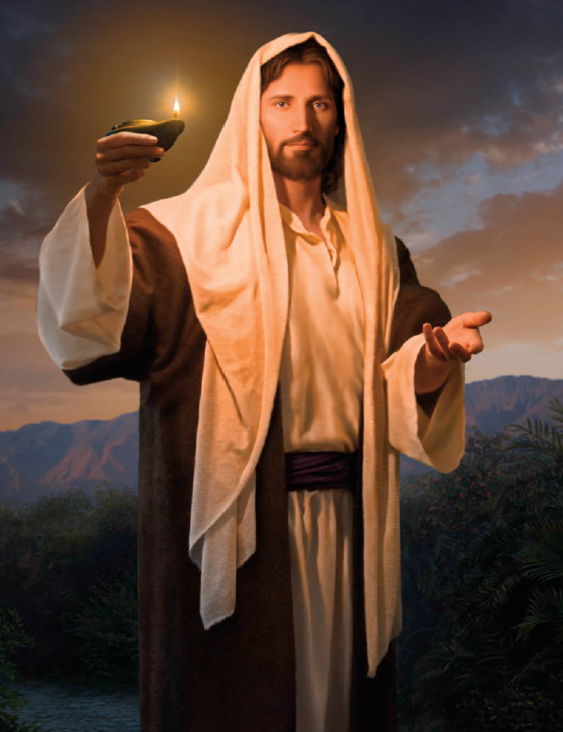
Gethsemane
Jesus loves me
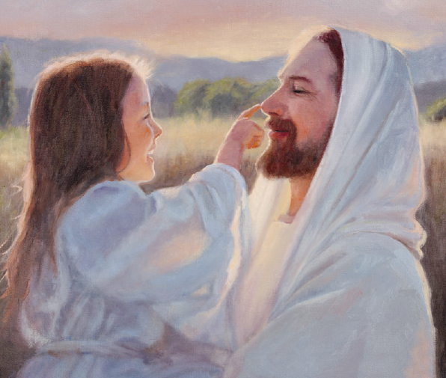
So He went willingly
To Gethsemane
He felt all that was sad, wicked or bad
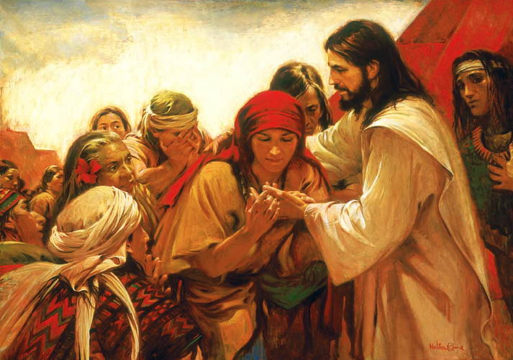
All the pain we would ever know
While His friends were asleep
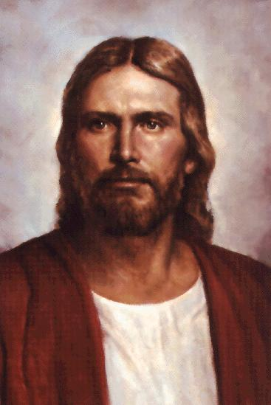
He fought to keep
His promise made long ago
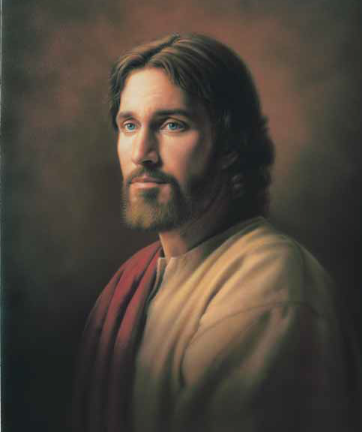
Gethsemane
Jesus loves me
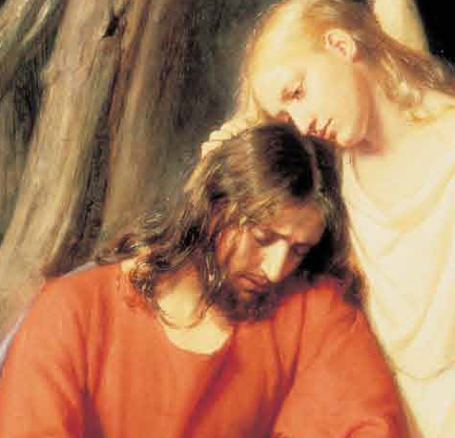
So He went willingly
To Gethsemane
The hardest thing That ever was done
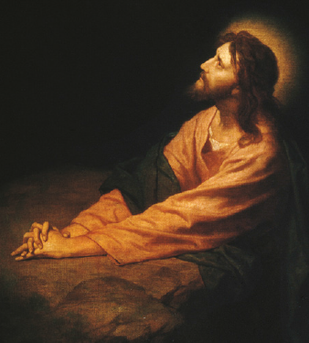
The greatest pain that ever was known
The biggest battle that ever was won
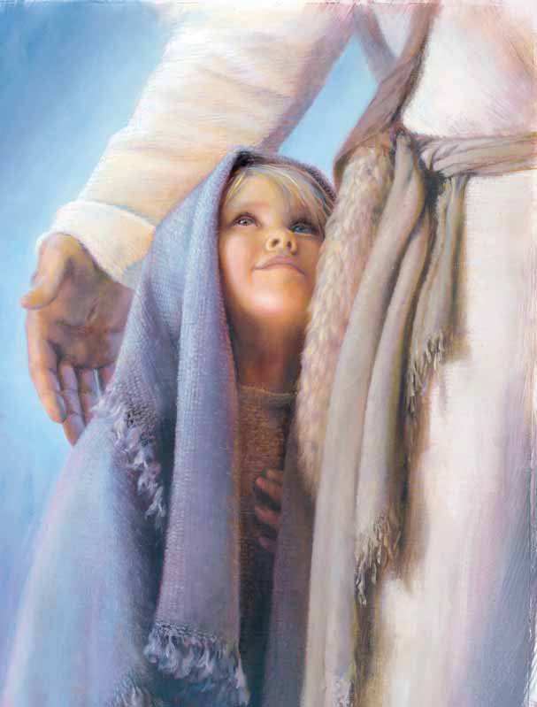
This was done by Jesus
The fight was won by Jesus
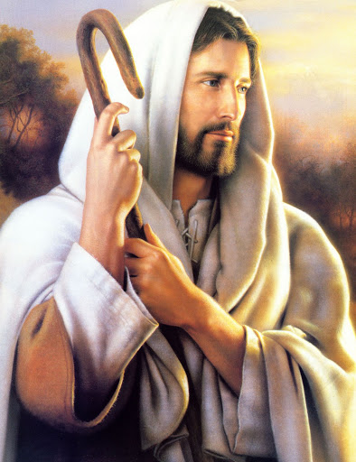
Gethsemane
Jesus loves me
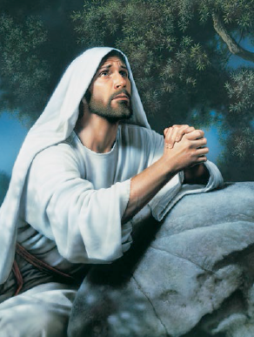
So he gave His gift to me
In Gethsemane
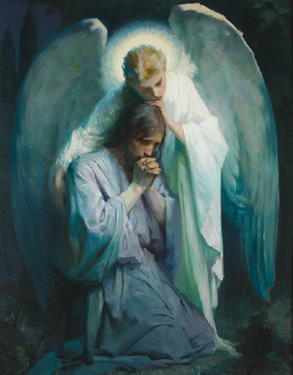
Gethsemane
Jesus loves me
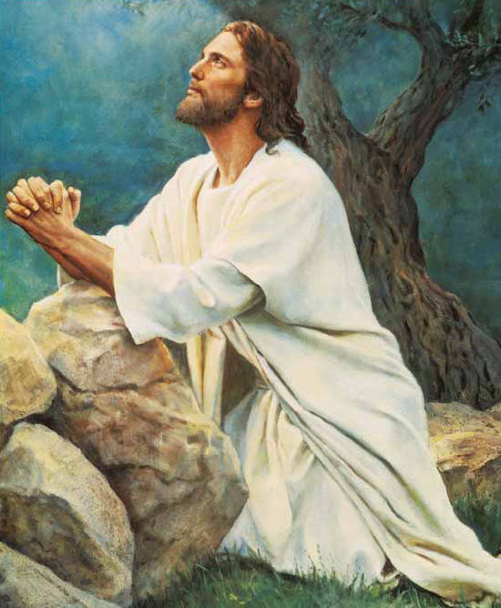
So he gives His gift to me
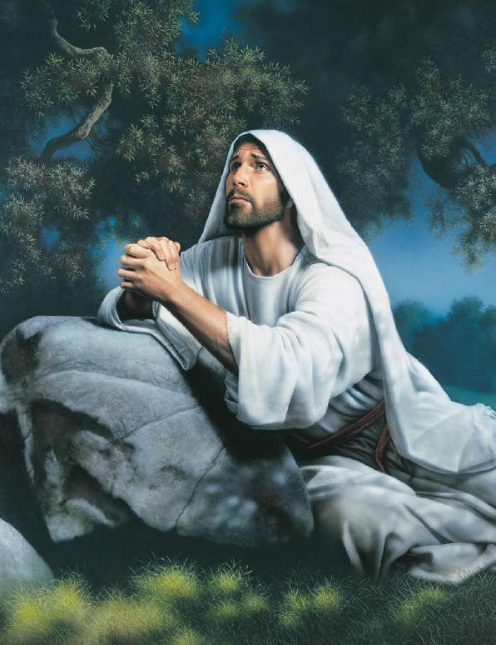
From Gethsemane

