Lehi was a prophet
sailed across the sea
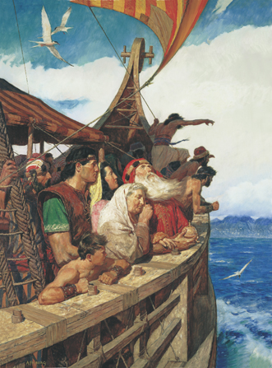
From Jerusalem the Lord told him to flee
Coming off the boat he knelt down in the sand
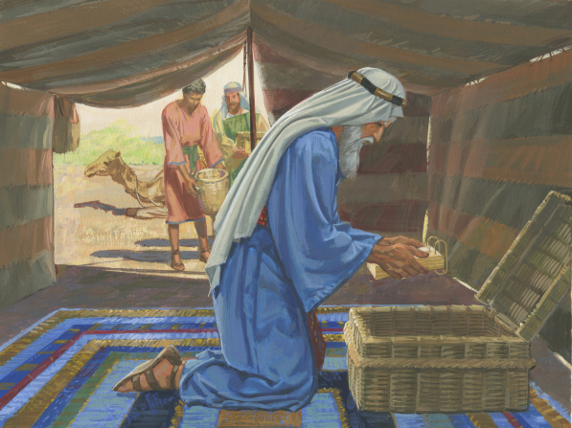
Thanked the Lord for leading them to the promise land
Nephi was a prophet
he chose to obey
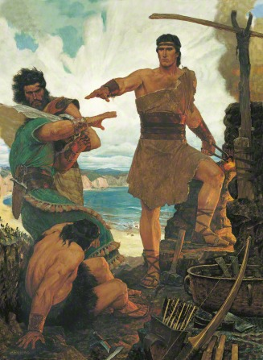
All of the commandments that the Lord did say
Nephi was courageous, valiant and true
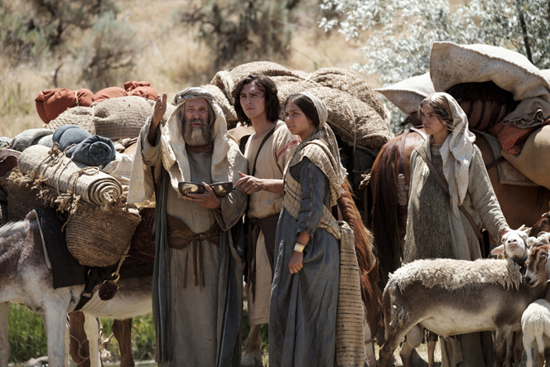
What the Lord commanded
he would go and do
Samuel the prophet was a Lamanite
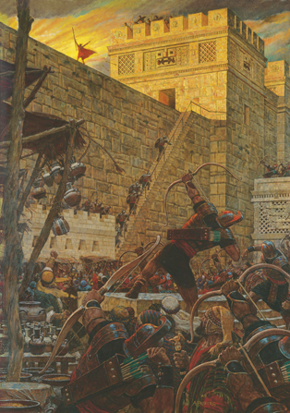
Called to teach the Nephites and bring them gospel light
Prophesied that Christ in five years would be born
“Repent or be destroyed,” are the things that Samuel warned
Joseph Smith the prophet, He restored the truth
He found the Book of Mormon
while still in his youth
He faced Persecution, endured until the end
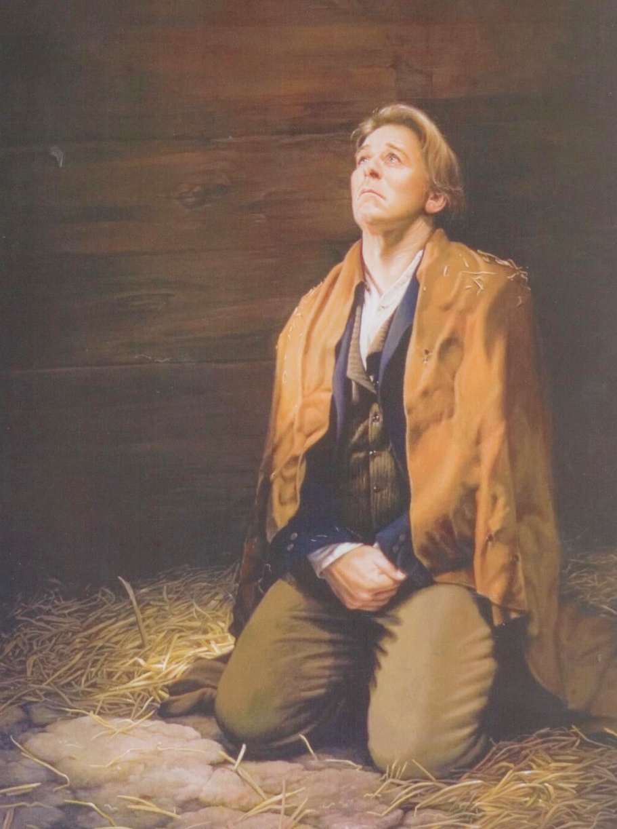
Served the Lord and now God says, Well done my faithful friend.”
Pres’dent Nelson is our prophet, he teaches us through God
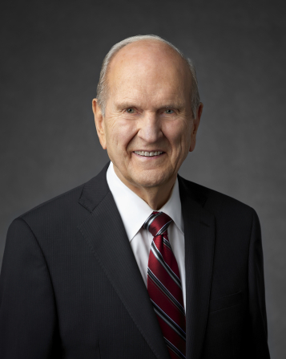
To follow the commandments and hold the iron rod
Our prophet has encouraged us, to gather Israel
Temple and mission service help both sides of the veil
Follow the prophet
Follow the prophet
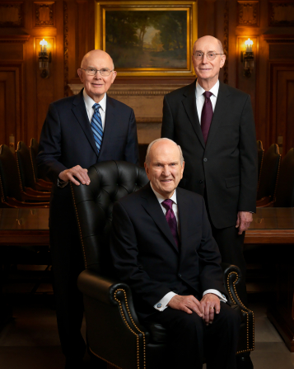
Follow the prophet
don’t go astray
Follow the prophet
Follow the prophet
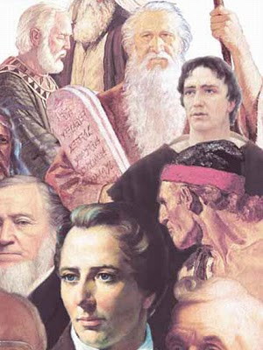
Follow the prophet
he knows the way

