Adam was a prophet first one that we know
In a placed called Eden, he helped things to grow
Adam served the Lord by following his ways
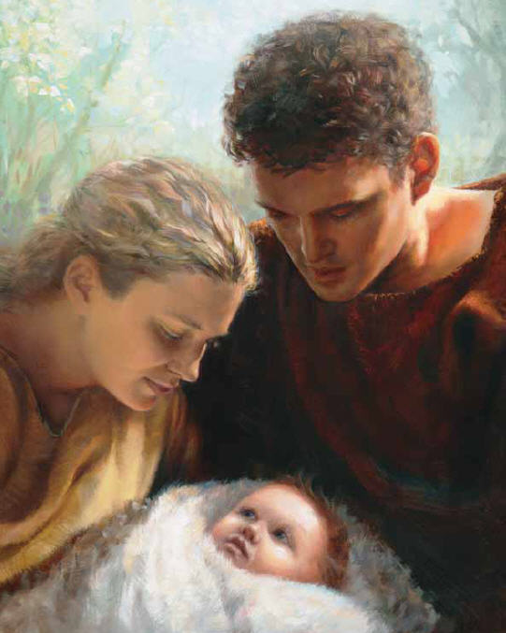
We are his descendants in the Latter Days
Follow the prophet…
don’t go astray
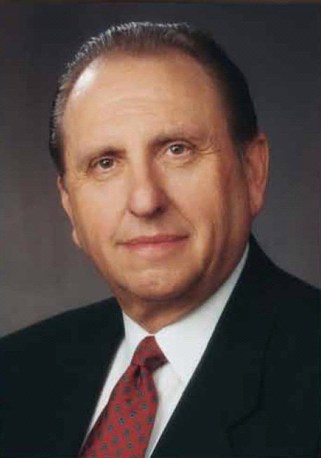
Follow the prophet…
He knows the way
Enoch was a prophet he taught what was good
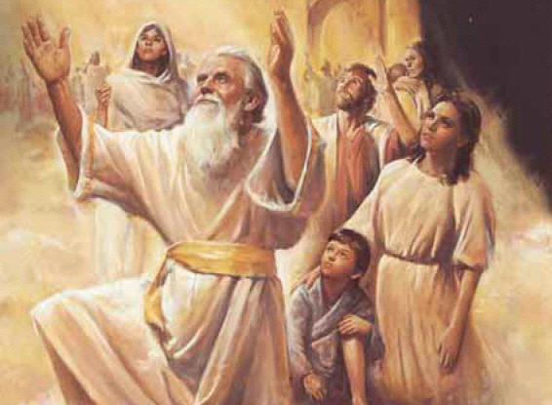

People in his city did just what they should
When they were so righteous that there was no sin
Heav’nly Father took them up to live with him.
Noah was a prophet called to preach the Word,
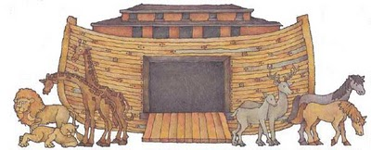

Tried to cry repentance, but nobody heard.

They were busy sinning—Noah preached in vain
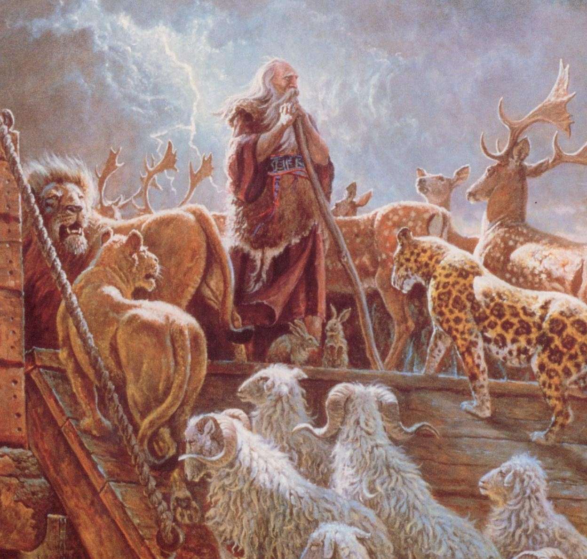
They wished they had listened when they saw the rain
Abraham the prophet prayed to have a son,
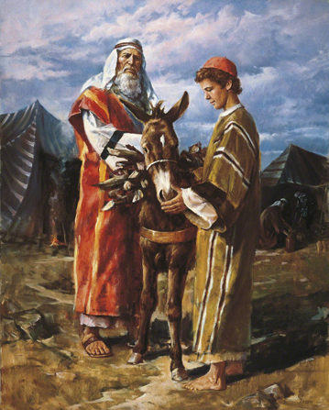
So the Lord sent Isaac as the chosen one
Isaac begat Jacob, known as Israel;
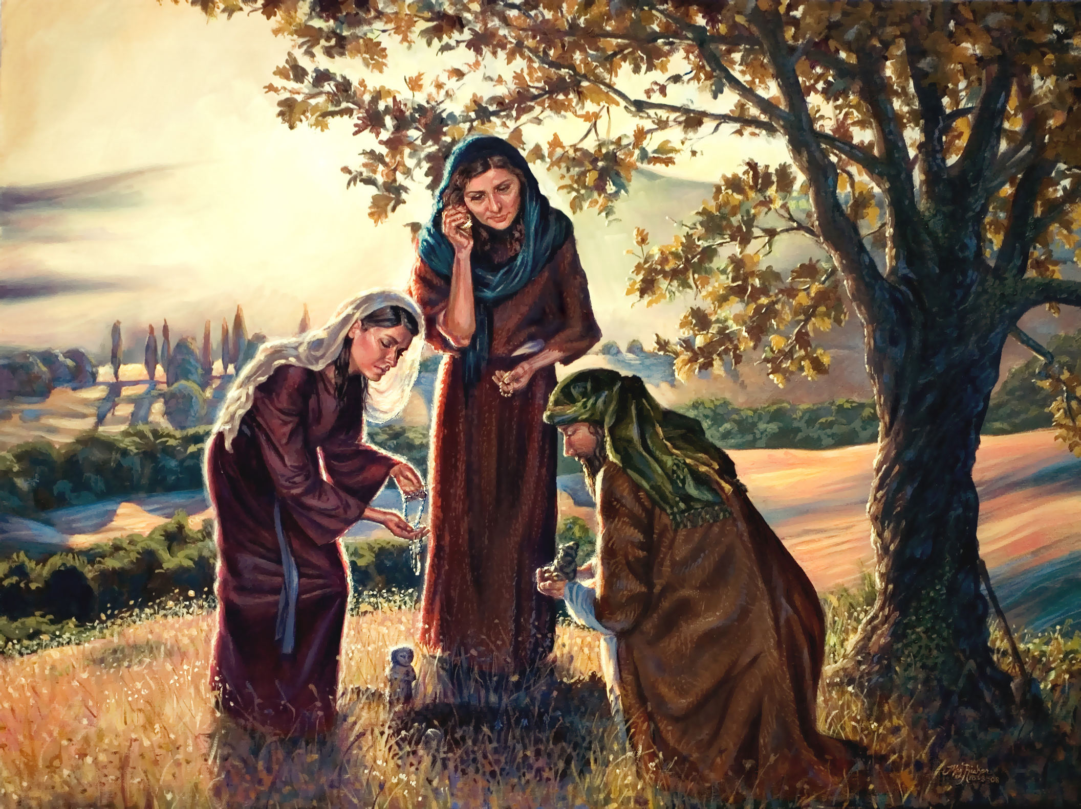
Jacob’s sons were twelve tribes, so the Bible tells
Moses was a prophet sent to Israel
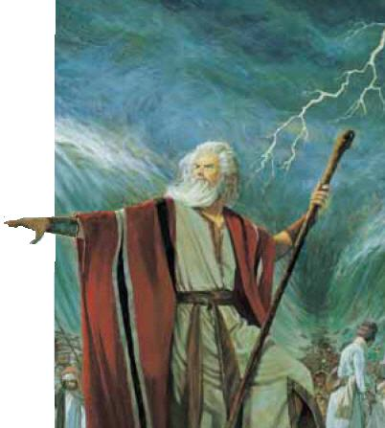
He would lead them to the promised land to dwell
They were slow to follow, or so it appears.
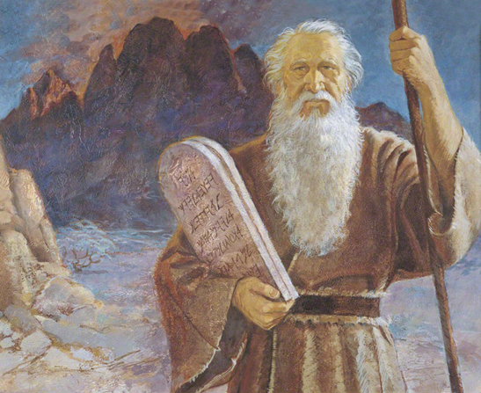They were in the wilderness for forty years
Samuel was a prophet chosen as a boy
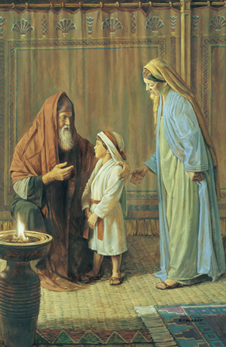
Hannah promised God her son would serve with joy
In the tabernacle, Samuel heard his name
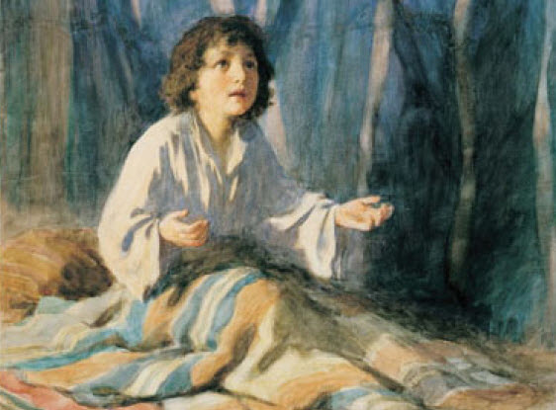
He was called by God and answered, “Here I am!”
Jonah was a prophet, tried to run away
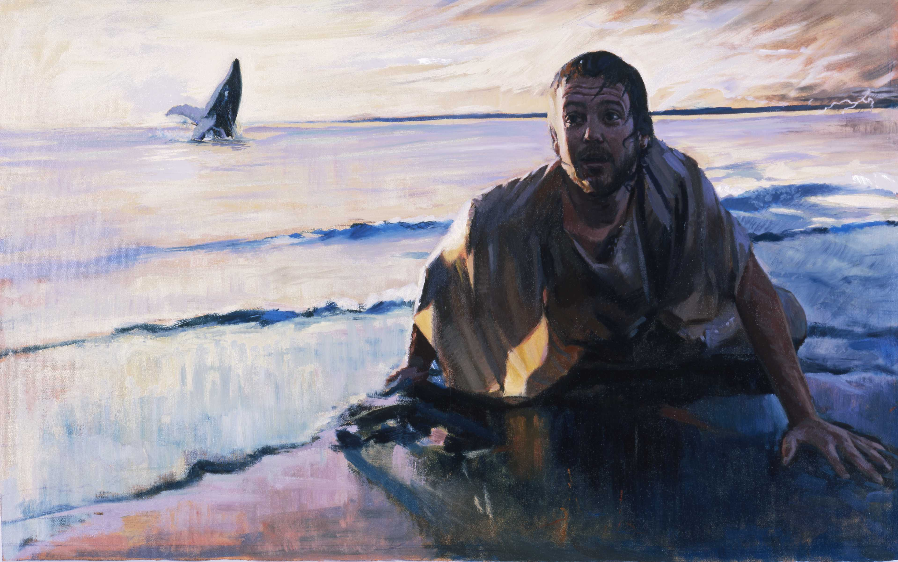
But he later learned to listen and obey

When we really try the Lord won’t let us fail
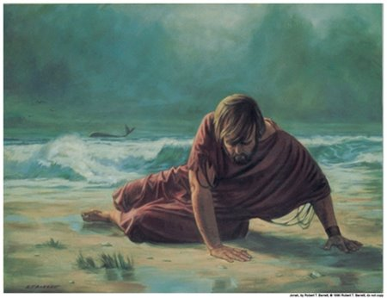
That’s what Jonah learned deep down inside the whale
Daniel was a prophet. He refused to sin
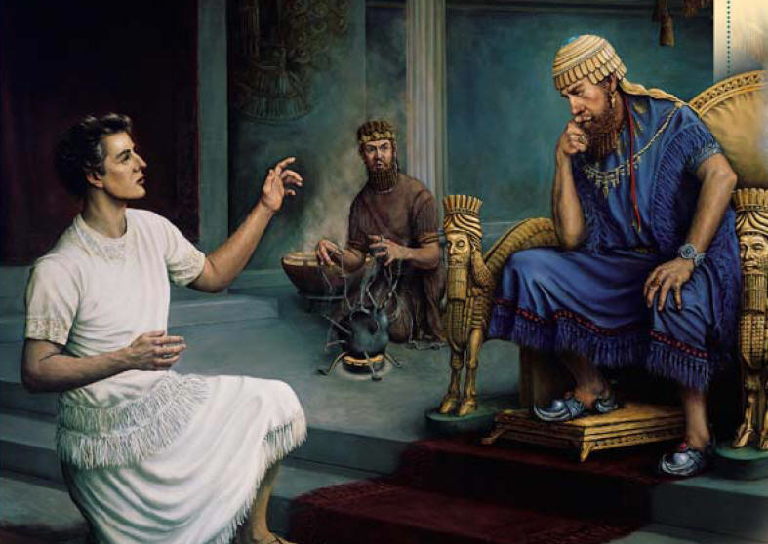
So the King threw Daniel in the lion’s den.
Angels calmed the lions, and the king soon saw
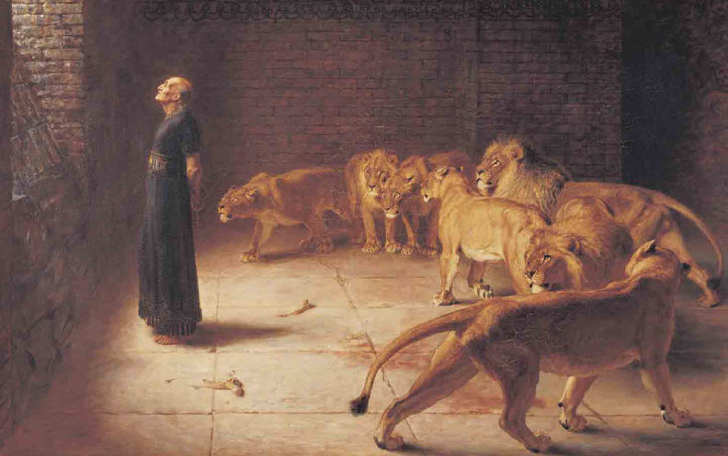
Daniels pow’r was great, for he obeyed God’s law.
Now we have a world where people are confused
If you don’t believe it, go and watch the news
We can get direction all along our way
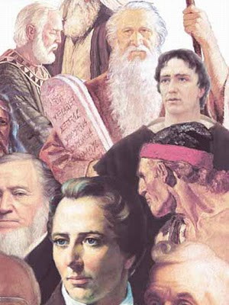
If we heed the prophets- follow what they say
