"Feliz Cumpleaños," (fay-lees coom-play-ahn-yos)
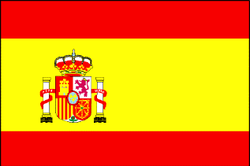
That's how they say it in Spain
"Fröhlicher Geburtstag," (frer-li-sher guh-burts-tahk)
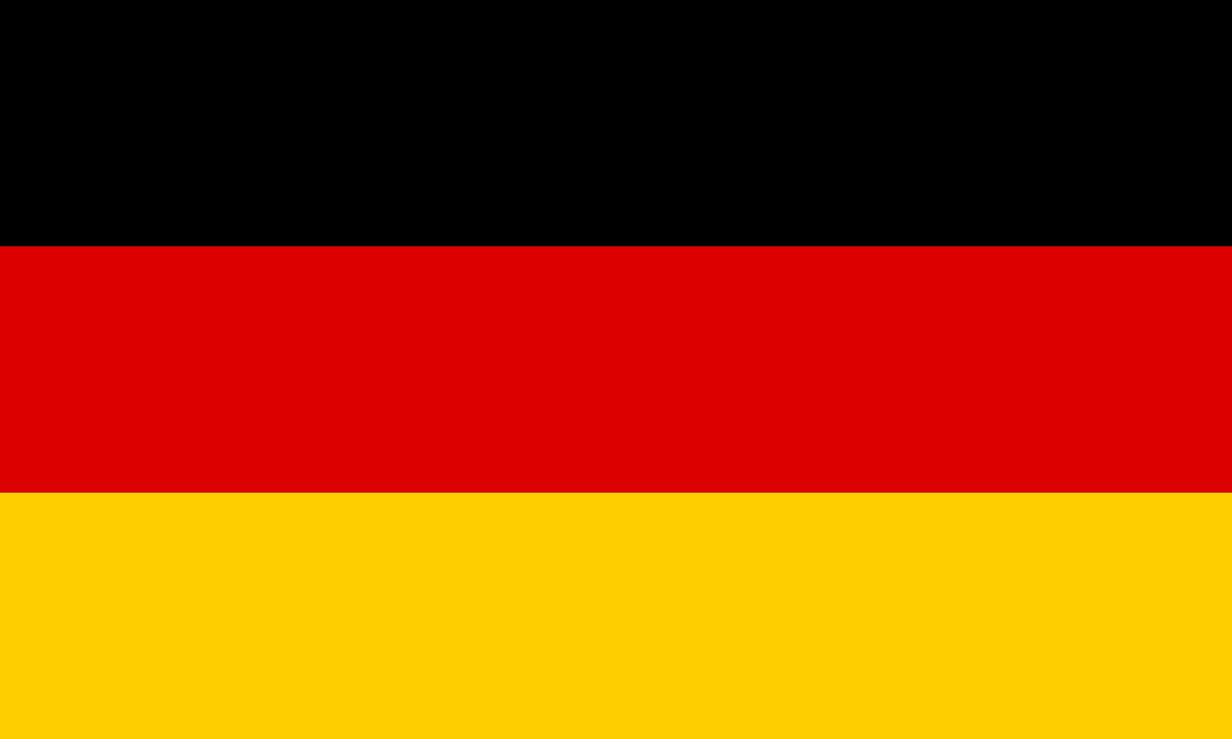
In German it means the same
"Gratulerer med dagen," (grah-too-lay-rare med dog-en)
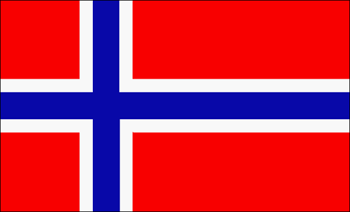
Norwegians say it too.
But any way you say it
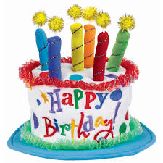
It means "Happy Birthday to you!"
They say in Samoa

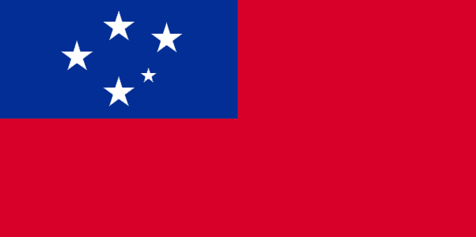
"Manuia lou aso fanau." (mah-noo-ee-yah low ah-so fah-now)
"Tanjobi omedeto," (tahn-joe-bee oh-meh-deh-toe)
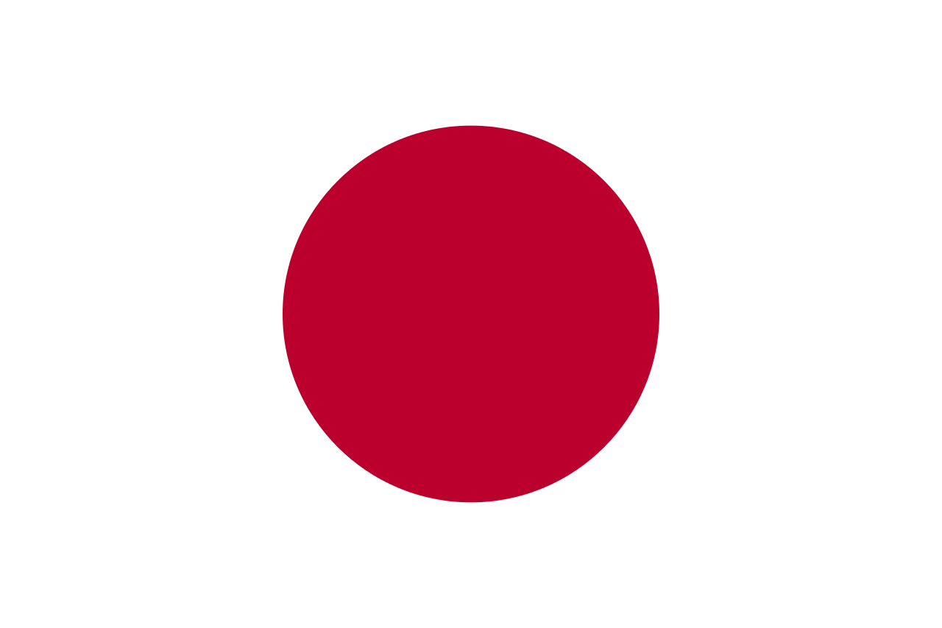

The Japenese say, and bow
"Saengilul ch'ukhahamnida," (sang-ill-ool chewk-ha-hahm-nee-dah)
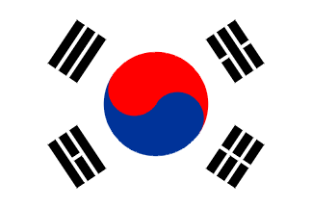

Koreans say it too.
But any way you say it
It means "Happy Birthday to you!"

