Faith is knowing the sun will rise
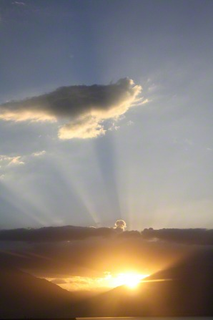
Lighting each new day
Faith is knowing the Lord will hear
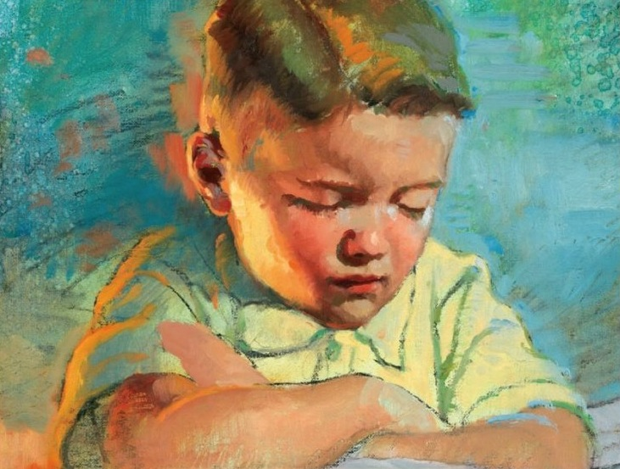
My prayers each time I pray
Faith is like a little seed
If planted it will grow
Faith is a swelling within my heart
When I do right,
I know
Faith is knowing I lived with God
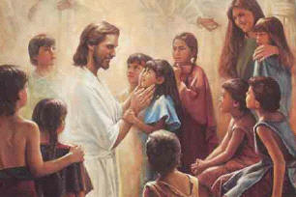
Before my mortal birth
Faith is knowing I can return
When my life ends on earth
Faith is trust in God above
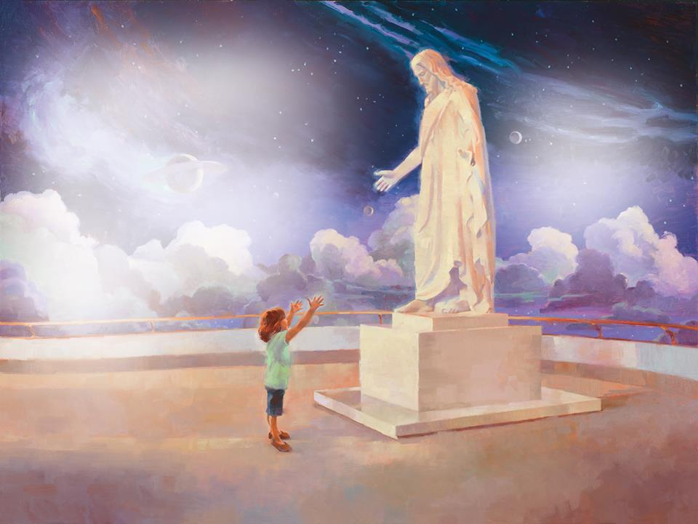
In Christ who showed the way
Faith is strengthened
I feel it grow
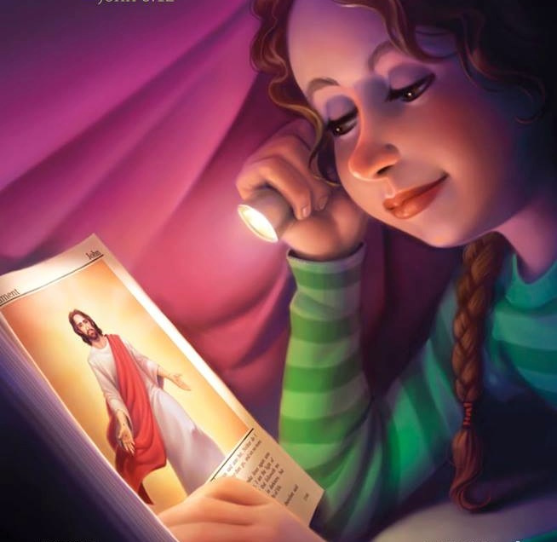
Whenever I obey

