Do as I'm doing
Follow, follow me

Do as I'm doing
Follow, follow me
If I do it high or low
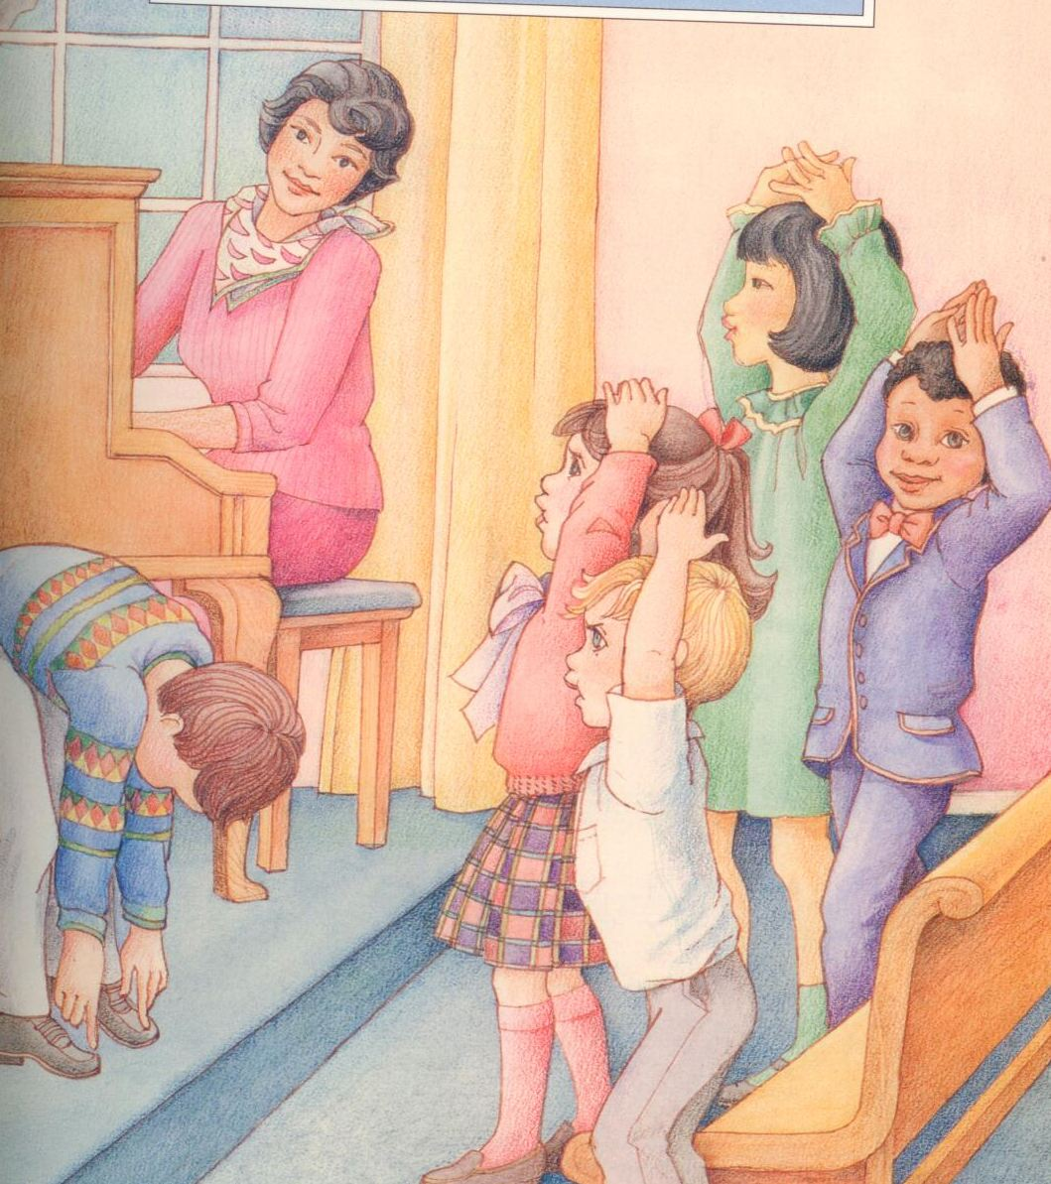
If I do it fast or slow
Do as I'm doing
Follow, follow me
Do as I'm doing
Follow, follow me

