Said the night wind to the little lamb
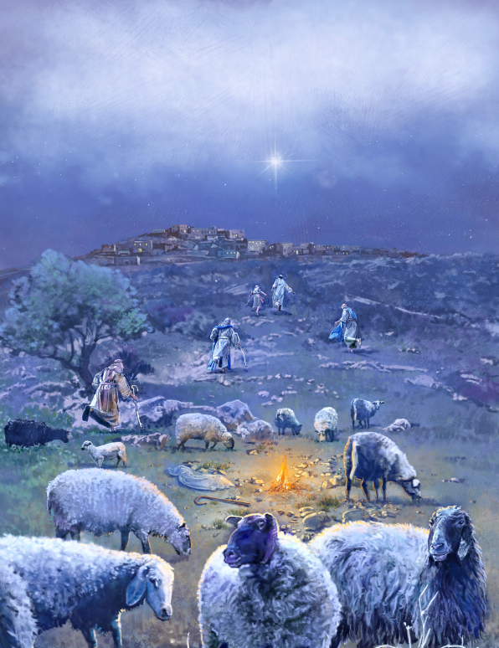
Do you see what I see
Way up in the sky little lamb
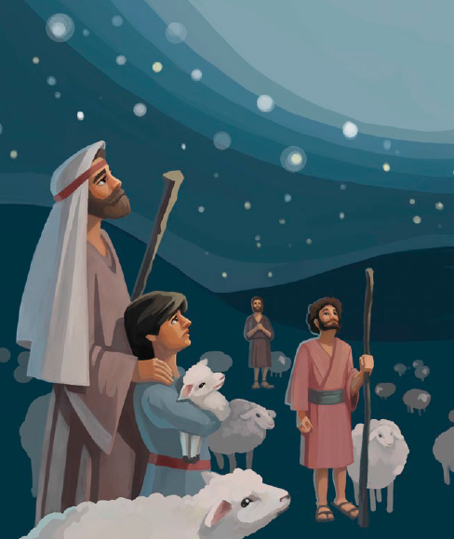
Do you see what I see
A star, a star
Dancing in the night
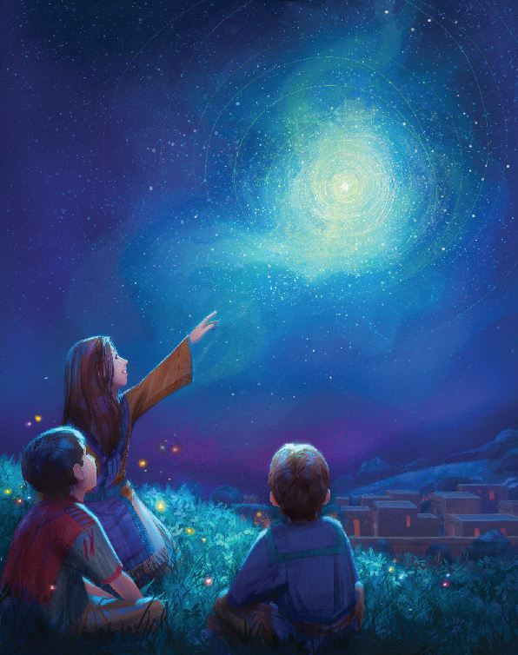
With a tail as big as a kite (X2)
Said the little lamb to the shepherd boy
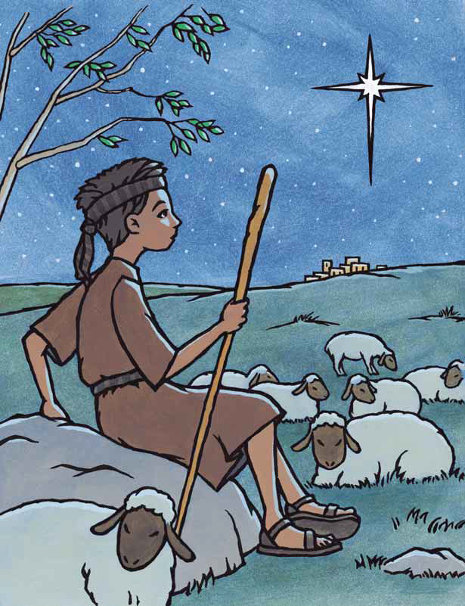
Do you hear what I hear
Ringing through the sky shepherd boy
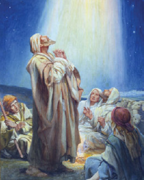
Do you hear what I hear
A song, a song
High above the trees
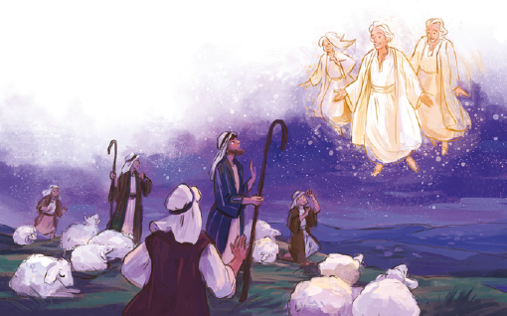
With a voice as big as the sea (X2)
Said the shepherd boy to the mighty king
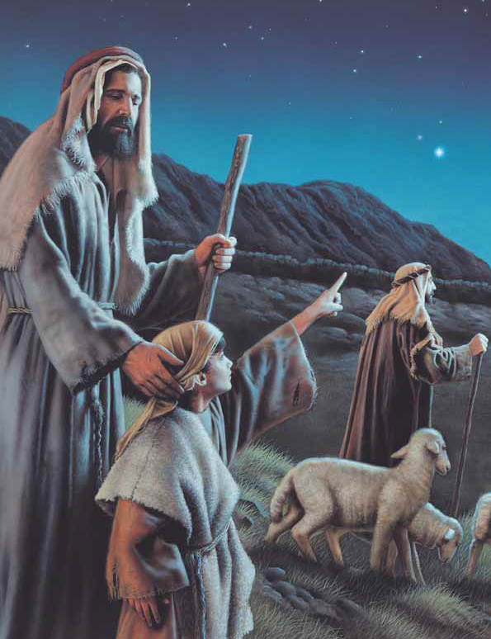
Do you know what I know
In your palace wall mighty king
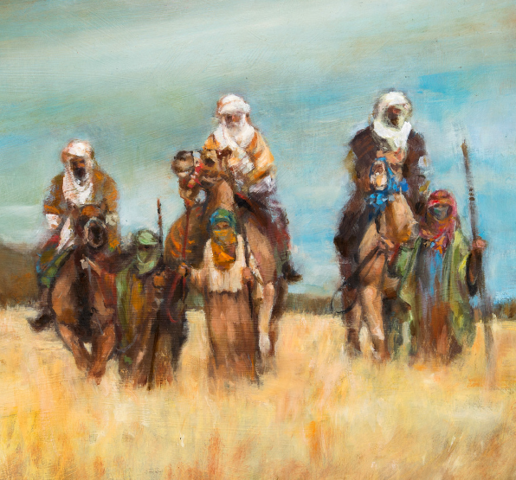
Do you know what I know
A child, a child
Shivers in the cold
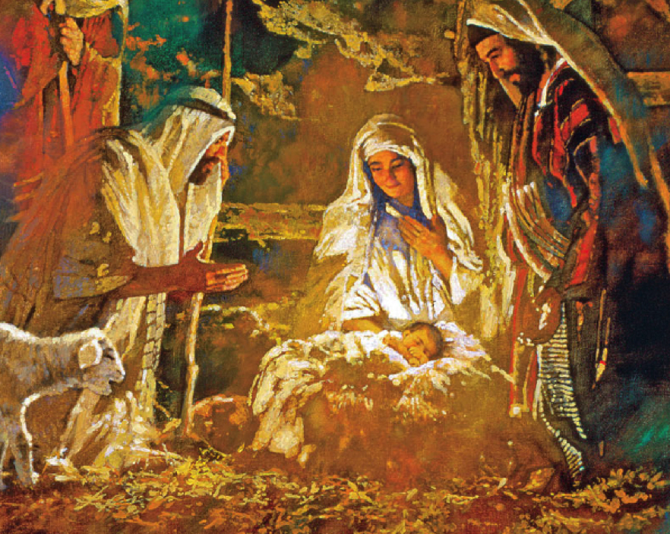
Let us bring him silver and gold (x2)
Said the king to the people everywhere
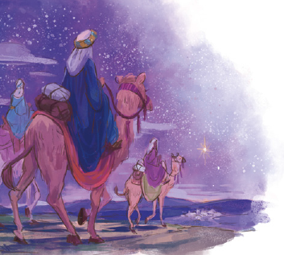
Listen to what I say
Pray for peace people everywhere
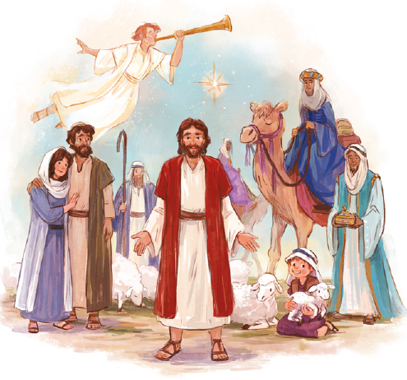
Listen to what I say
The child, the child
Sleeping in the night
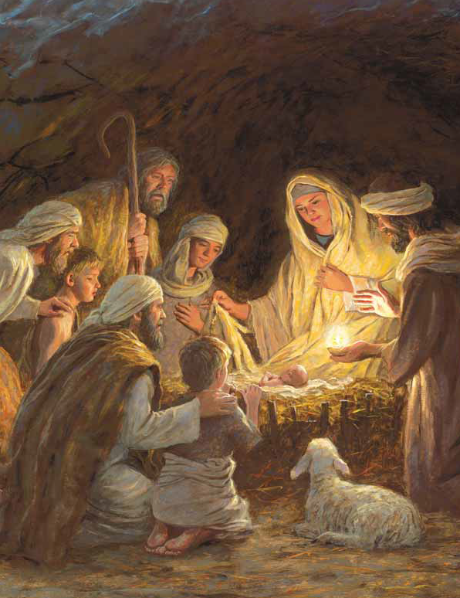
He will bring us goodness and light (X3)

