Did Jesus really live again?
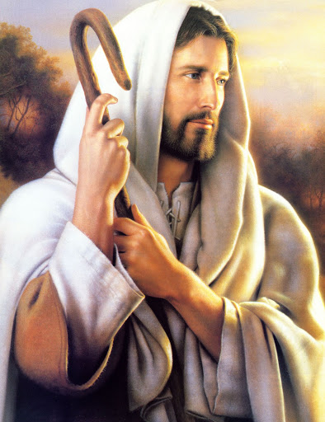
Yes, when the third day came
He wakened and he left the tomb
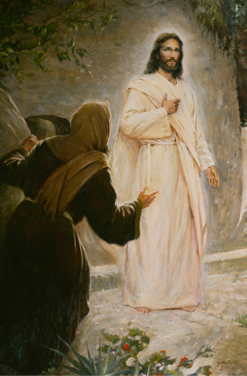
He called Mary's name
Did Jesus come to those he loved?
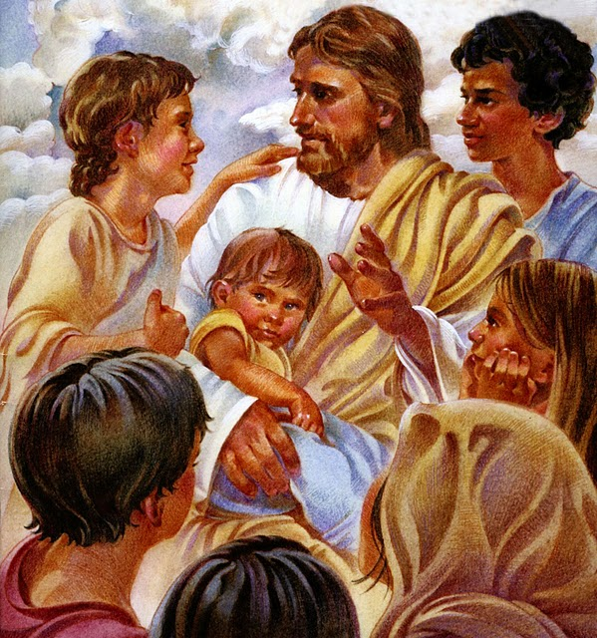
Yes, people touched his feet
And of the fish and honeycomb
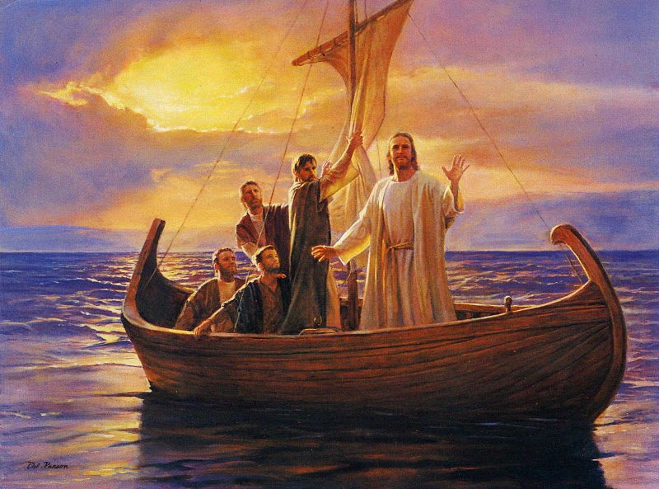
He did truly eat
And there were nail-prints in his hands
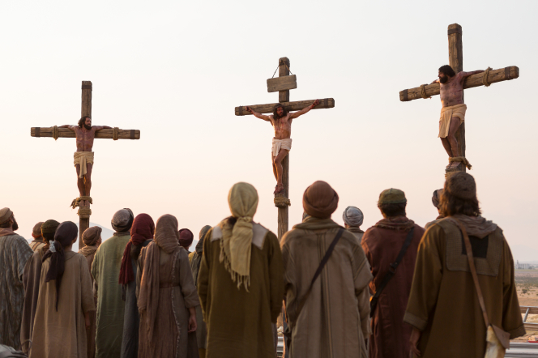
And a spear wound in his side
Did Jesus really live again
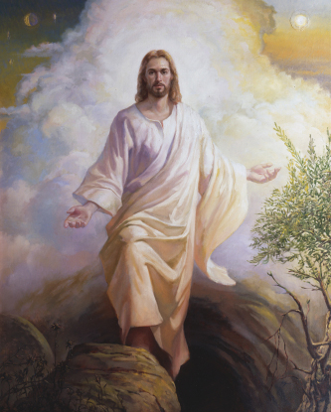
After he had died?
Oh yes!
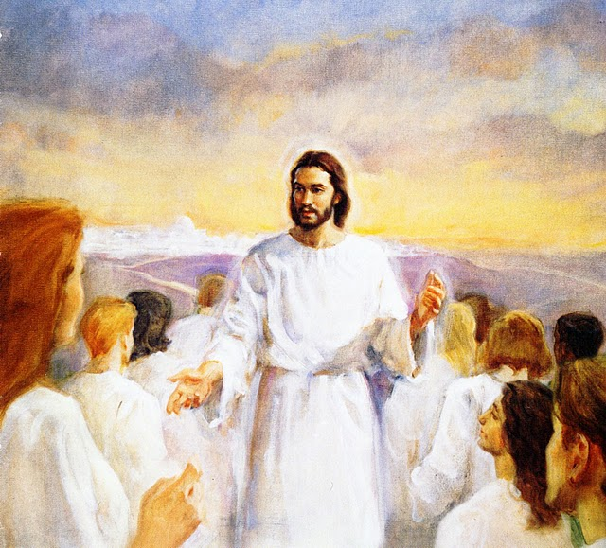
And so shall I!

