Dear to the heart of the Shepherd
Dear are the sheep of his fold
Dear is the love that he gives them
Dearer than silver or gold
Dear to the heart of the Shepherd
Dear are his "other" lost sheep
Over the mountains he follows
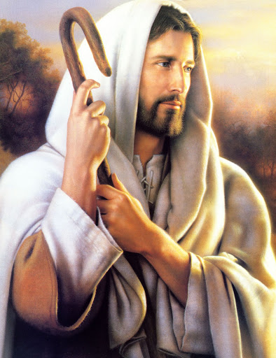
Over the waters so deep
Out in the desert they wander
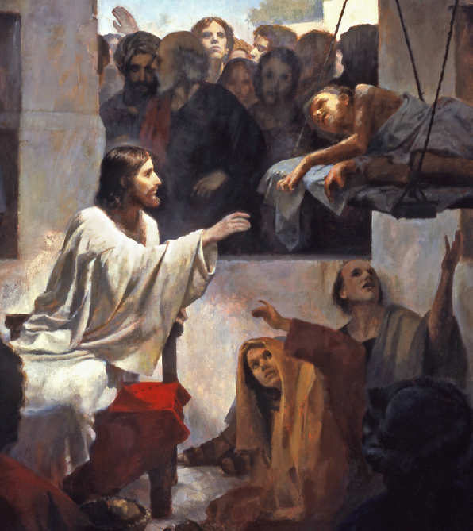
Hungry and helpless and cold
Off to the rescue he hastens
Bringing them back to the fold
Dear to the heart of the Shepherd
Dear are the lambs of his fold
Some from the pastures are straying
Hungry and helpless and cold
See the Good Shepherd is seeking
Seeking the lambs that are lost
Bringing them in with rejoicing
Saved at such infinite cost
Dear to the heart of the Shepherd
Dear are the "ninety and nine"
Dear are the sheep that have wandered
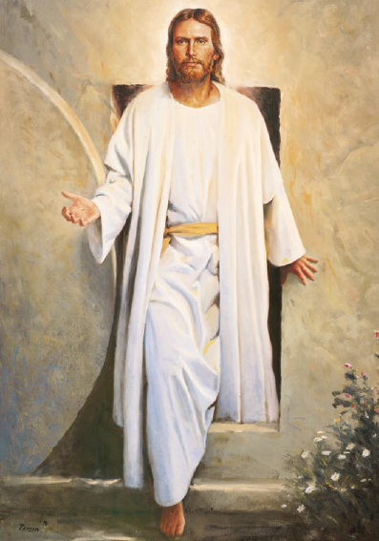
Out in the desert to pine
Hark! he is earnestly calling
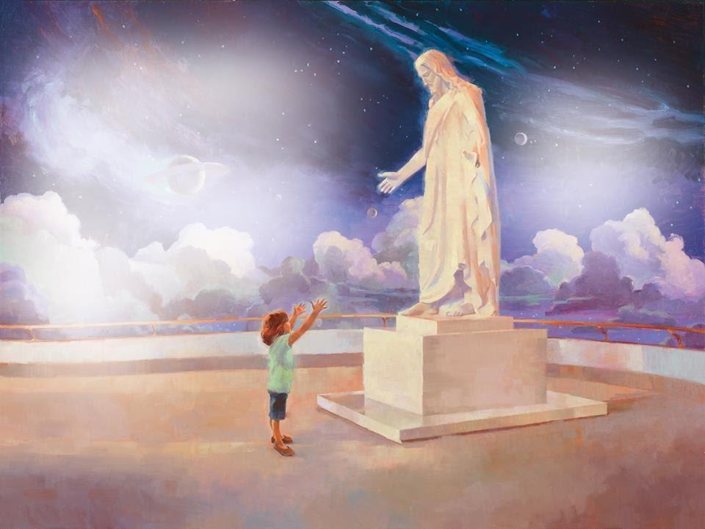
Tenderly pleading today:
"Will you not seek for my lost ones
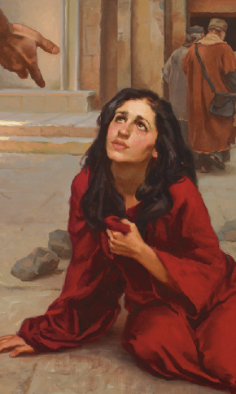
Off from my shelter astray?"
Green are the pastures inviting
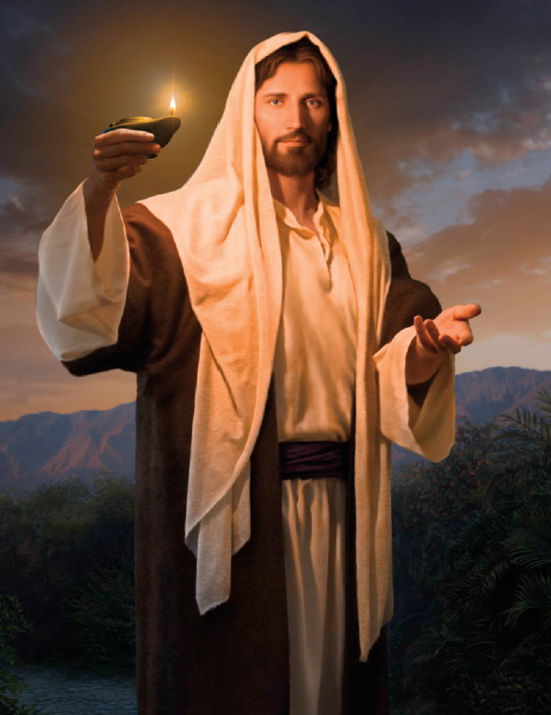
Sweet are the waters and still
Lord we will answer thee gladly
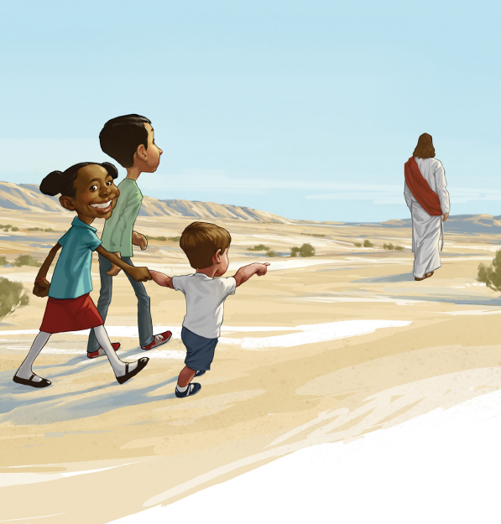
"Yes blessed Master we will!
Make us thy true under-shepherds
Give us a love that is deep
Send us out into the desert
Seeking thy wandering sheep"

