O let us go
the shepherds said
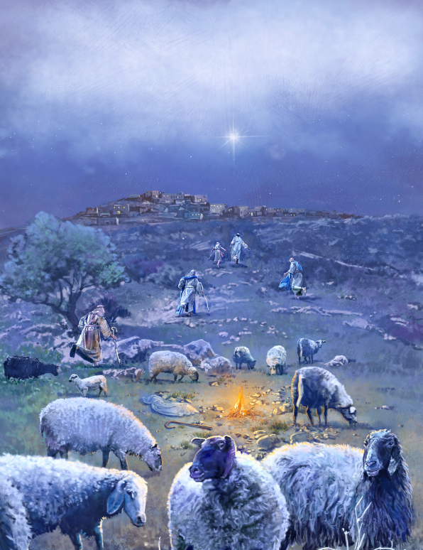
To Bethlehem
to Bethlehem
The Child is born the Christ is come
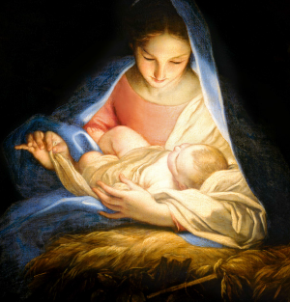
O let us go
And worship Him
To Bethlehem
to Bethlehem
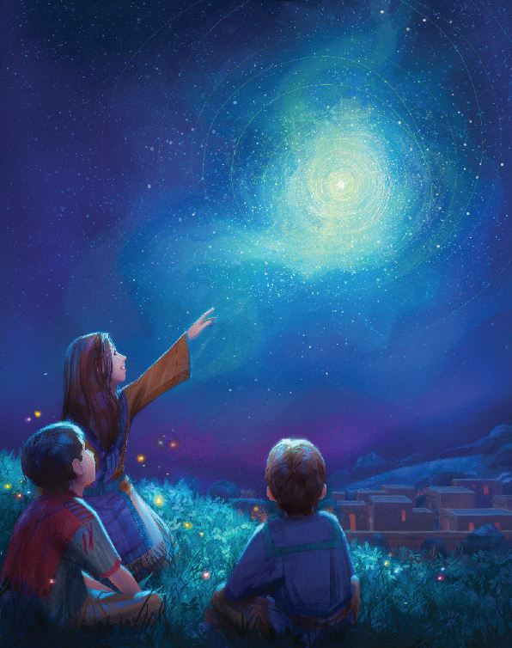
The Child is born the Christ is come
To Bethlehem
to Bethlehem
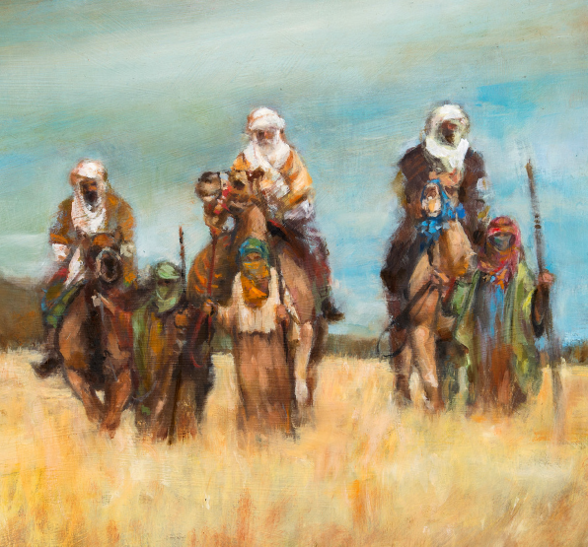
Now let us come and worship Him
O let us come all men today
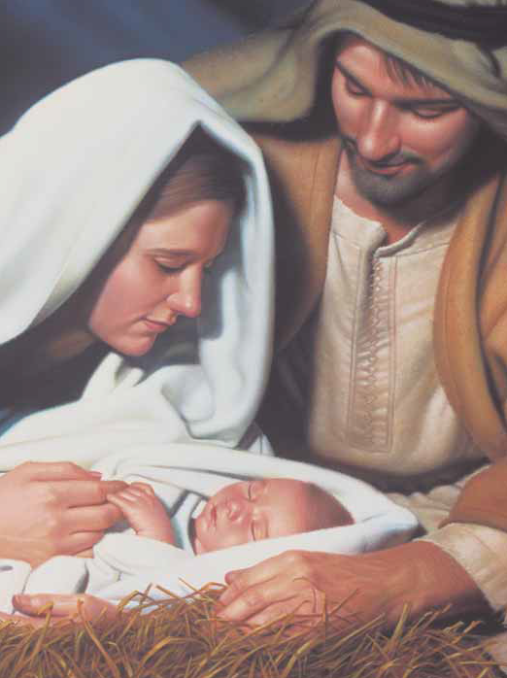
To worship Jesus Lord and King
To bring the Babe of Bethlehem
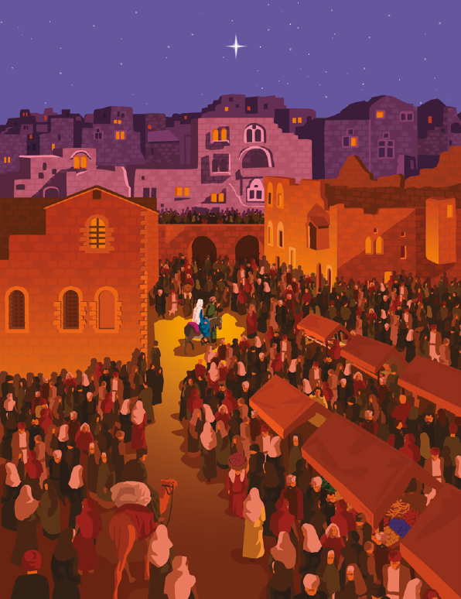
Our faith, our love, our songs to sing
O let us come
let each one come
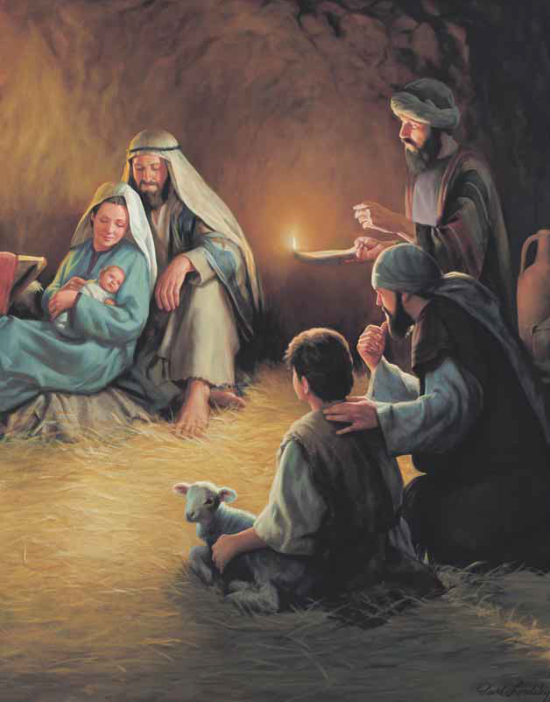
To Jesus Christ to worship Him
For then will heaven come to earth
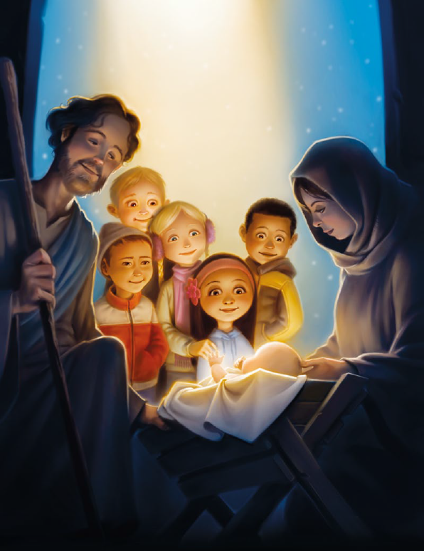
And crown the Babe of Bethlehem

