Come Worship the King

By
Sandra L. Govin

In a place called Bethlehem
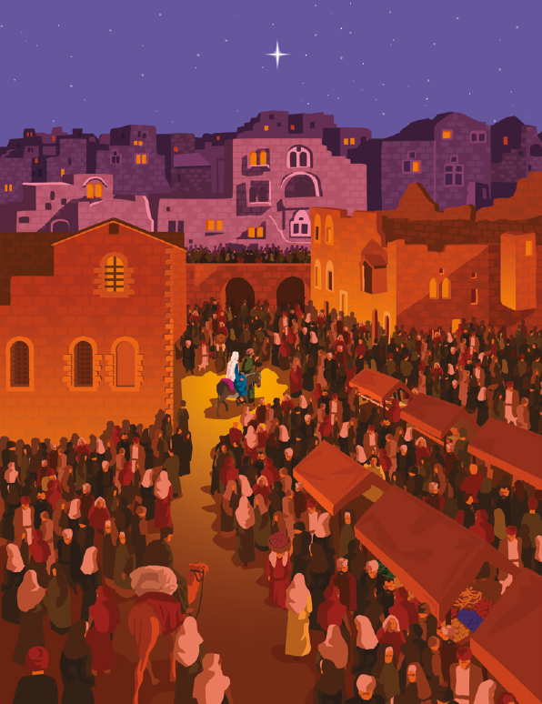
In a time some time ago
Mary rocked her infant son
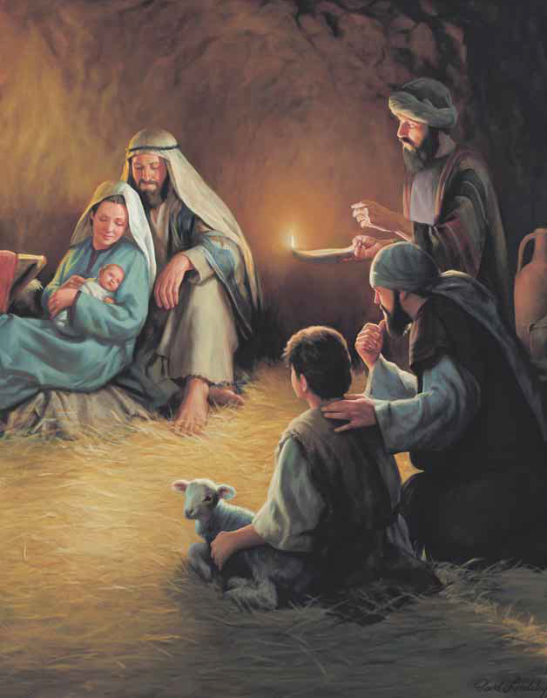
Singing songs so soft and low
Words of comfort, love and peace
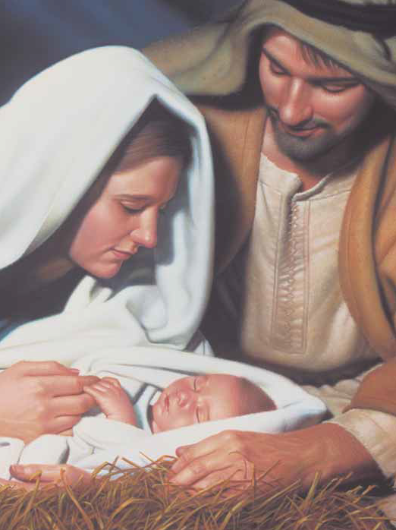
Father’s love beyond compare
To the earth He sent his Son
Ever radiant and rare
For Him all the heavens did shout for joy!
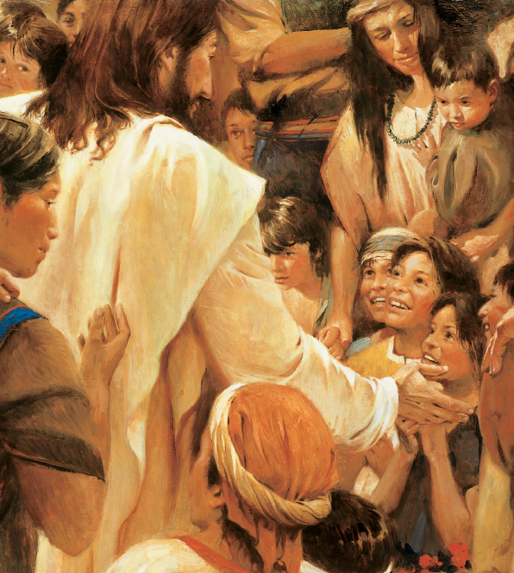
For Him all creation did sing!
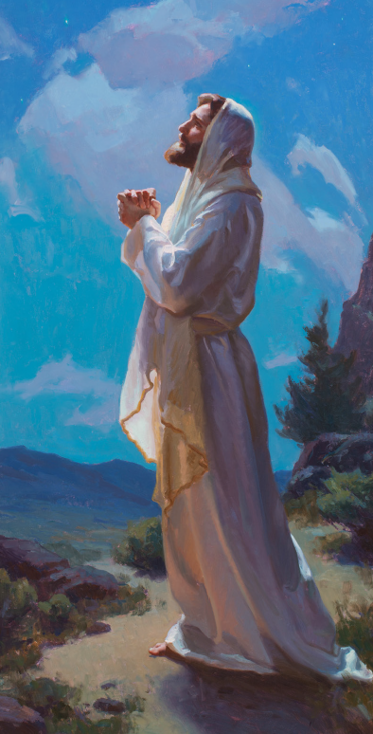
Through Him sweet redemption at last has come
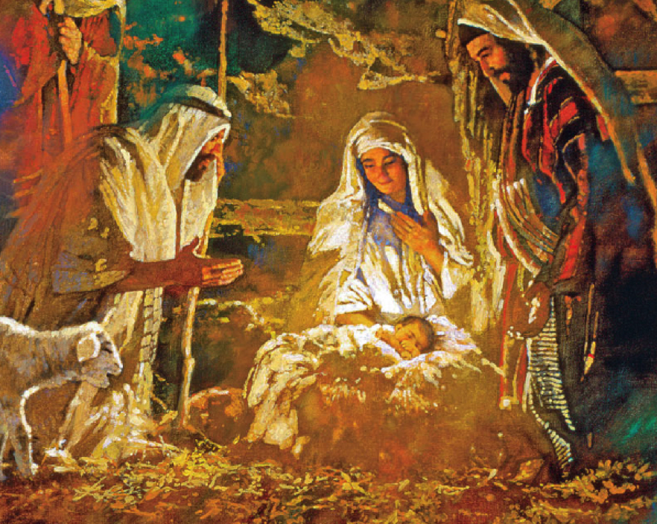
Alleluia come worship our King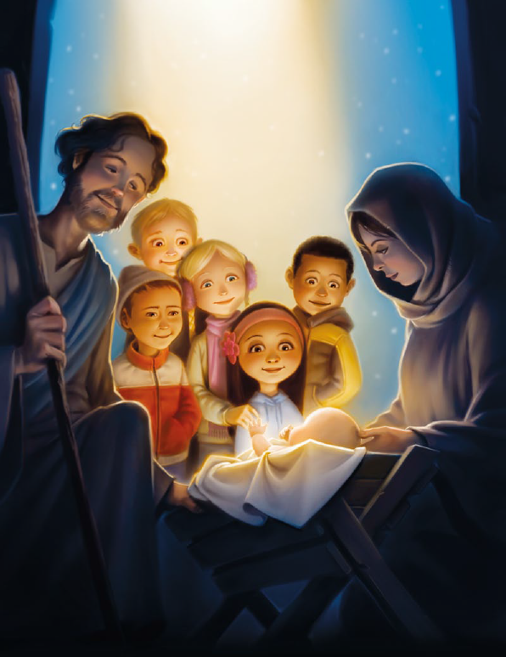
In the sky was placed a star
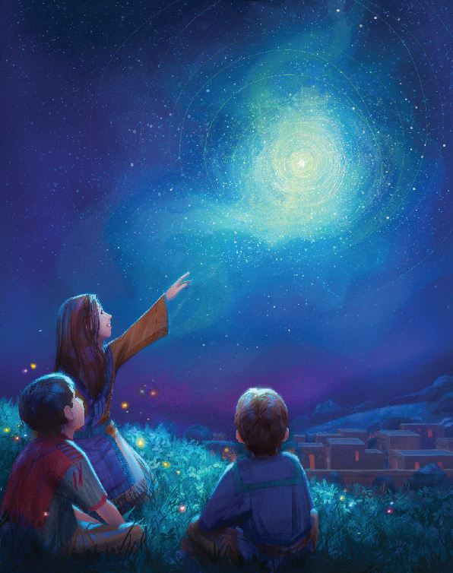
Angels robed in golden light
Joyous sang the news of hope
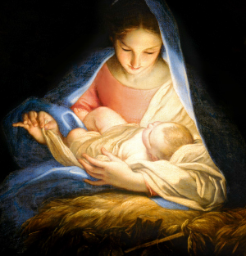
On that very sacred night
Shepherds watchful of their flocks
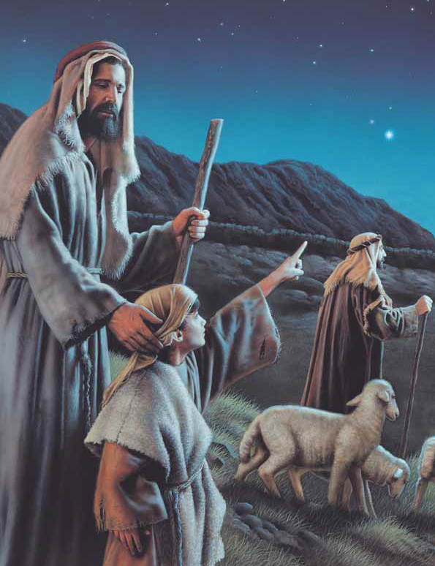
Were the first to hear the praise
And they quickly sought the place
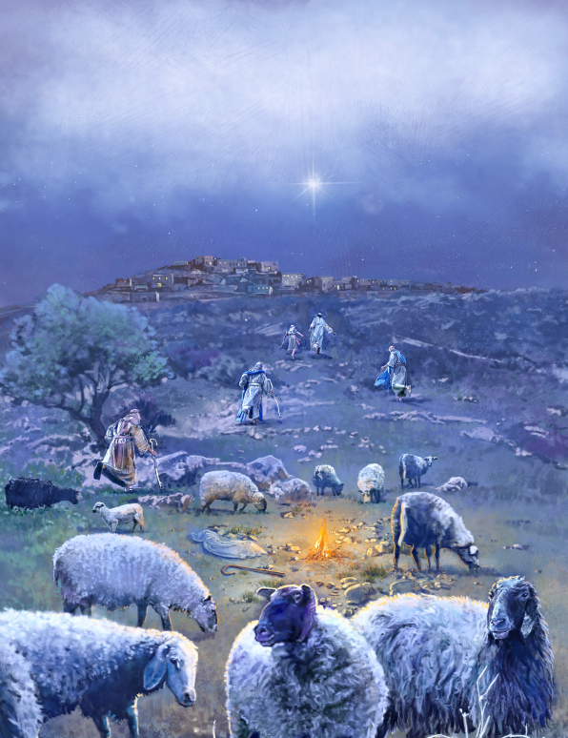
Where the tiny Savior laid
Gentle Joseph, Mary mild,
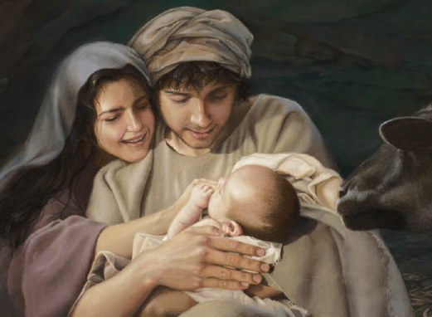
Humble people
Holy Child
On that dark and chilly night
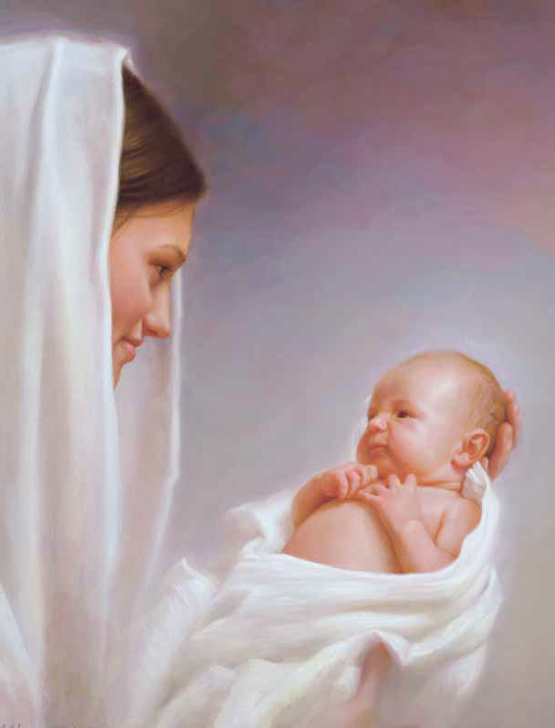
Came God’s Gift of truth and light
Born the Savior
Jesus Christ
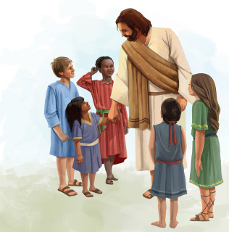
Follow Him and stand for right

