He's the One who healed the leper
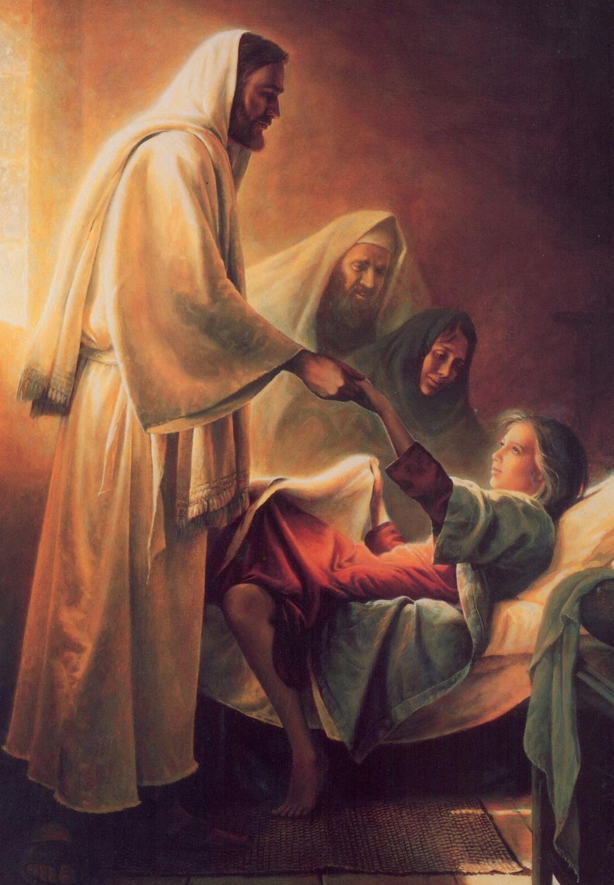
And who brought the dead to life
He's the One who fed the hungry
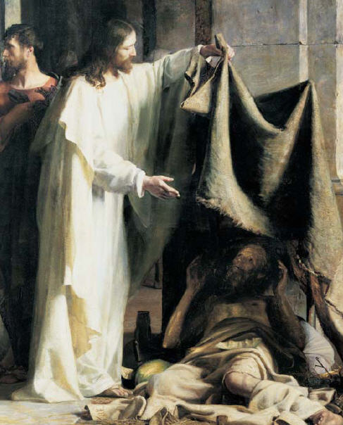
And gave the blind their sight
He's the One who walked on water
And He brought the saved to shore
And if ever you may need Him
He's the One your looking for
So let Him in
and He will take away your pain
Once you feel His love
You'll never be the same
Come unto Christ Come unto Him
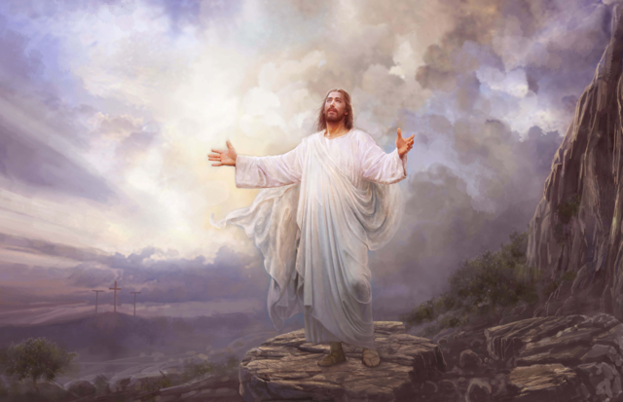
And by His grace be made holy again
He's calling your name
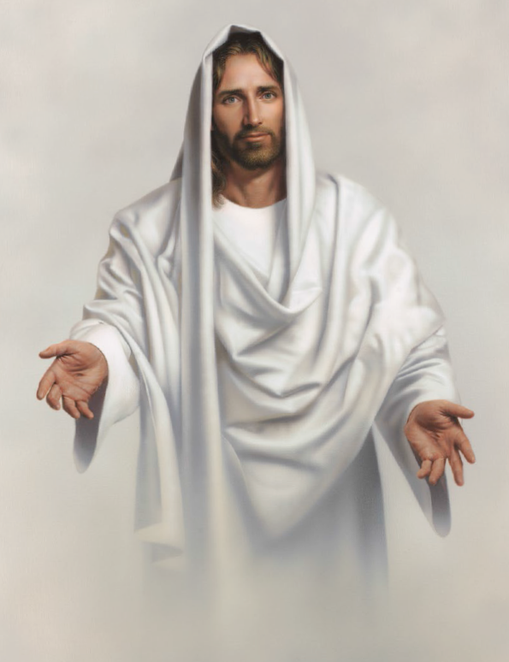
He's waiting for you
With arms open wide
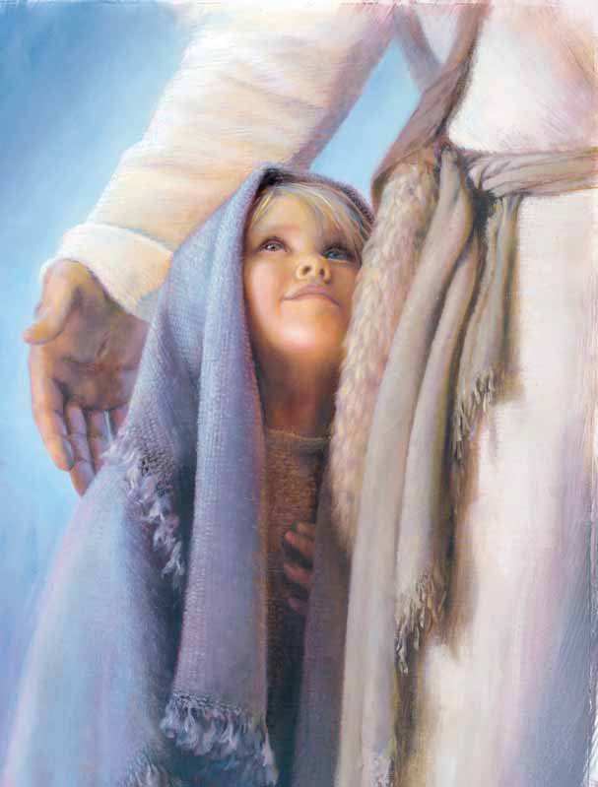
Come unto Christ
He's the One who taught forgiveness
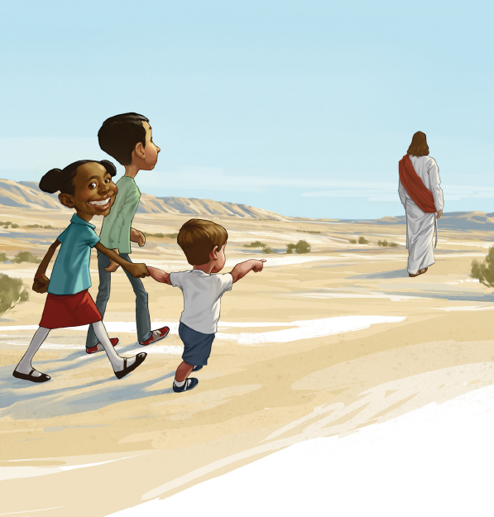
And who showed a better way
He's the one who helped the hopeless
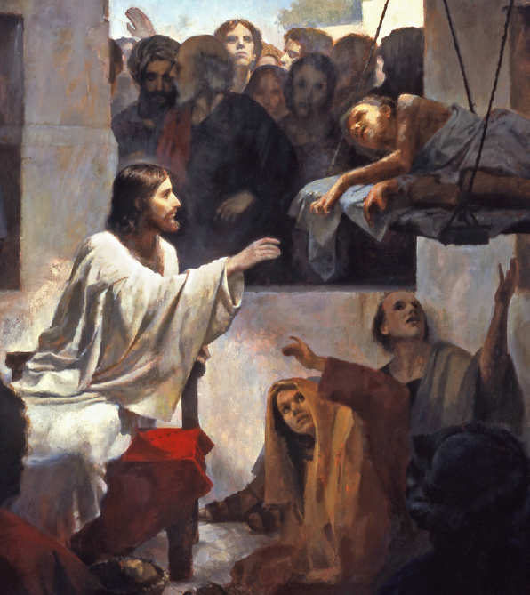
And those who've gone astray
He's the Savior and Redeemer
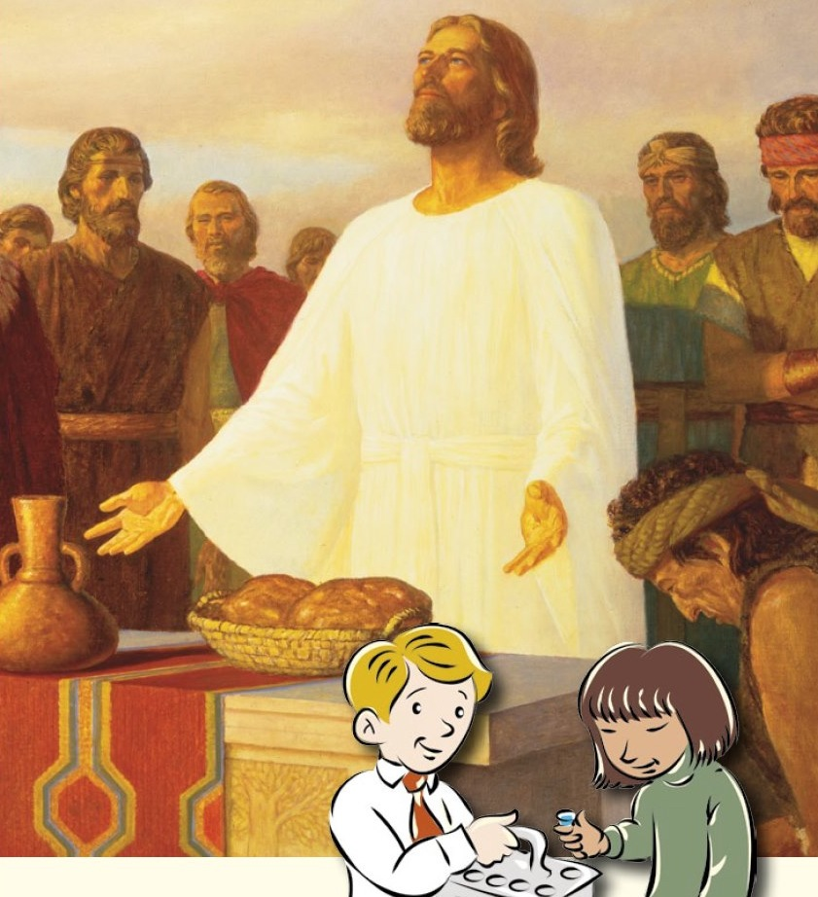
Bread of Life, the Prince of Peace
If you're hungry, lost or captive
He's the one who'll set you free
So let Him in
and remember who you are
He will mold your life
and change your willing heart
Come unto Christ, Come unto Him
And by His grace be made holy again
He's calling your name,
He's waiting for you
With arms open wide
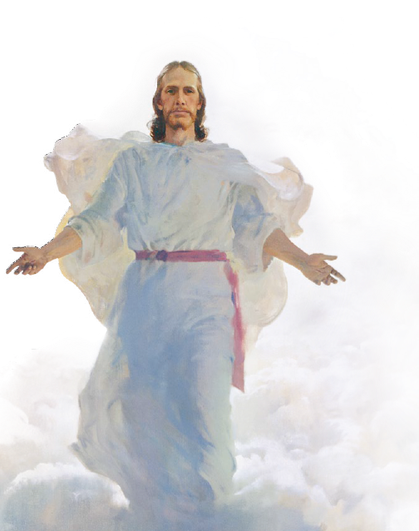
Come unto Christ
And you will find eternal life
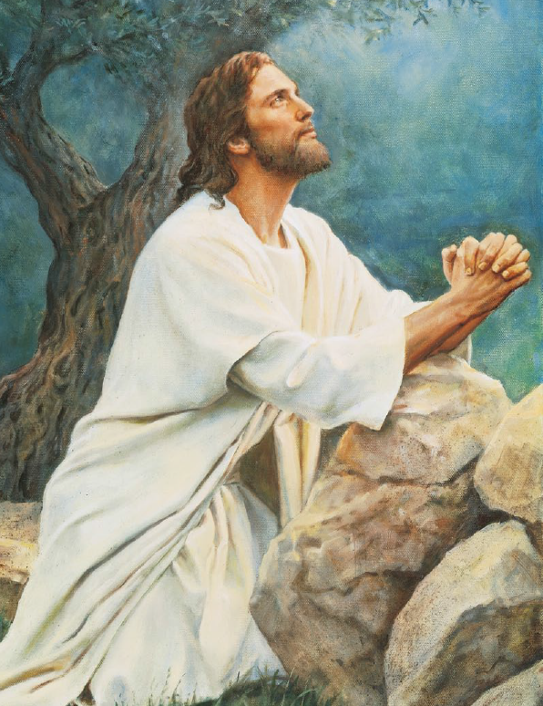
Come unto Christ
Come unto Him
And by His grace
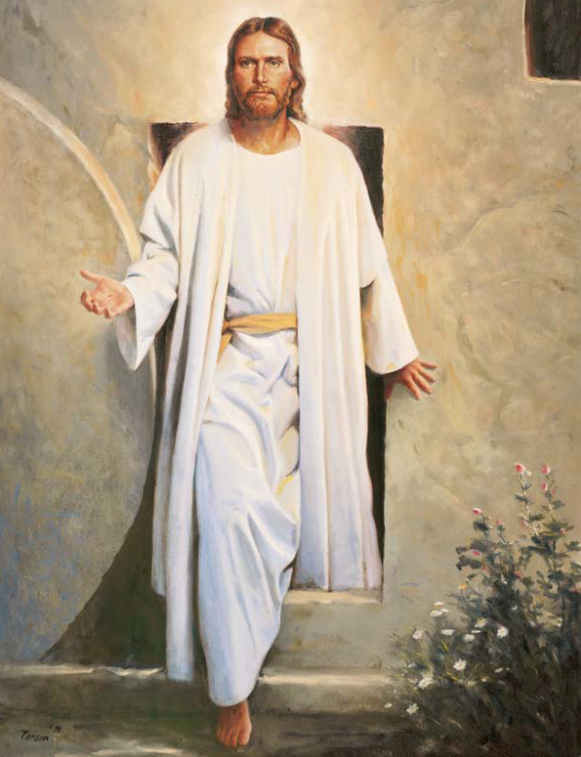
Be made holy again
He's calling your name
He's waiting for you
With arms open wide
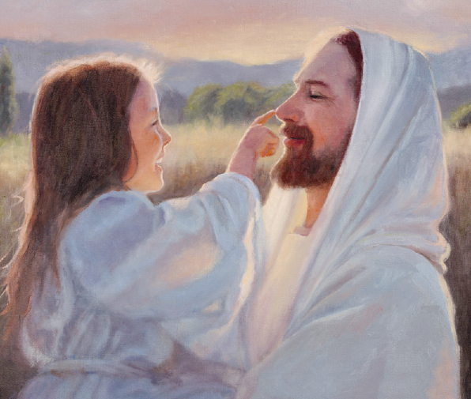
Come unto Christ

