Come, Lord Jesus, to the manger

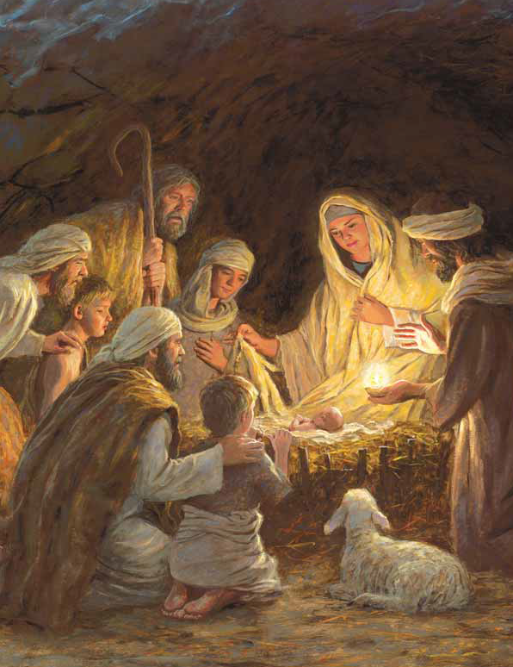

May we see Thy tender face—

Great Creator, here a stranger



Infant in this humble place

Darkness scatter; morning swell

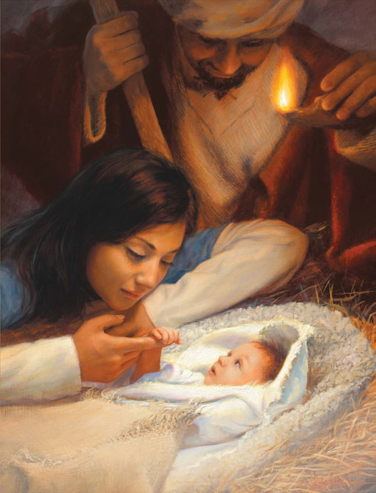

Come, dear Lord Immanuel

Come, Lord Jesus, to the manger

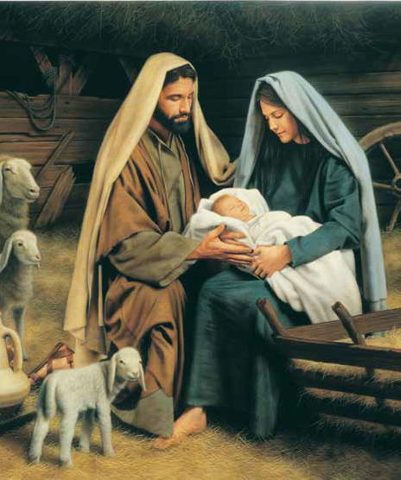

Come, Lord Jesus, come!

Come, Lord Jesus, to the wounded—

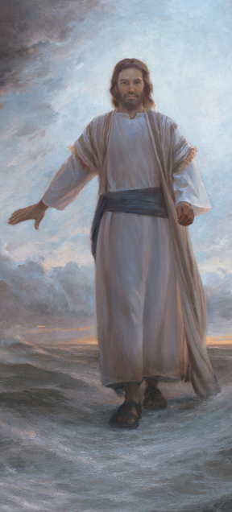

Broken heart and bended knee

Worthy Lamb, Thy love unbounded

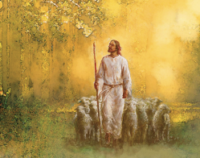

Bid our souls to rest in Thee

Grant us mercy, Savior, King

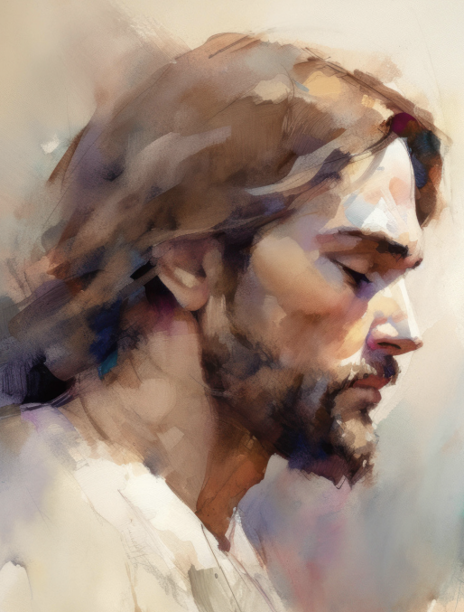

Come with healing in Thy wings

Come, Lord Jesus, to the wounded

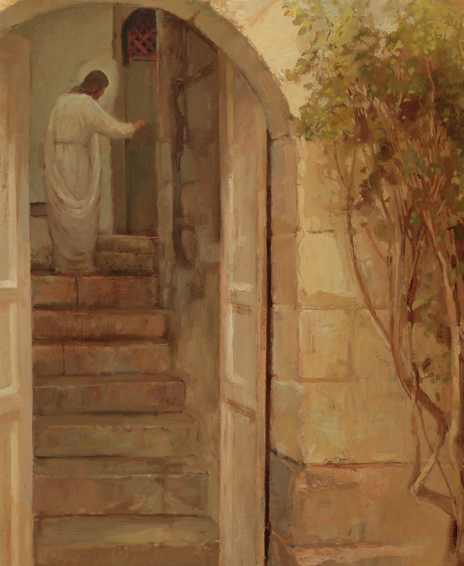

Come, Lord Jesus, come!

Come, Lord Jesus, great Redeemer

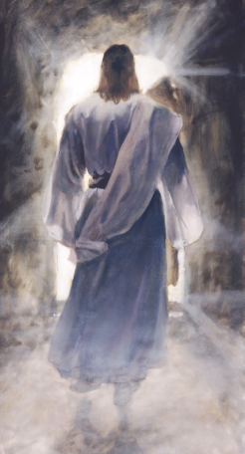

Light of Morning, Prince of Peace

We will be Thy children ever

Dry our tears; may weeping cease

Come in glory; come again

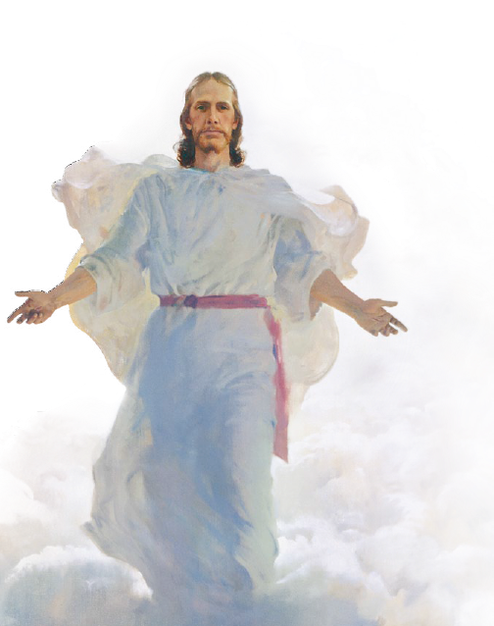

Come to us to rule and reign

Ready us to kneel and greet Thee

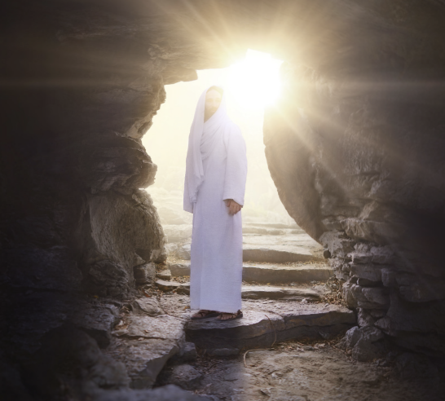

Come, Lord Jesus, come!