Come Lord Jesus to the manger
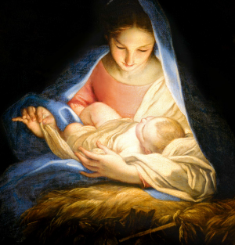
May we see thy tender face?
Great Creator here a stranger
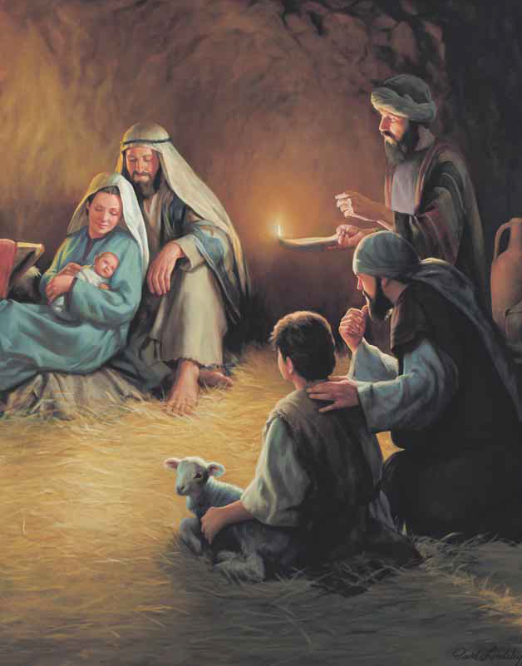
Infant in this humble place
Darkness scatter morning sweet
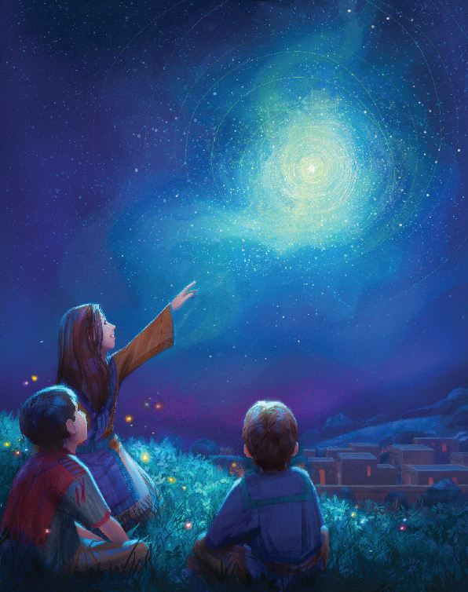
Come dear Lord Immanuel
Come Lord Jesus to the manger
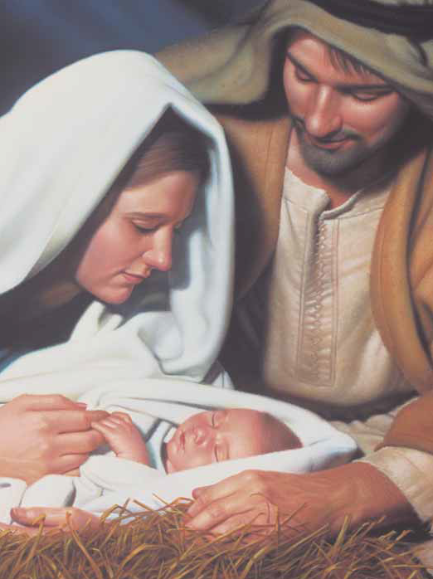
Come Lord Jesus come!
Come Lord Jesus to the wounded
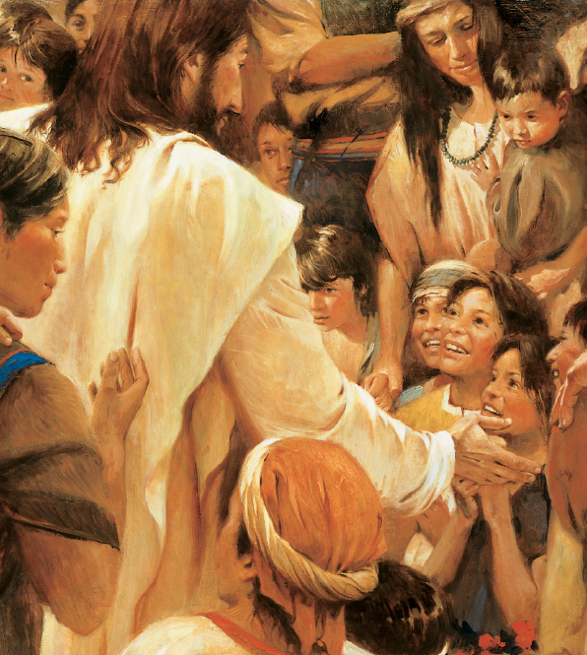
Broken heart and bended knee
Worthy Lamb, Thy love unbounded
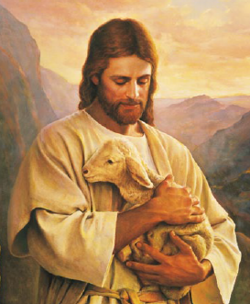
Bid our souls to rest in Thee
Come in glory to the earth
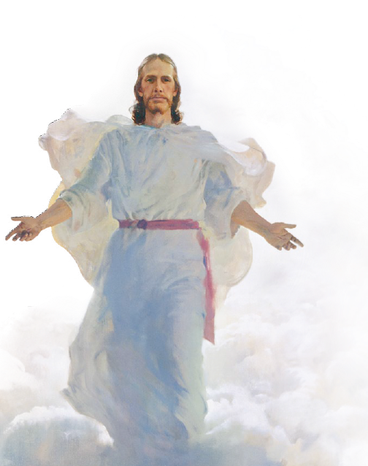
Come to us to rule and reign
Ready us to kneel and greet thee
Come Lord Jesus come
Come Lord Jesus great Redeemer
Light of morning from the East
We will be Thy children ever
Dry our tears all weeping cease
Come in glory to the earth
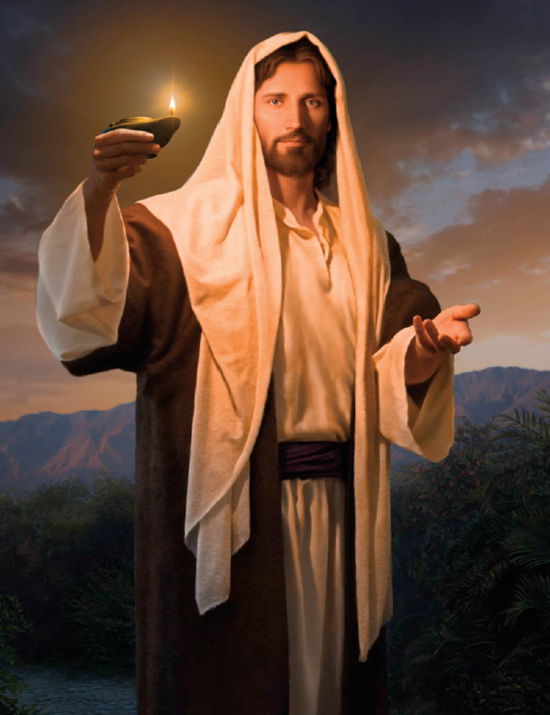
Come to us to rule and reign
Ready us to kneel and greet thee
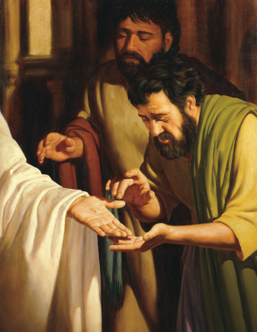
Come Lord Jesus come

