Come, listen to a prophet’s voice
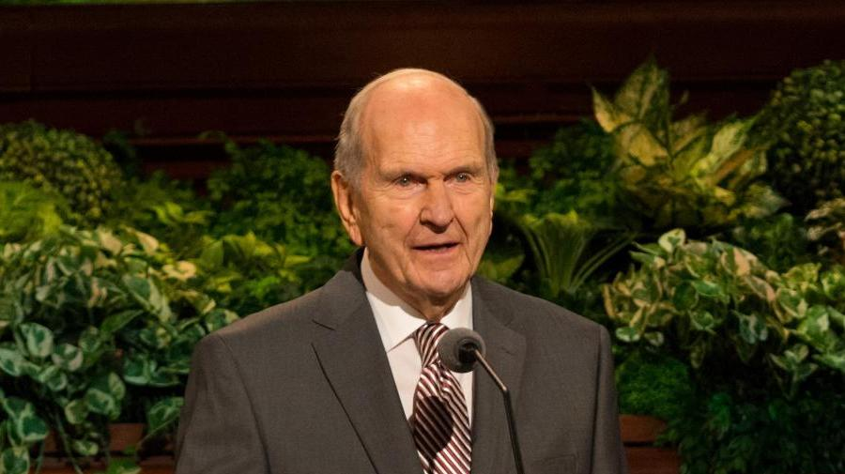
And hear the word of God
And in the way of truth rejoice
And sing for joy aloud
We’ve found the way the prophets went
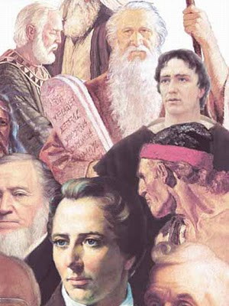
Who lived in days of yore
Another prophet now is sent
This knowledge to restore
The gloom of sullen darkness spread
Thru earth’s extended space
Is banished by our living Head
And God has shown his face
Thru erring schemes in days now past
The world has gone astray
Yet Saints of God have found at last
The straight and narrow way
’Tis not in man they put their trust
Nor on his arm rely
Full well assured all are accursed
Who Jesus Christ deny
The Savior to his people saith
“Let all my words obey,
And signs shall follow living faith,
Down to the latest day.”
Then heed the words of truth and light
That flow from fountains pure
Yea, keep His law with all thy might
Till thine election’s sure
Till thou shalt hear the holy voice
Assure eternal reign
While joy and cheer attend thy choice
As one who shall obtain

