Moment by moment
by night or by day
My Heavenly Father
is not far away
And He will be near
When I whisper His name
He is close as a quiet prayer
Close as a quiet prayer
I can pray to my Father above
Anytime, anywhere
When I call He will always be
Close as a quiet prayer
Close as a quiet prayer
When I am thankful
For blessings He sends
He smiles as I offer

My praises to Him

And when I’m alone
and in need of a friend
He is close as a quiet prayer
Close as a quiet prayer
Whether I’m kneeling
To seek Him with words
Or silently praying
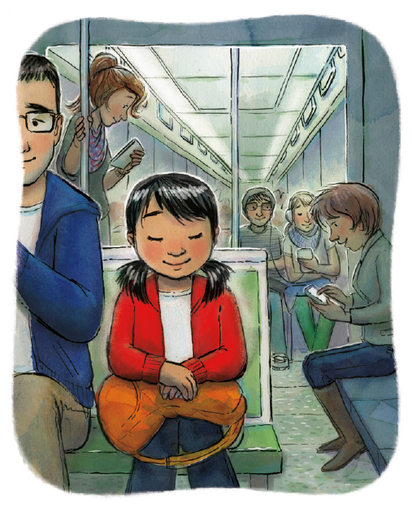
My heart will be heard
His love will enfold me
His promise is sure
He is close as a quiet prayer
Close as a quiet prayer

