Choose Him Again

By Shawna Edwards

Access the Sheet Music at
http://shawnaedwardsmusic.com/collections/choose-him-again
Before we came here we all lived in heaven
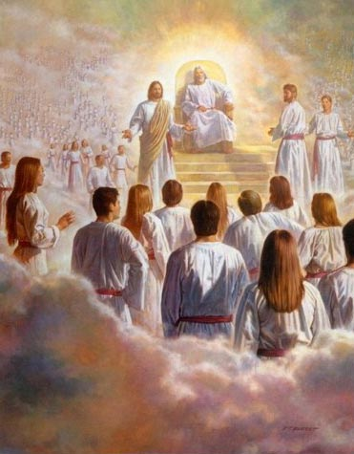
With Heav’nly Father and Jesus His Son
It’s where they taught us
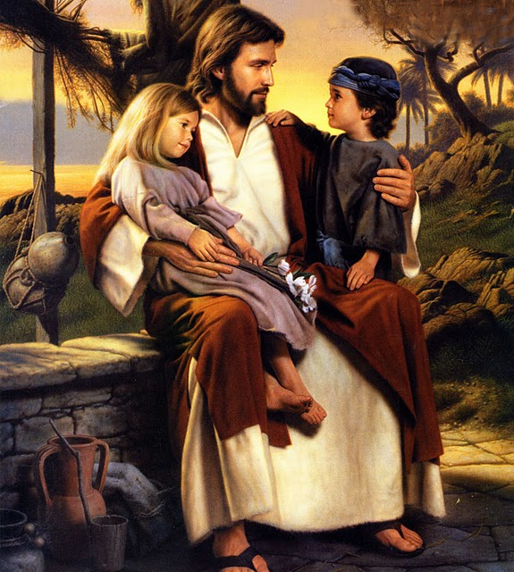
To choose good from evil
To be prepared
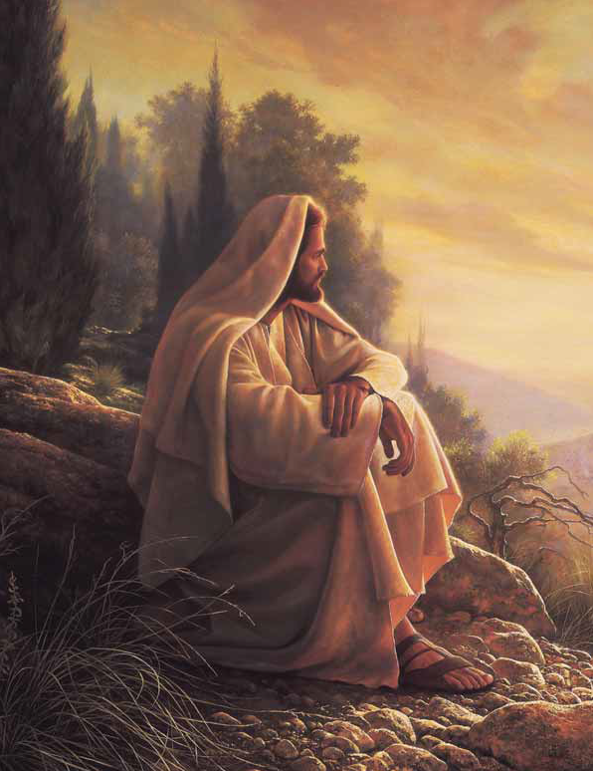
For the battle to come
For Satan tried to destroy us forever
To make us turn from the things we were taught
But nothing could keep us from choosing Jesus
For we loved the plan of God
And we will choose Him again
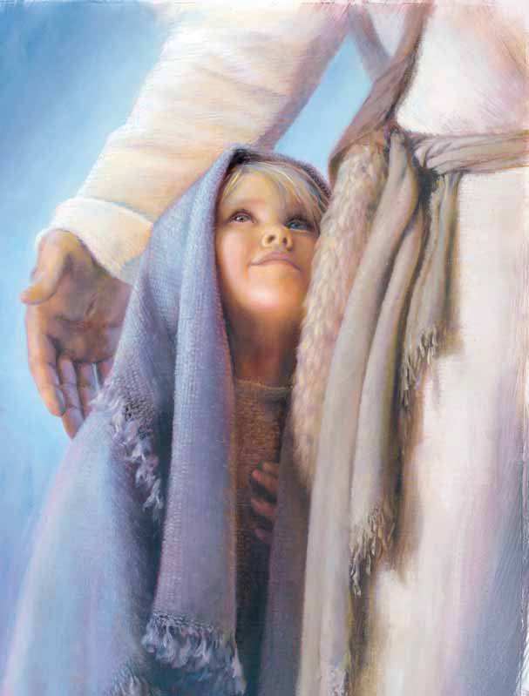
For He’s our Savior and friend
He’ll help
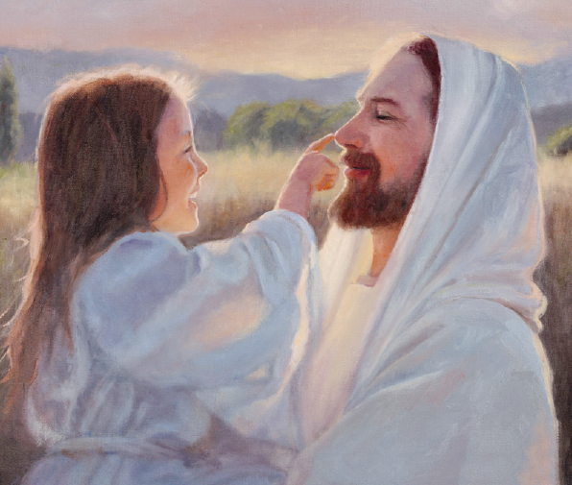
And guide us each day
And He will show us the way
To be the best us we possibly can
Oh we will choose Him
We will choose Him again
And now we’re on earth
To prove we’ll be faithful
Keep His commandments
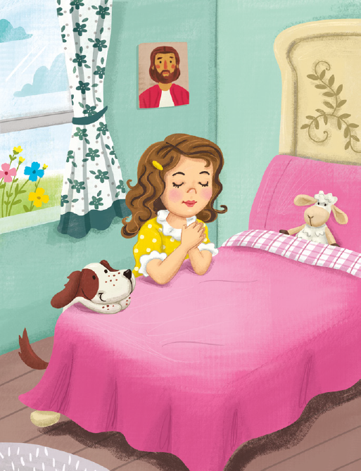
And follow His ways
For we’re still fighting for good over evil
Not with a sword but with courage and faith
And we will rise up
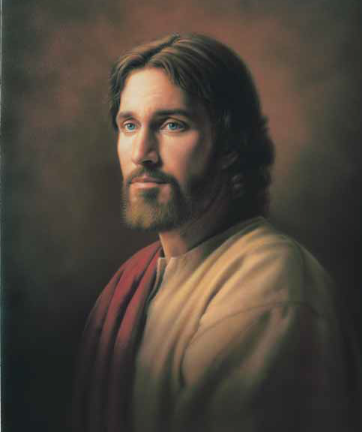
And stand with our Savior
Forever true to the things
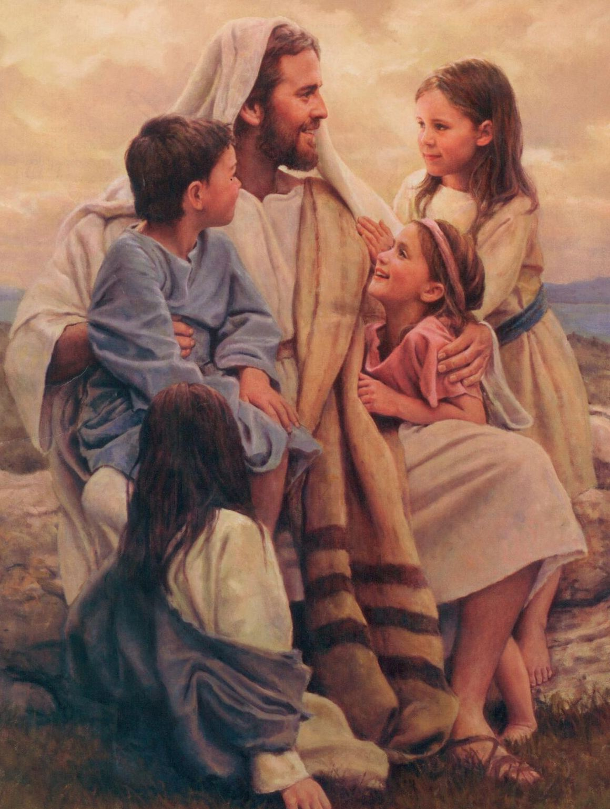
We’ve been taught
And nothing can keep us from choosing Jesus
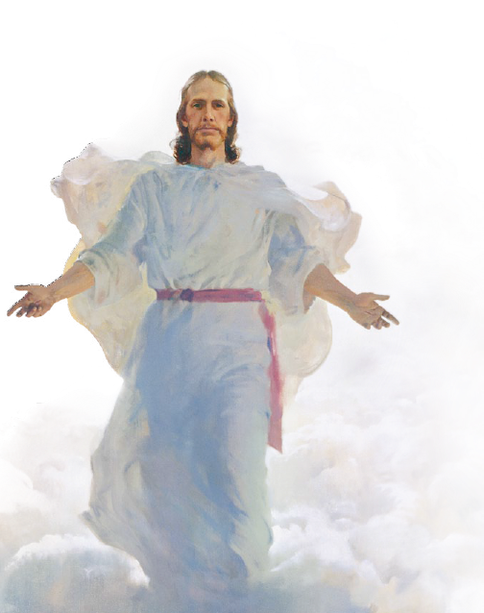
For we love the plan of God
And we will choose Him again
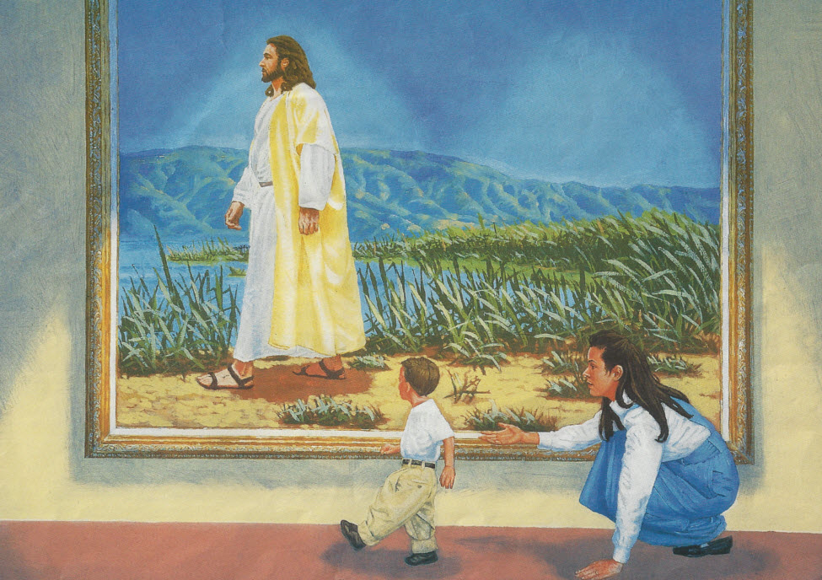
For He’s our Savior and friend
He’ll help
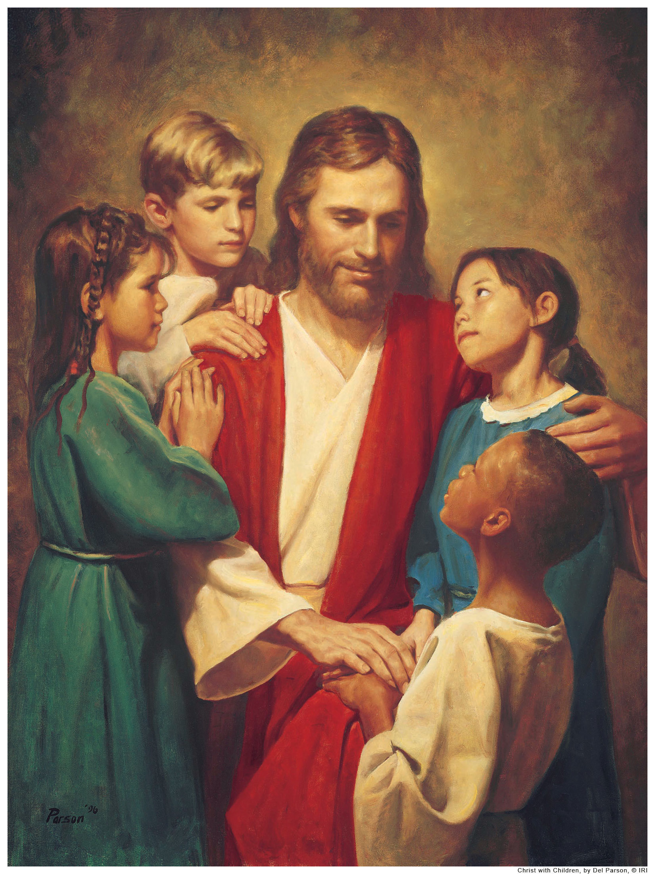
And guide us each day
And He will show us the way
To be the best us we possibly can
Oh we will choose Him
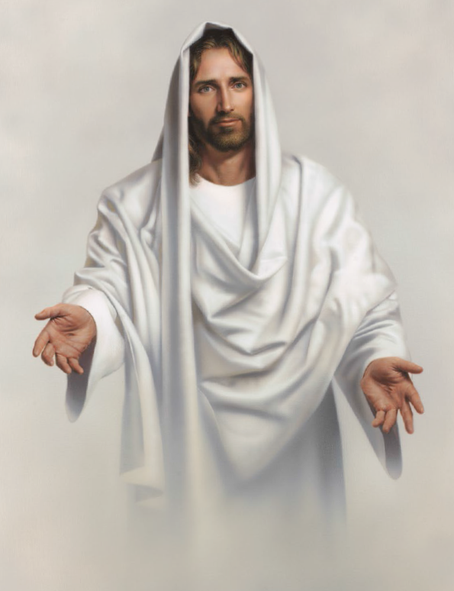
We will choose Him again
We will choose him again
