Baby Jesus sleeps in a manger
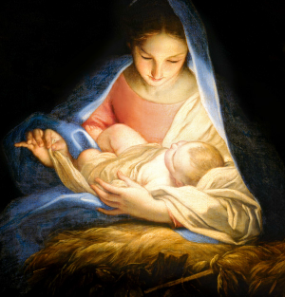
His mother holds Him in her gentle arms
Could He really be
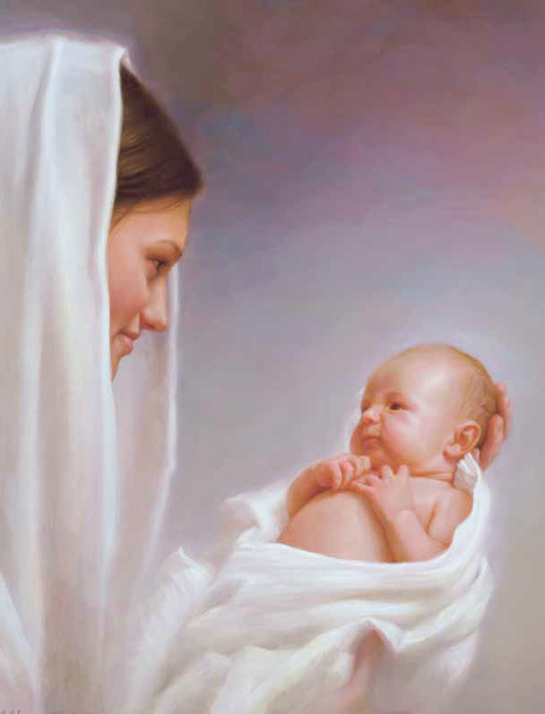
Called the Son of God?
This baby here is born to be a king
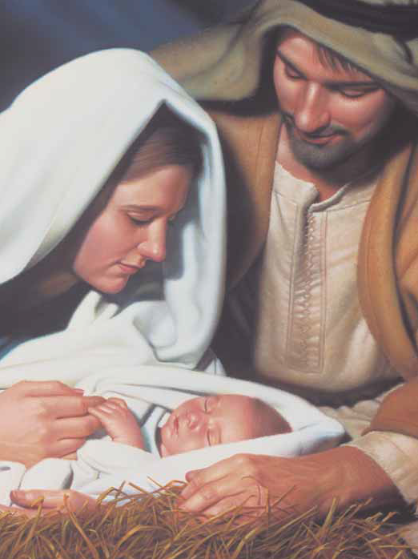
Hallelujah the angels sing His name
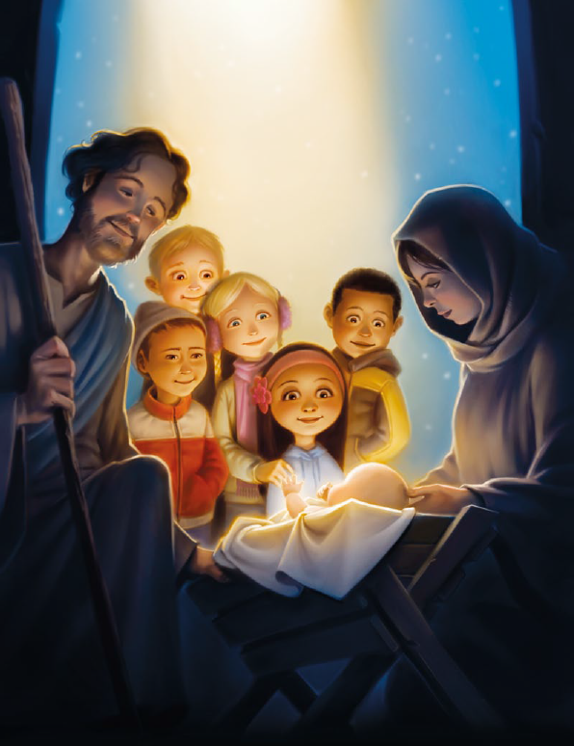
For unto us is born a king this day
Bells are ringing
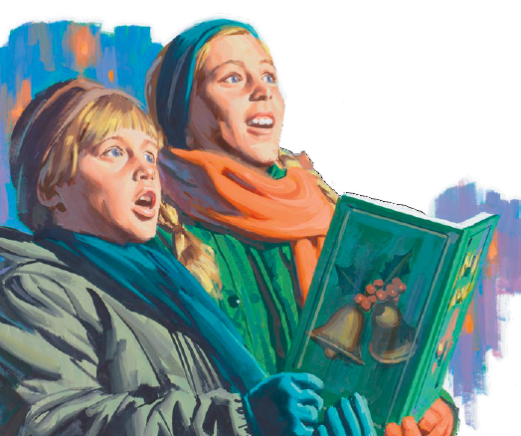
As children sing along
They sing a heavenly song
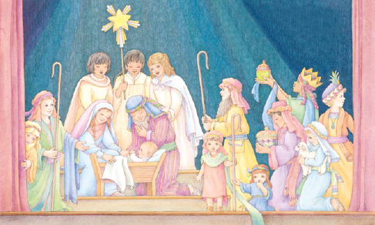
To praise His holy name
Softly, softly His mother sings to Him
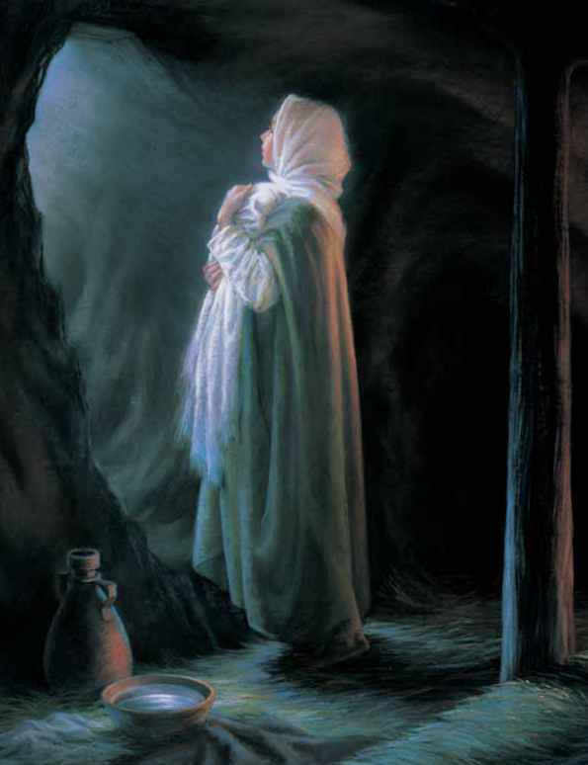
I wish I knew him all those year ago
I will praise Him
The spirit testifies
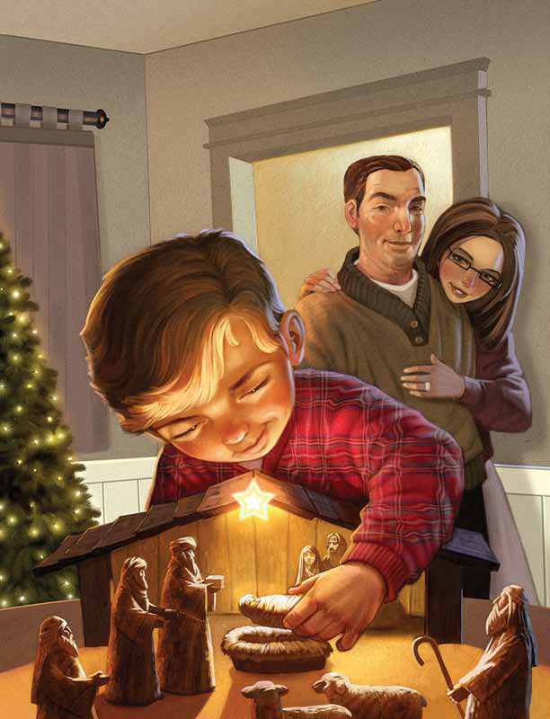
That He is Jesus Christ his only son
Hallelujah
Hallelujah
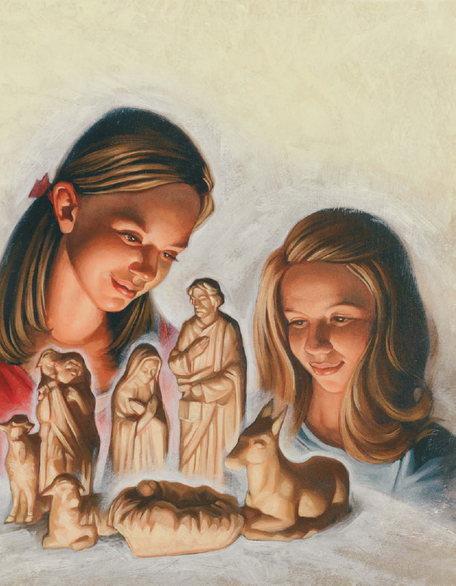
For unto us is born a King this day
Ding dong! Ding Dong! Ding Dong!
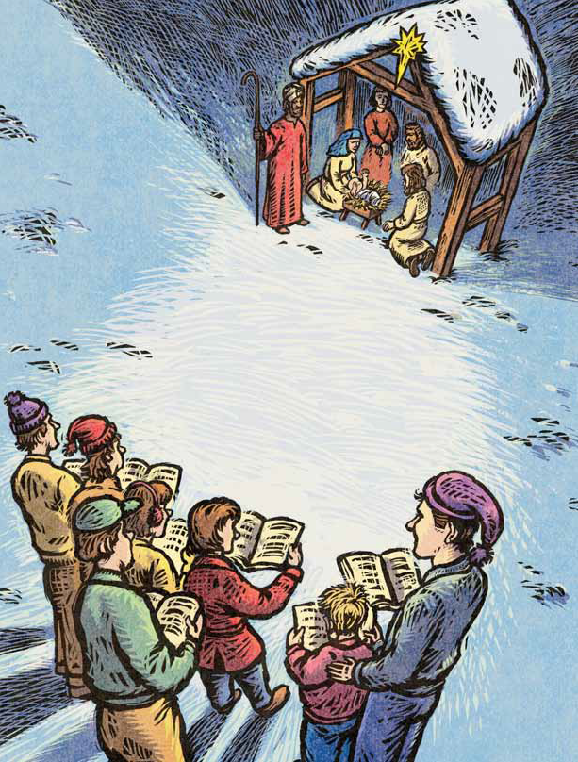
Sing along
They sing a heav’nly song
To praise His holy name

