Book of Mormon Christmas

By

Melinda Nixon Allred

Find the Free Music at

http://freeldssheetmusic.org/

The prophets of the Book of Mormon
Knew that Christ would be
A baby born in Bethlehem
In a land across the sea
They told the people they should watch
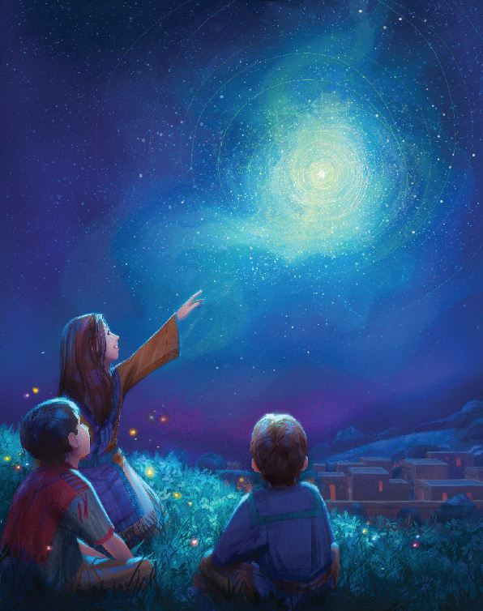
For a day, a night, and day
And baby Jesus would be born
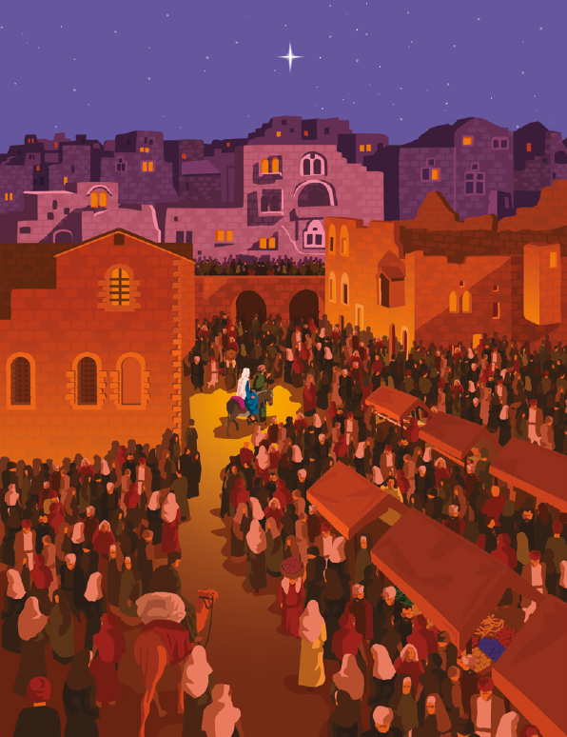
In a land far, far away
This night shall the sign be given
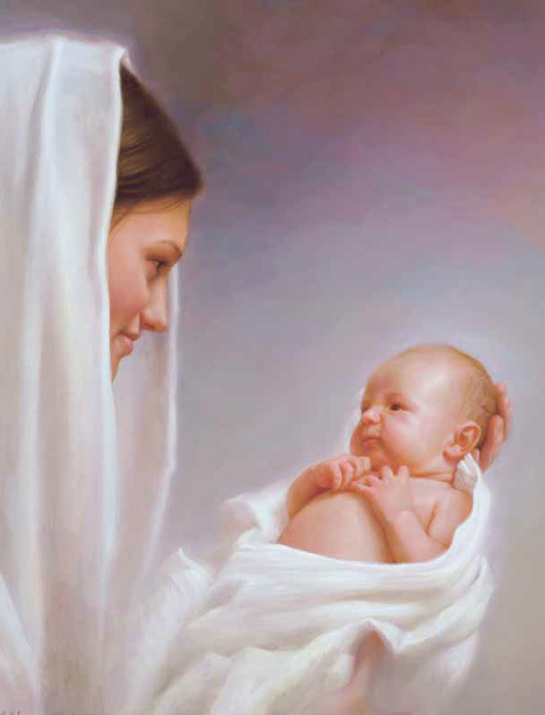
And the King of Kings shall come
As a baby in a manger
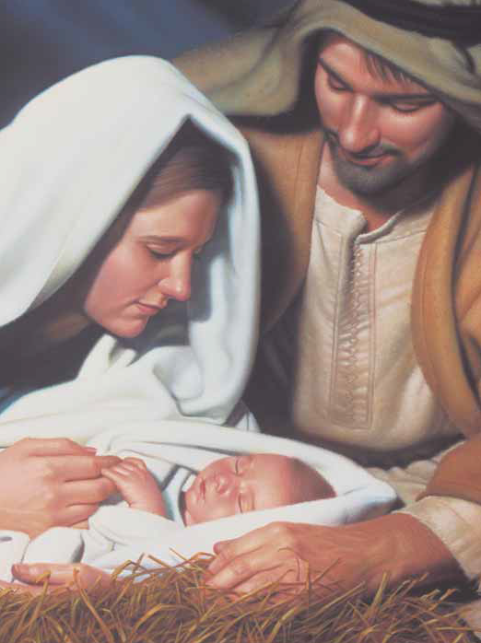
God’s own begotten son
Hallelujah and Hosannah!
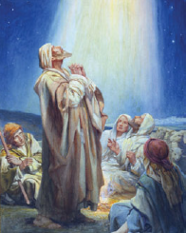
The choirs of angels sing
For on this night, a tiny child
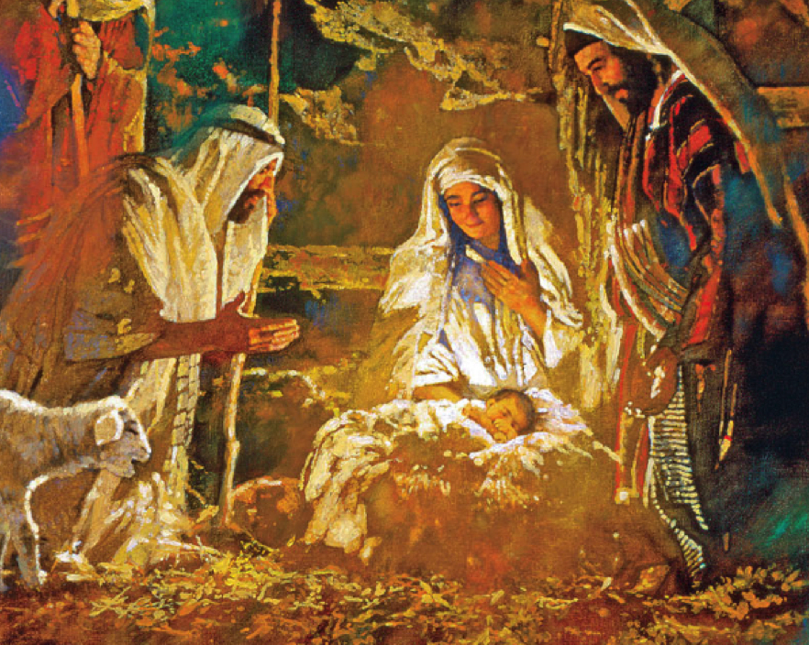
Was born to be our King
The day had come
The sun went down
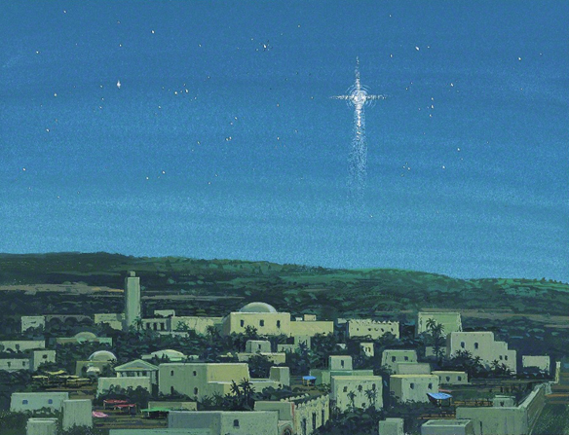
But still the sky was bright
And then the people knew that this
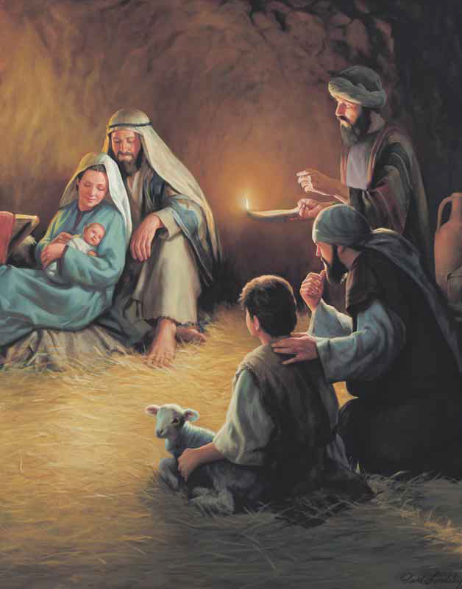
Would be the holy night
They saw the star up in the sky
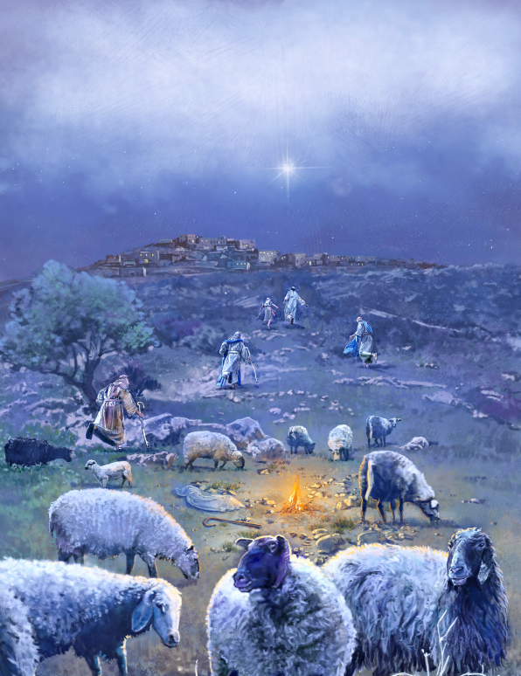
Proclaim Messiah’s birth
And they rejoiced that Christ had come
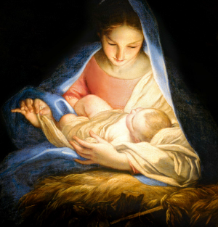
To live with men on earth

