Behold the great Redeemer die
A broken law to satisfy
He dies a sacrifice for sin
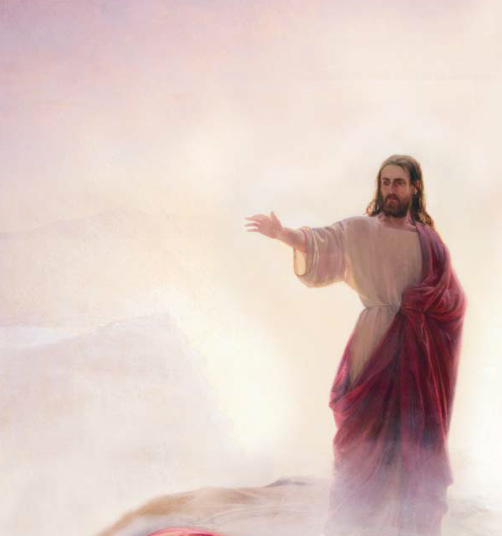
He dies a sacrifice for sin
That man may live and glory win
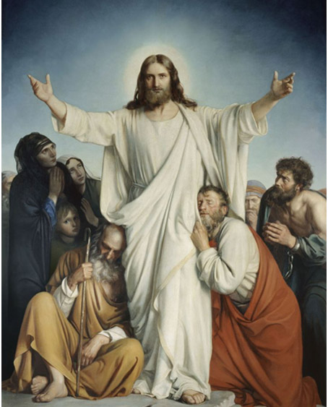
While guilty men his pains deride
They pierce his hands and feet and side
And with insulting scoffs and scorns
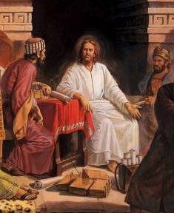
And with insulting scoffs and scorns
They crown his head with plaited thorns
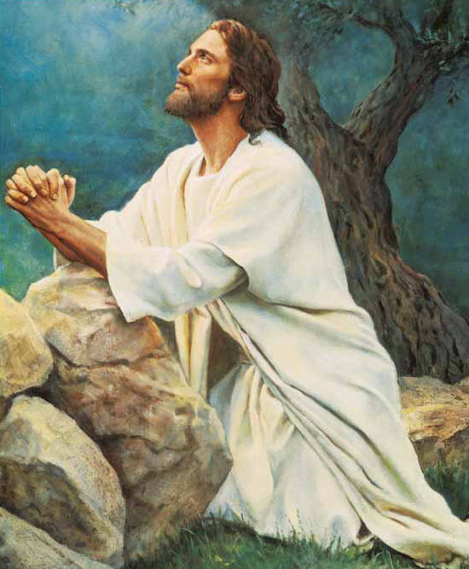
Although in agony he hung
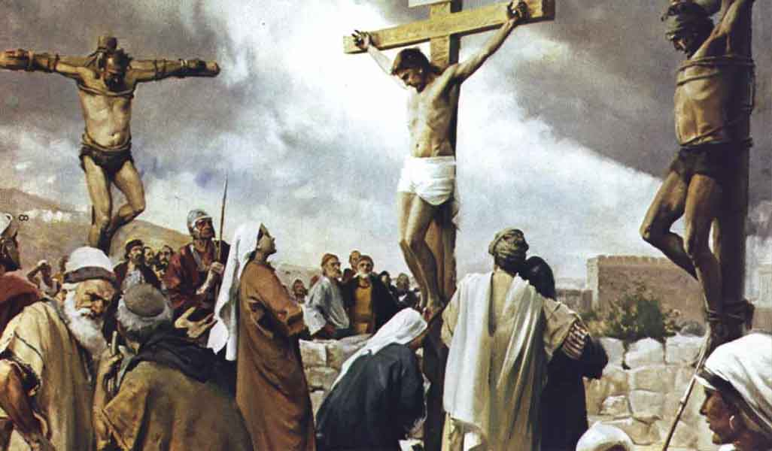
No murm’ring word escaped his tongue

His high commission to fulfill
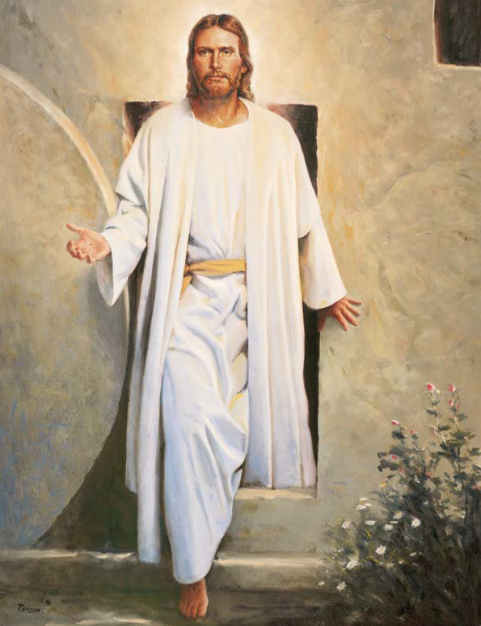
His high commission to fulfill
He magnified his Father’s will
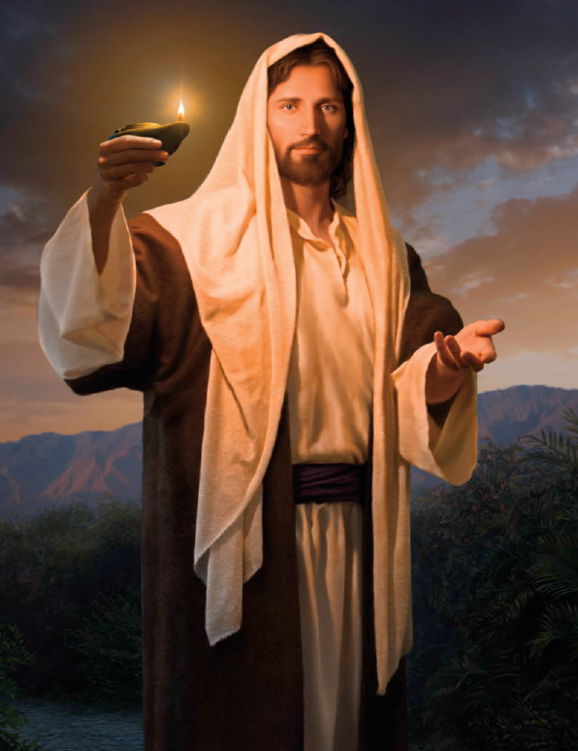
“Father from me remove this cup
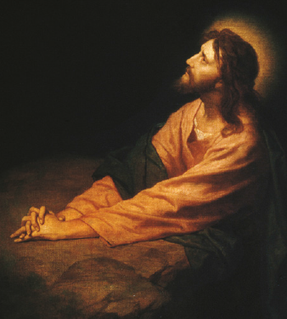
Yet if thou wilt I’ll drink it up
I’ve done the work thou gavest me
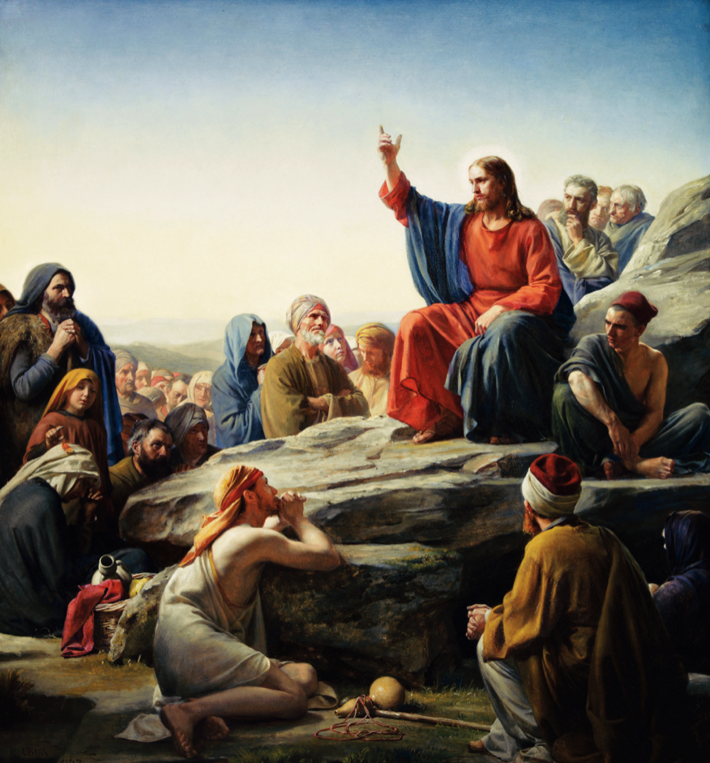
I’ve done the work thou gavest me
Receive my spirit unto thee
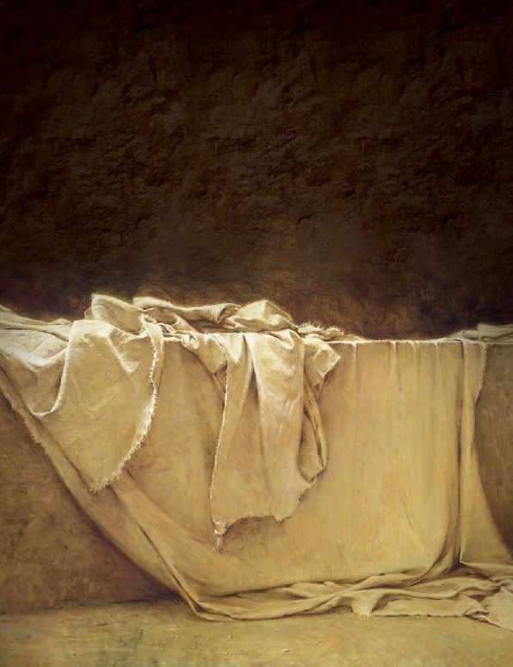
He died and at the awful sight
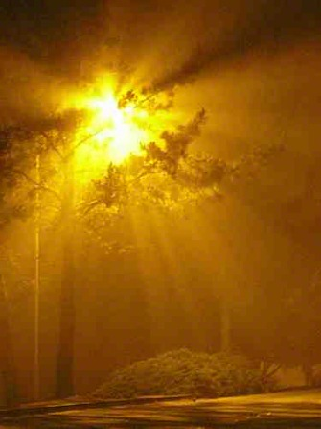
The sun in shame withdrew its light!
Earth trembled and all nature sighed
Earth trembled and all nature sighed
In dread response “A God has died!”
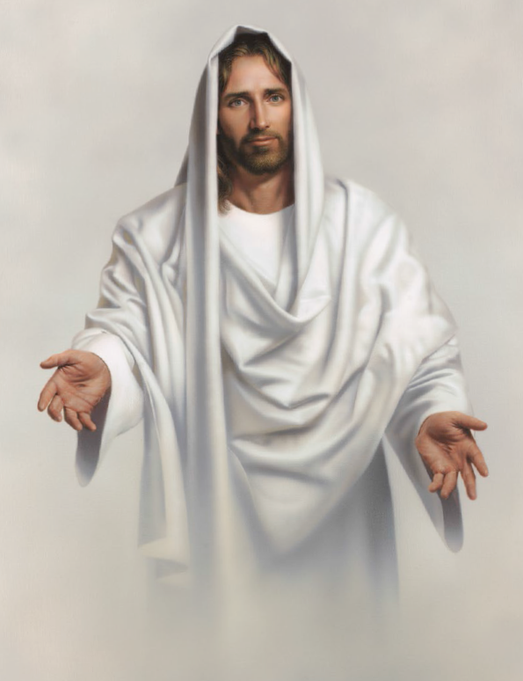
He lives—he lives We humbly now
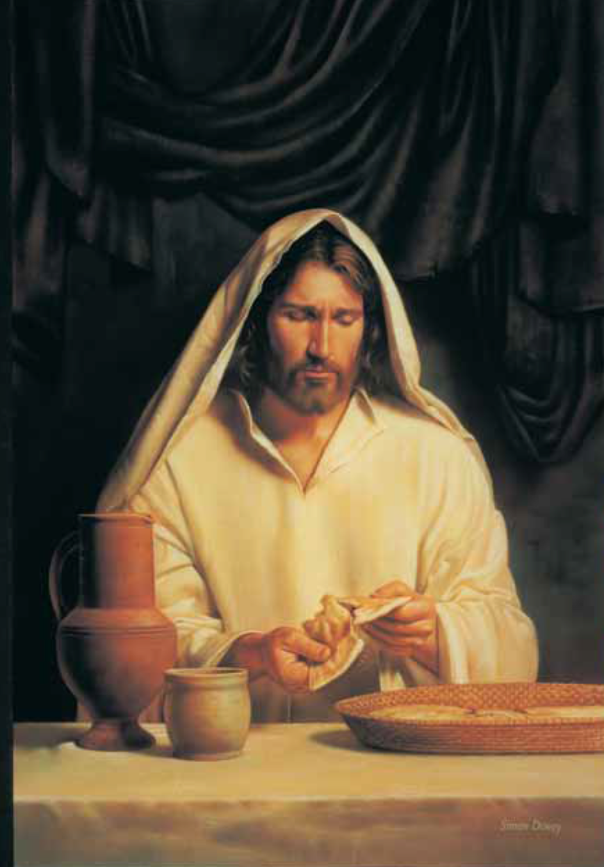
Around these sacred symbols bow
And seek as Saints of latter days
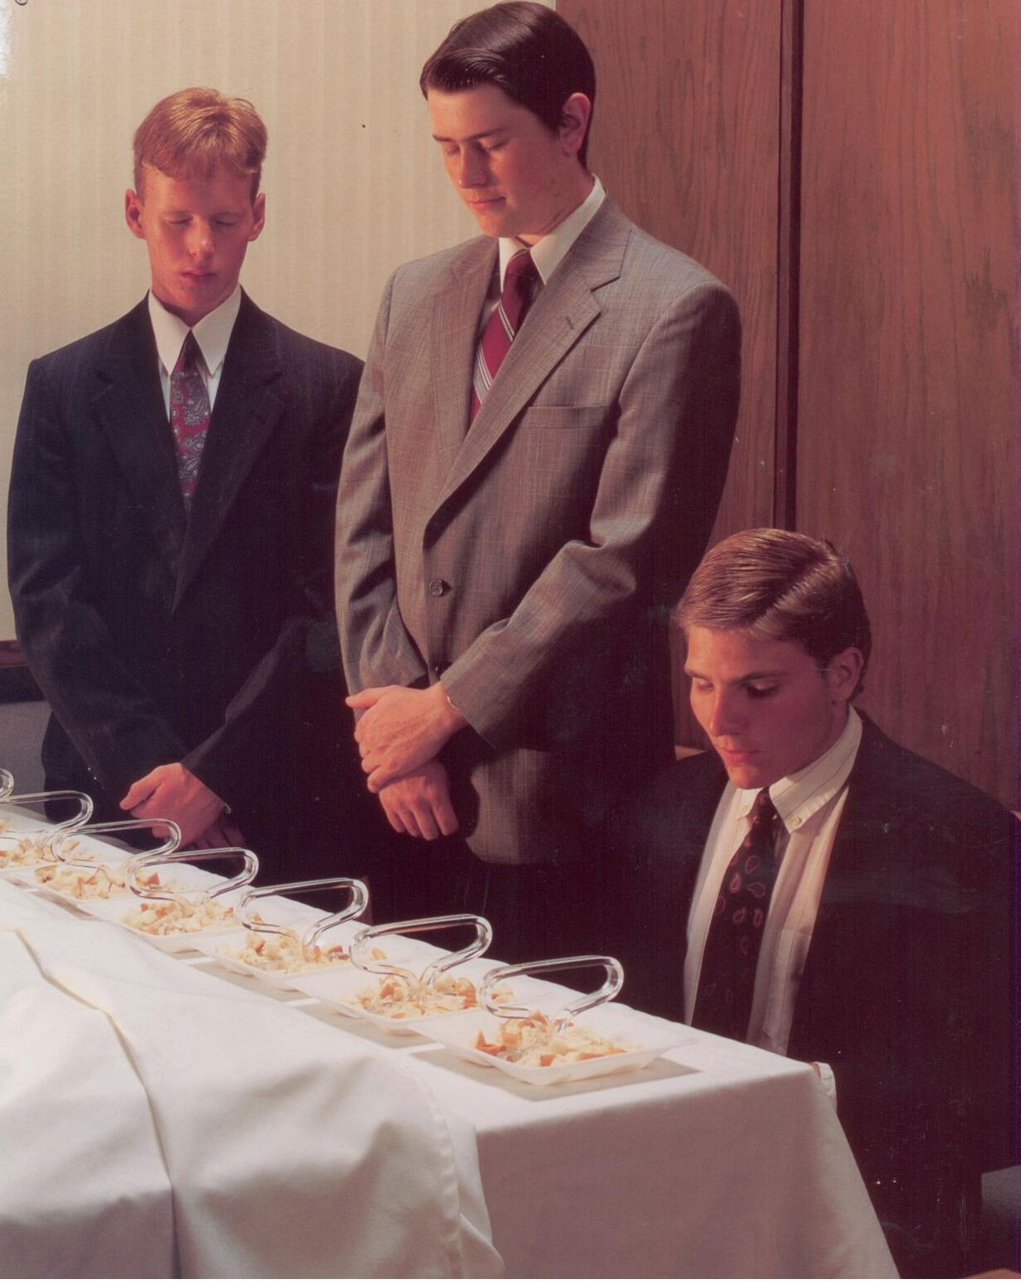
And seek as Saints of latter days
To do his will and live his praise
