Many years ago
when Christ was on the earth
In the land of Bountiful
He came to heal us
And I can't forget his touch
Tears of joy on His face
As He wept for all of us
So great was our faith
Encircled by fire
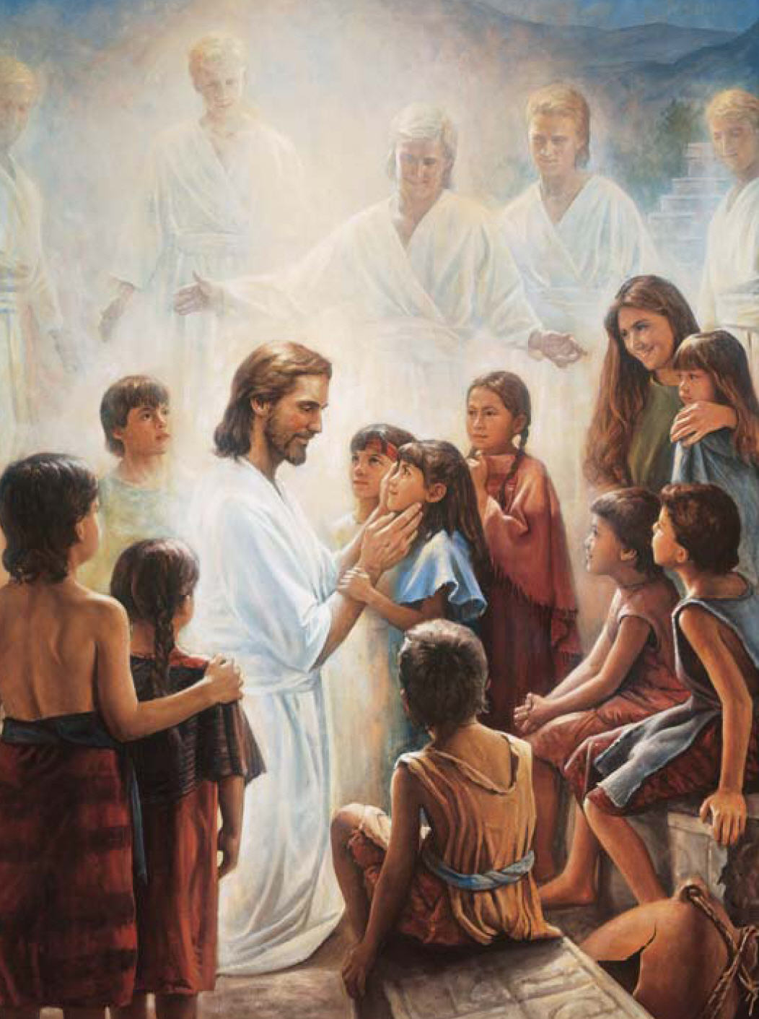
angels coming down
A beautiful choir
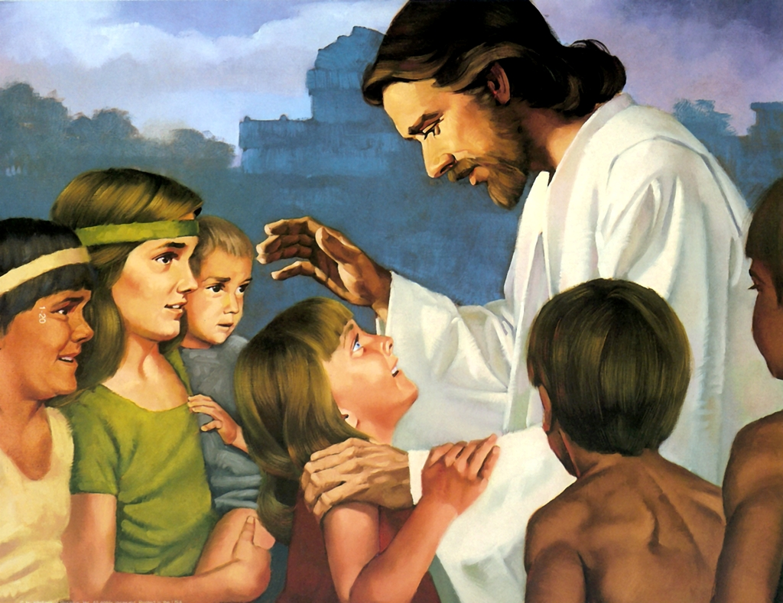
as we learned from the heavens

And I won't forget
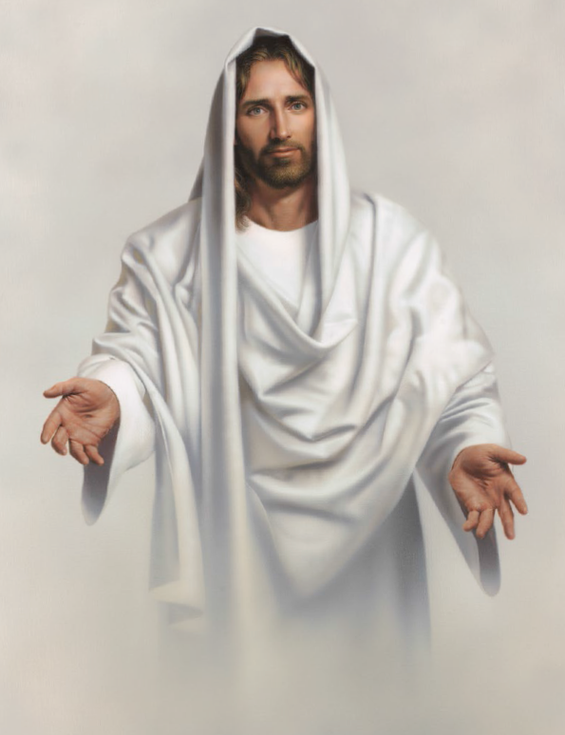
the words He said to all of us
"My joy is full
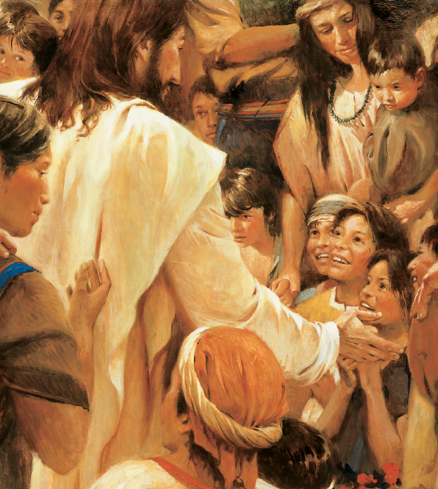
Behold your little ones"
He gathered us around
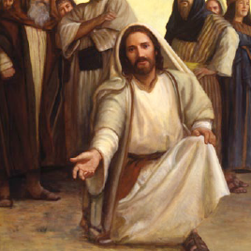
His bended knees
One by one we felt
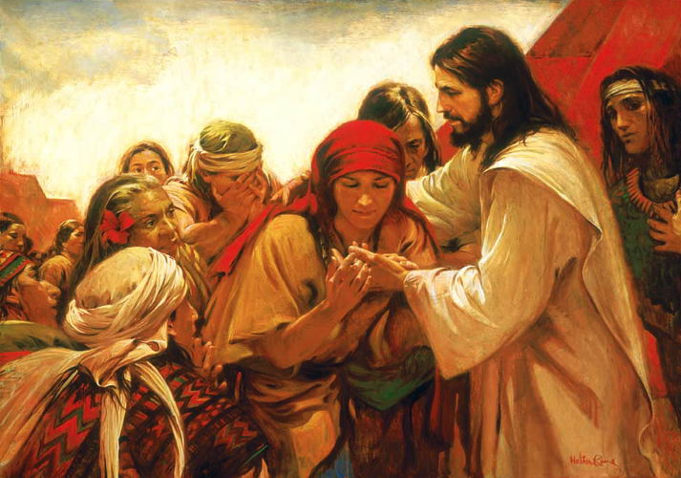
His hands and the prints on His feet
And I can't forget his touch
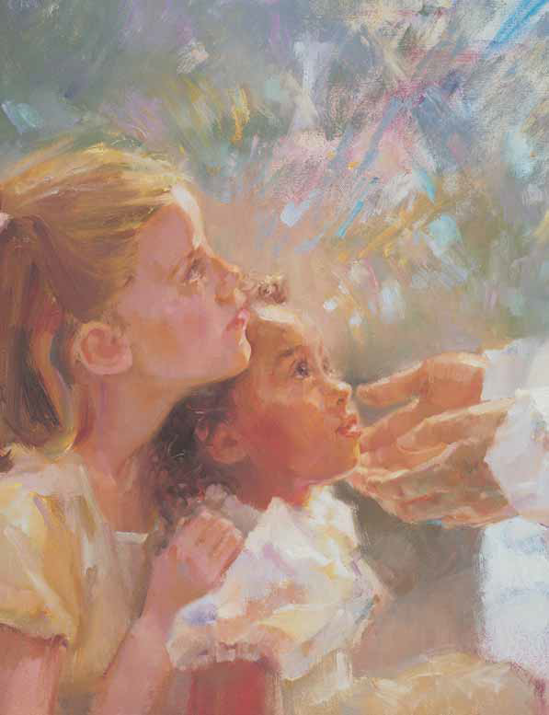
tears of joy on His face
As He wept for all of us
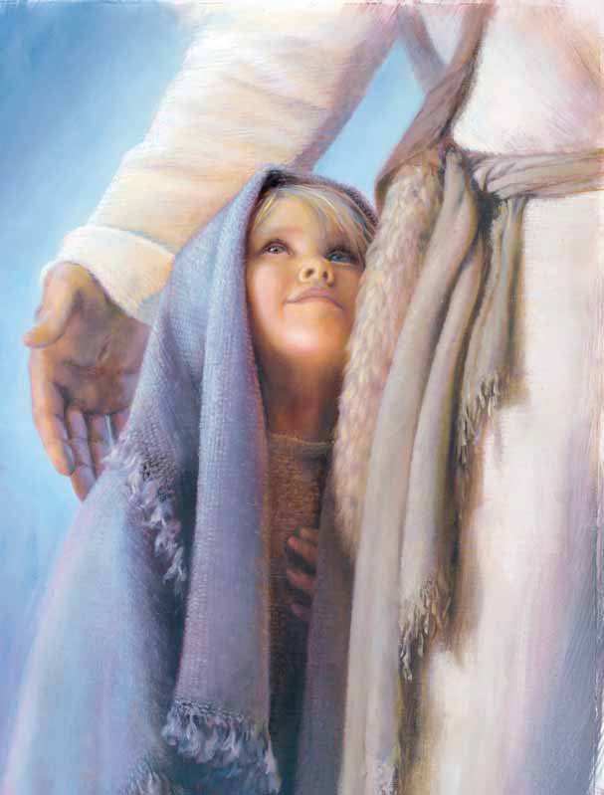
so great was our faith

