Because

By Shawna Edwards

Access the Sheet Music at
http://shawnaedwardsmusic.com

Because He walked with men
I know the way
Because He calmed the storm
I’m not afraid
Because He bowed beneath all things
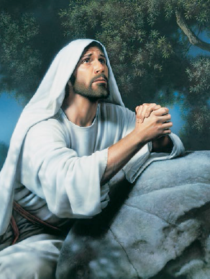
He lifted me above
Because He shed His blood for me
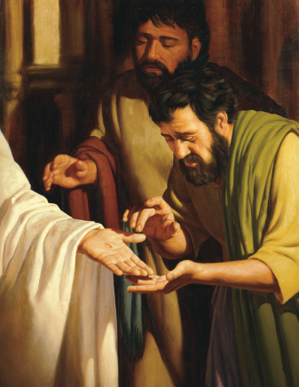
I know His love
And I will praise forever
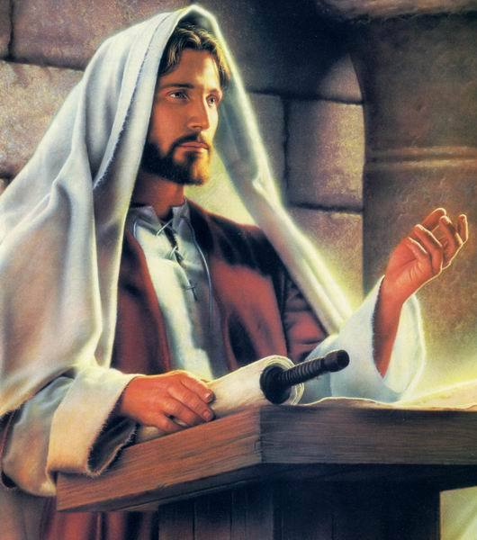
The Savior of the World
And I will sing together
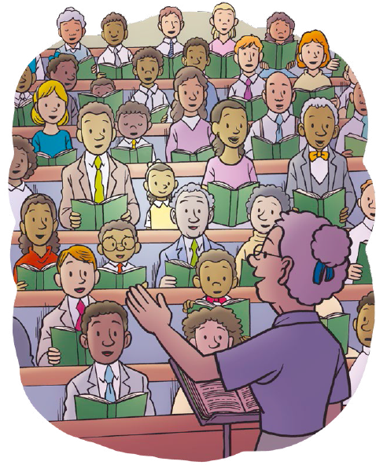
With all the saints on earth
Because He gave to me everything
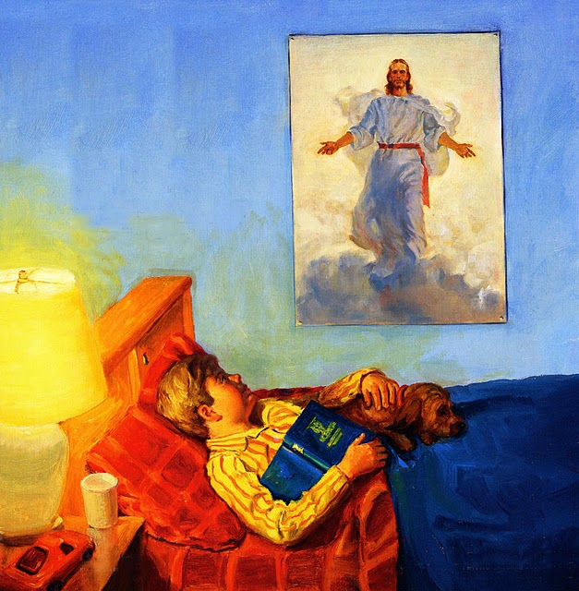
He had to give
I breathe, I see, I hope, I love
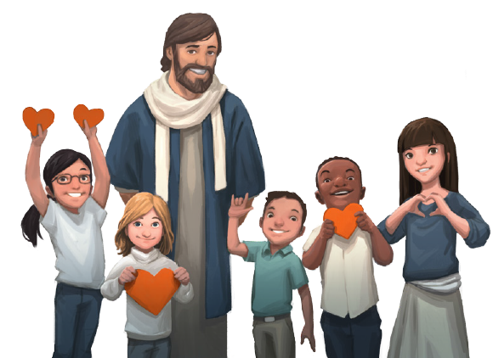
I live

Because He conquered death
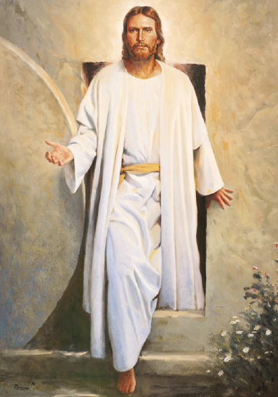
I’ll live again
Because He is my friend
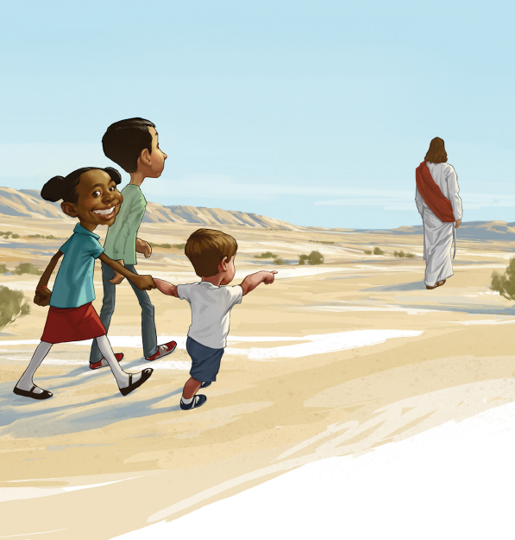
I’ll follow Him
Because He felt all grief and pain
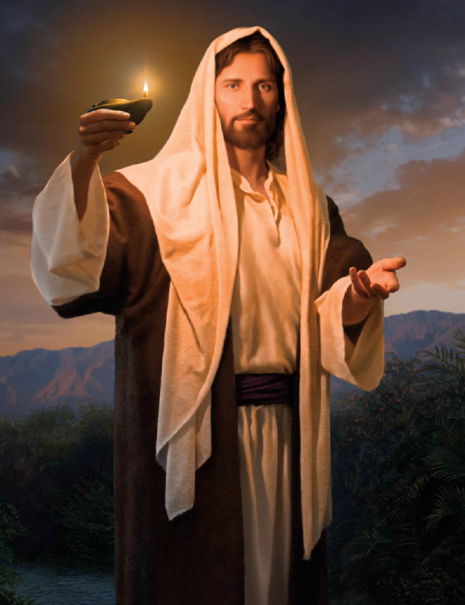
He makes my burden sweet
And when He comes to earth again
I’ll kneel before his feet

